All Saints National Academy
LEARNING POLICY
Policy Review

This policy will be reviewed in full by the Governing Body on an annual basis.
The policy was last reviewed and agreed by the Governing Body on 28/09/20
It is due for review on 28/9/21 (up to 12 months from the above date).
Signature …………………………………. Date ……………………
Principal
Signature ………………….………………. Date ….…………………
Chair of Governors

Mark.
Marking and assessment has two purposes, one, students act on feedback to make progress over time. Two, it informs future planning and teaching.
- Teachers must have a secure overview of the starting points, progress and context of all.
- Marking must be primarily formative, may be selective and include steps for pupils to act upon.
- The marking policy must be used
Plan.
Planning is a process not a product. It has one purpose, to enable high quality delivery which meets the needs of all pupils.
- Be clear and precise about the knowledge/skills you want pupils to LEARN not what you want them to do.
- Match the teaching to meet what the children are to learn
- Ask the question “so why?” Activities including homework are designed to facilitate learning and not to keep pupils busy.
- Differentiation is planned over time to ensure a Quality First approach which meets the needs of all pupils and maximises the use of additional adults in the room
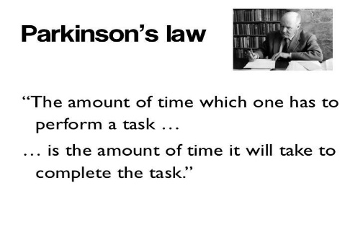
- There should be no “dead” time, this includes a “flying” start with pupils having purposeful learning opportunities and appropriate pace to achieve the intended outcome – Parkinson’s Law

Teach.
Teaching is a lifetime’s craft. “Every teacher needs to improve, not because they are not good enough, but because they can be even better.” (Professor Dylan Williams)
- Go with the learning: the “flow” of great progress is more important than following a lesson plan
- Ensure that learning has “stuck” , through checking and revisiting
- All pupils must be working harder than the teacher
- Constant checking to address misconceptions immediately should be made throughout lessons
- Teachers should be explicit of the learning intentions at the start and within lessons
- Teaching should share the academy values of:

