All Saints National Academy
Calculation Policy 2019/2020

Vision:

A consistent Calculation Policy, used by all staff, parents, carers and Governors will enable all children to develop secure strategies for calculating for each of the four operations - addition, subtraction, multiplication and division (including fractions). Children need to be able to select an efficient method of their choice (whether this be mentally or written) that is appropriate for a given task.

This policy has been produced to inform all staff, parents, carers and Governors of the methods used in school in the teaching of Mathematical calculations. This policy contains the key pencil and paper procedures that will be taught within our school. It has been written to ensure consistency and progression throughout the school and reflects a whole school agreement.

Developmental Aims:

To introduce children to the processes of calculation through concrete, pictorial and abstract methods including mental activities.
To support children in developing ways of recording to support their thinking and calculation methods
Enable children to learn to interpret and use the signs and symbols.

To facilitate children’s use of models and images, such as empty number lines and Numicon to support their mental and informal written methods of calculation.
To enable children to strengthen and refine their mental methods in order to develop informal written methods.
To support children in becoming more efficient and succinct in their recordings which will ultimately lead to efficient written methods that can be used more generally.

By the end of Key Stage 1 children should be equipped with mental and written methods that they understand and can use correctly.

By the end of Key Stage 1, when faced with a calculation, children will be able to decide which method is most appropriate and have strategies to check its accuracy.

At whatever stage in their learning, and whatever method is being used, children’s methods of calculating will be underpinned by a secure and appropriate knowledge of number facts, along with the mental skills that are needed to carry out the process and judge if it was successful.

1

The overall aims when children leave All Saints National Academy are for children to:

- have a secure understanding of mental mathematics facts to apply to written mathematics; which can be built upon in their junior education
- have a secure knowledge of number facts and developing understanding of the four operations
- have an efficient and reliable method of calculation for each operation that children can apply with confidence when undertaking calculations that they cannot carry out mentally;

- be able to use their knowledge and understanding to solve problems;
- check the steps involved in their calculations and decide if the numbers displayed make sense.

- to be provided with the skills necessary for secondary education.

Mental methods of calculation

Oral and mental mathematics is essential, particularly so in calculation. Early concrete, pictorial, oral and mental work lays the foundations by providing children with a good understanding of how the four operations build on efficient counting strategies and a secure knowledge of place value and number facts. Later learning and skill development must ensure that children recognise how the operations relate to one another and how the rules and laws of arithmetic are to be used and applied. Ongoing oral and mental mathematics learning provides practice and consolidation of these ideas. It must give children the opportunity to apply what they have learned to particular cases, exemplifying how the rules and laws work and to general cases where children make decisions and choices for themselves.

The ability to calculate mentally, forms the basis of all methods of calculation and has to be maintained and refined. A good knowledge of numbers or a 'feel' for numbers is the product of structured practice and repetition. It requires an understanding of number patterns and relationships developed through directed enquiry, use of models and images and the application of acquired number knowledge and skills. Secure mental calculation requires the ability to:

- recall key number facts instantly - for example, all addition and subtraction facts for each number to at least 10 (Year 2), sums and differences of multiples of 10 (Year 3) recall all times tables up to 12 x 12 by then end of year 4. Learnt as follows:

Foundation – by end of year begin counting sequences

Year 1 – counting sequences (which follow times tables e.g. 2, 4, 6, 8 10 … for x2). By the end of year 1, children can start learning 2, 10 and 5 times tables.

Year 2 – Refine 2, 10, 5 times tables. Learn 3 and 4 times tables.

2

- use taught strategies to work out the calculation - for example, recognise that addition can be done in any order and use this to add mentally a one-digit number or a multiple of 10 to a one-digit or two-digit number (Year 1), partition two-digit numbers in different ways including into multiples of ten and one and add the tens and ones separately and then recombine (Year 2)

- understand how the rules and laws of arithmetic are used and applied - for example, to add or subtract mentally combinations of one-digit and two-digit numbers (Year 3)

The aim is that by the end of Key Stage 1, the great majority of children should be able to use an efficient informal method of recording for each operation with confidence and understanding. Children will develop the ability to use what are commonly known as 'standard' written methods - methods that are efficient and work for any calculations, including those that involve whole numbers or decimals in their Key Stage 2 learning. They are compact and consequently help children to keep track of their recorded steps. Being able to use these written methods gives children an efficient set of tools they can use when they are unable to carry out the calculation in their heads or do not have access to a calculator. We want children to know that they have such a reliable, written method to which they can turn when the need arises.

In setting out these aims, the intention is that there will be a consistent approach to the learning of calculation strategies and that all teachers understand the progression of skills and key concepts. The great majority of children will benefit greatly from learning how to use the most efficient methods. The challenge for teachers will be in determining when their children should move on to a refinement in the method and become confident and more efficient at written calculation. Guidance is given below for the steps in reaching the most efficient methods for each of the four number operations.

3

EYFS & KS1
Addition
 |  |  |  | EYFS |  |  |  |  |  |  |  | Year 1 |  |  |  |  | Year 2
 |  | Mental Strategies |  |  |  |  | Statutory Requirements |  |  |  |  |  |  |  |  | Statutory Requirements 
 |  | Numicon shapes are introduced |  |  |  |  |  | • Read, |  | write and interpret mathematical statements |  |  |  |  |  | • | Solve problems with addition: 
 |  | straight away and can be used to: |  |  |  |  |  |  | involving addition and equals (=) signs |  |  |  |  |  |  | -using concrete objects and pictorial representations,
 |  |  | • | identify 1 more/ 1 less |  |  |  | • Represent and use number bonds within 20 |  |  |  |  |  |  |  | including those involving numbers, quantities and
 |  |  | • | combine pieces to add |  |  |  |  | Add one-digit and two-digit numbers to 20, including |  |  |  |  |  |  | measures
 |  |  | • | find number bonds |  |  |  | • |  |  |  |  |  |  |  | -applying their increasing knowledge of mental and
 |  |  | • | add without count |  |  |  |  | zero
 |  |  |  |  |  |  |  | • |  |  |  |  |  |  |  | written methods
 |  |  |  |  |  |  |  |  | Solve | one-step problems that |  |  |  | involve addition using
 |  |  |  |  |  |  |  |  |  |  |  |  |  |  |  | • | Recall and use addition facts to 20 fluently,
 |  | Children can record this by printing or |  |  |  |  |  |  | concrete objects and pictorial |  |  |  |  | representations, and
 |  |  |  |  |  |  |  |  |  |  |  |  |  |  |  |  | and derive and use related facts up to 100
 |  | drawing around numicon pieces. |  |  |  |  |  |  | missing number problems such as 10 = + 9.
 |  |  |  |  |  |  |  |  |  |  |  |  |  |  |  | • | Add numbers using concrete objects,
 |  |  |  |  |  |  |  |  |  |  |  |  |  |  |  |  | pictorial representations, and mentally,
 |  |  |  |  |  |  |  |  |  |  |  |  |  |  |  |  | including: a two-digit number and ones, a
 |  |  |  |  |  |  |  |  |  |  |  |  |  |  |  |  | two-digit number and tens, two two-digit
 | • |  | Children begin to combine groups |  |  |  |  | • | They should see addition and subtraction as related |  |  |  |  |  |  |  | numbers, adding three one-digit numbers
 |  |  |  |  |  |  |  |  |  |  |  |  |  |  |  | • | Show that addition of two numbers can be
 |  |  | of objects using concrete |  |  |  |  |  | operations. E.g. 7 + 3 = 10 is related to 10 – 3 = 7,
 |  |  |  |  |  |  |  |  |  |  |  |  |  |  |  |  | done in any order (commutative) and
 |  |  | apparatus. |  |  |  |  |  | understanding of which could be supported by an image
 |  |  |  |  |  |  |  |  |  |  |  |  |  |  |  |  | subtraction of one number from another
 |  |  |  |  |  |  |  |  | like this.
 |  |  |  |  |  |  |  |  |  |  |  |  |  |  |  |  | cannot
 |  |  |  | +
 |  |  |  |  |  |  |  |  |  |  |  |  |  |  |  | • Recognise and use inverse relationship
 |  |  |  |  |  |  |  |  |  |  |  |  |  |  |  |  | between addition and subtraction and
 | • |  | Construct number sentences |  |  |  |  |  |  |  |  |  |  |  |  |  | use this to check calculations and solve
 |  |  | verbally or using cards to go with |  |  |  |  |  |  |  |  |  |  |  |  |  | missing number problems.
 |  |  | practical activities.
 |  |  |  |  |  |  |  | • Concrete and Pictorial models can be used to show
 | • |  | Children are encouraged to read |  |  |  |  |  |  |  |  |  |  |  |  | • | Number lines are used to support
 |  |  |  |  |  |  |  |  | children how subtraction and addition are related
 |  |  | number sentences aloud in different |  |  |  |  |  |  |  |  |  |  |  |  |  | mathematical thinking, e.g. to model how to
 |  |  |  |  |  |  |  |  | operations.
 |  |  | ways “two add one equals three” |  |  |  |  |  |  |  |  |  |  |  |  |  | add 9 by adding 10 and adjusting.
 |  |  |  |  |  |  |  |  | 6 + 4 = 10 | part, part, whole model
 |  |  | “three is equal to two add one”
 |  |  |  |  |  |  |  |  | 4 + 6 = 10
 | • Children make a record in
 |  |  |  |  |  |  |  |  | 10 – 4 = 6
 |  |  | pictures,words or symbols of addition
 |  |  |  |  |  |  |  |  | 10 – 6 = 4
 |  |  | activities already carried out |  |  |  | bar model |  |  |  |  |  |  |  |  |  | Children should practice addition to 20 to
 | • Solve problems using fingers |  |  |  |  |  |  |  |  |  |  |  |  |  |  | •
 |  |  |  |  |  |  |  |  | 10
 |  |  |  |  |  |  |  |  |  |  |  |  |  |  |  |  | become increasingly fluent. They should
 |  |  |  |  |  |  |  |  | 6 | 4
 |  |  |  |  |  |  |  |  |  |  |  |  |  |  |  |  | use the facts they know to derive others
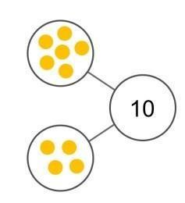
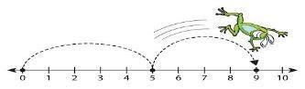
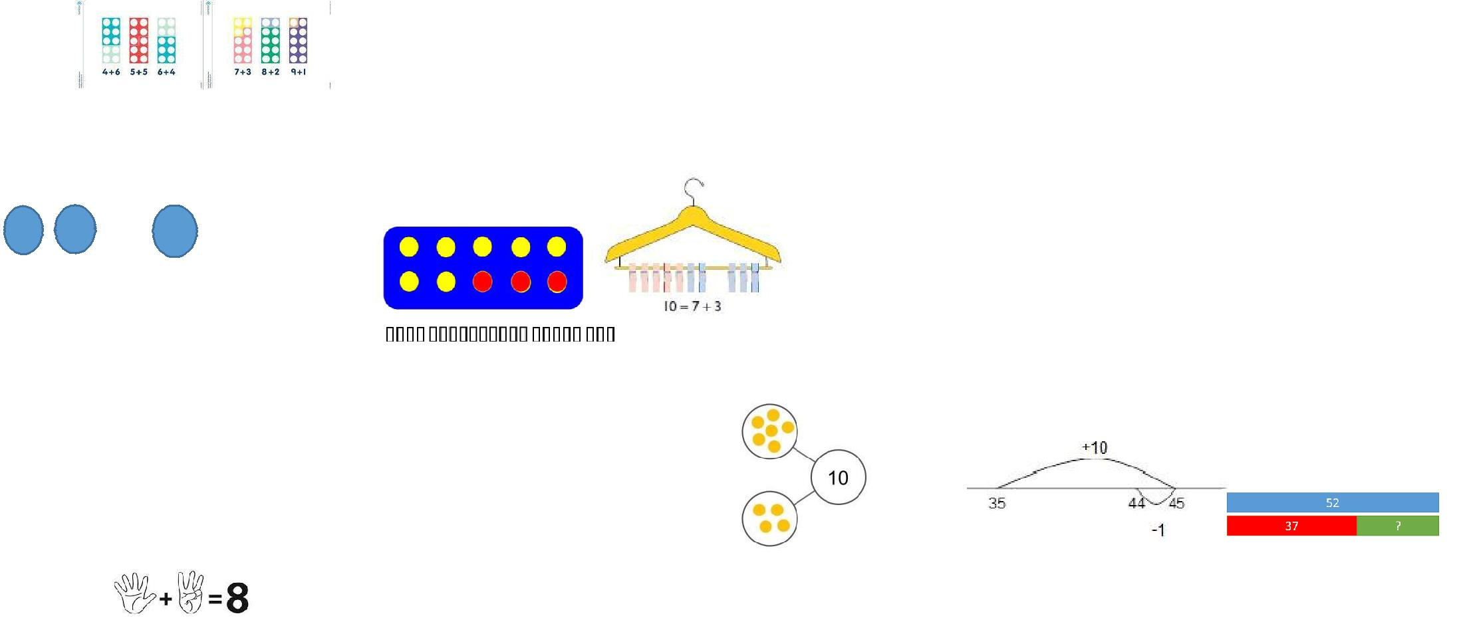

4

o count up on and to find one more:

side number tracks and practical ions and word problems.

ow numbers get larger when others are

Vocabulary

y to begin using vocabulary involved in

”

Add, more, and, make, sum, total, altogether, score, double, one more, two more, ten more….

- Number lines can be used alongside number tracks and practical apparatus to solve addition calculations and word problems.

- Number squares are used to show how numbers get larger when others are added to them

- Use bundles of straws and Dienes to model partitioning numbers into tens and ones and develop understanding of place value.

47
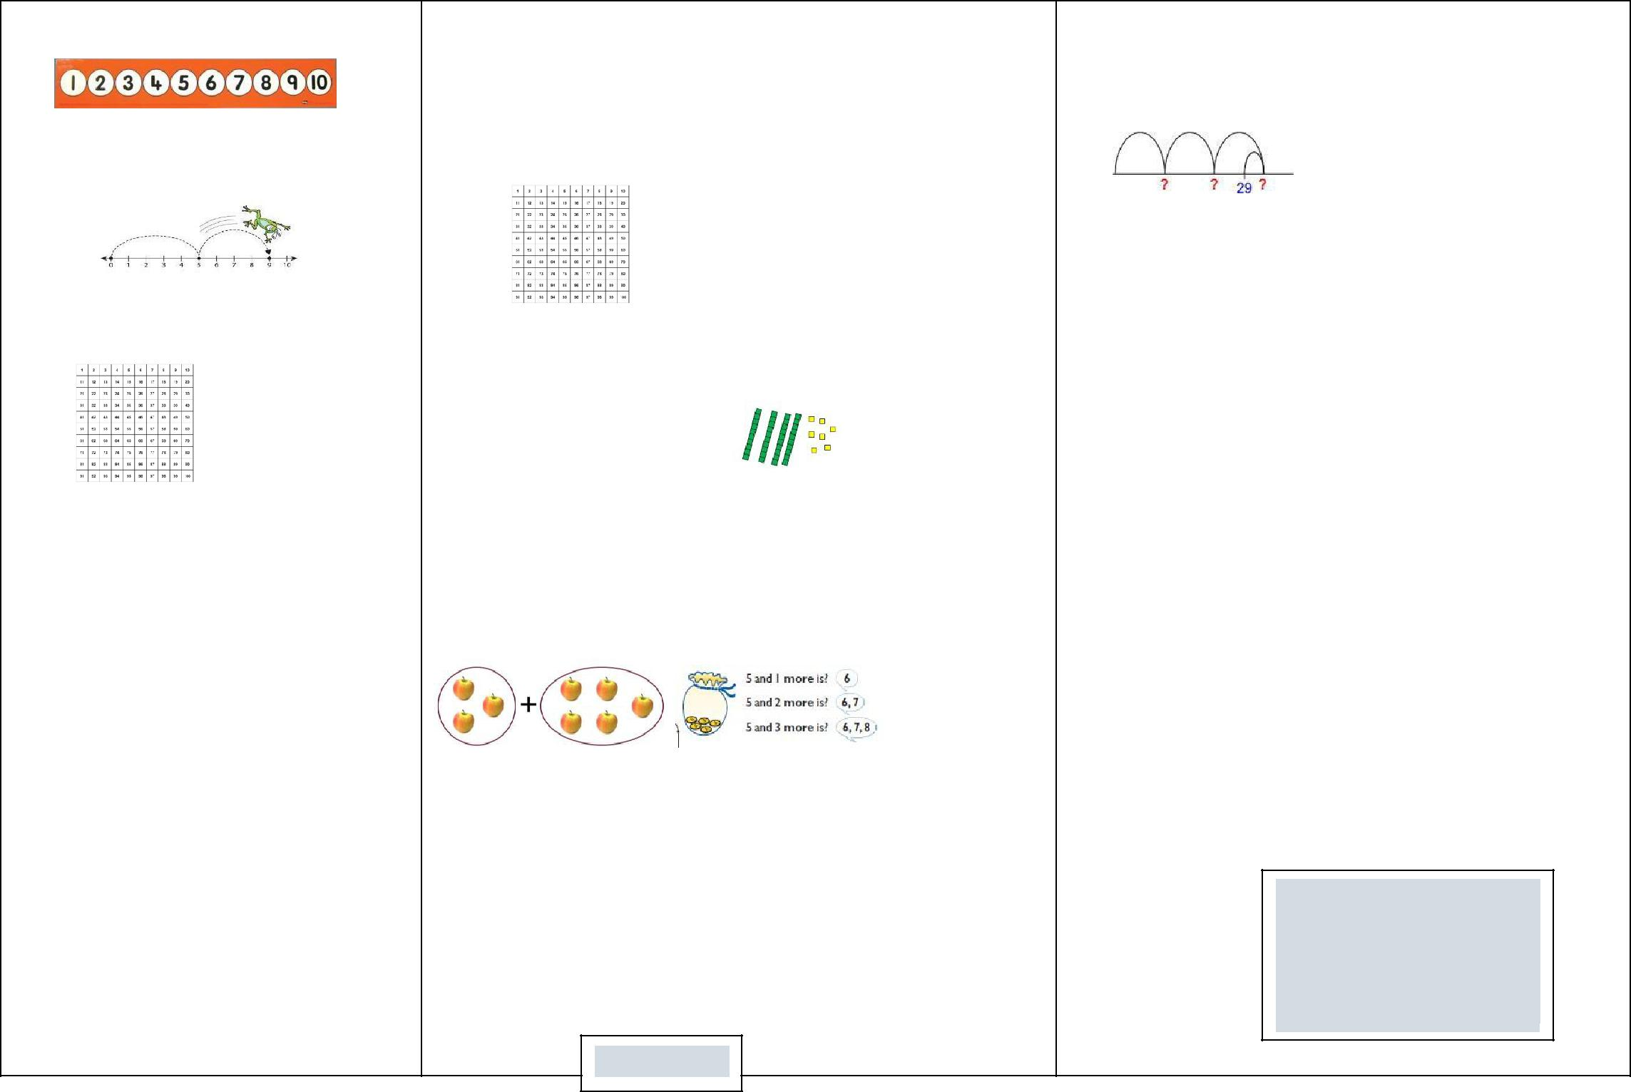

Children have opportunities to explore partitioning numbers in different ways.
e.g. 7 = 6 + 1, 7 = 5 + 2, 7 = 4 + 3 =

Children should begin to understand addition as combining groups and counting on.

Vocabulary

Addition, add, forwards, put together, more than, total, altogether, distance between, difference between, equals = same as, most, pattern, odd, even, digit, counting on.

(Links between addition and subtraction)
- When introduced to the equals sign, children should see it as signifying equality.

4 + 1 = 2 + 3

e.g using 7 + 3 = 10 to find 17 + 3= 20 or 70 + 30 = 100
- They should use concrete objects such as bead strings and number lines to explore missing numbers

- As well as number lines, 100 squares are used to explore patterns in calculations such as 74 +11, 77 + 9 encouraging children to think about ‘What do you notice?’ where partitioning or adjusting is used.

- Concrete and Pictorial methods are still taught to show children how subtraction and addition are related operations.
6 + 4 = 10
4 + 6 = 10 | bar model
10 – 4 = 6 | part whole model
10 – 6 = 4 | (see Year 1)
 

Children should learn to check their calculations, by using the inverse.

They should continue to see addition as both combining groups and counting on.

They should use Dienes to model partitioning into tens and ones and learn to partition numbers in different ways e.g. 23 20 + 3 = 10 + 13.
Children will also partition two 2-digit numbers into tens and ones, adding the tens, the ones and totaling both answers.
23 + 12
20 + 3 | 10 + 2
20 + 10 = 30
3 + 2 = | 5
30 + 5 = 35

5

- Children should become used to seeing equations in different orders and using ‘?’ to represent the missing number.

4 = ? + 3 4 = 3 + ? 3 + ? =4

- + 3 = 4

 

 
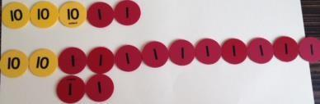
 

 
 
 

Place value counters are used to help children partition numbers in lots of different ways.

Vocabulary

+, add, addition, more, plus, make, sum, total, altogether, how many more to make…? how many more is… than…? how much more is…? =, equals, sign, is the same as, Tens, ones, partition

Near multiple of 10, tens boundary, More than, one more, two more… ten more… one hundred more

6

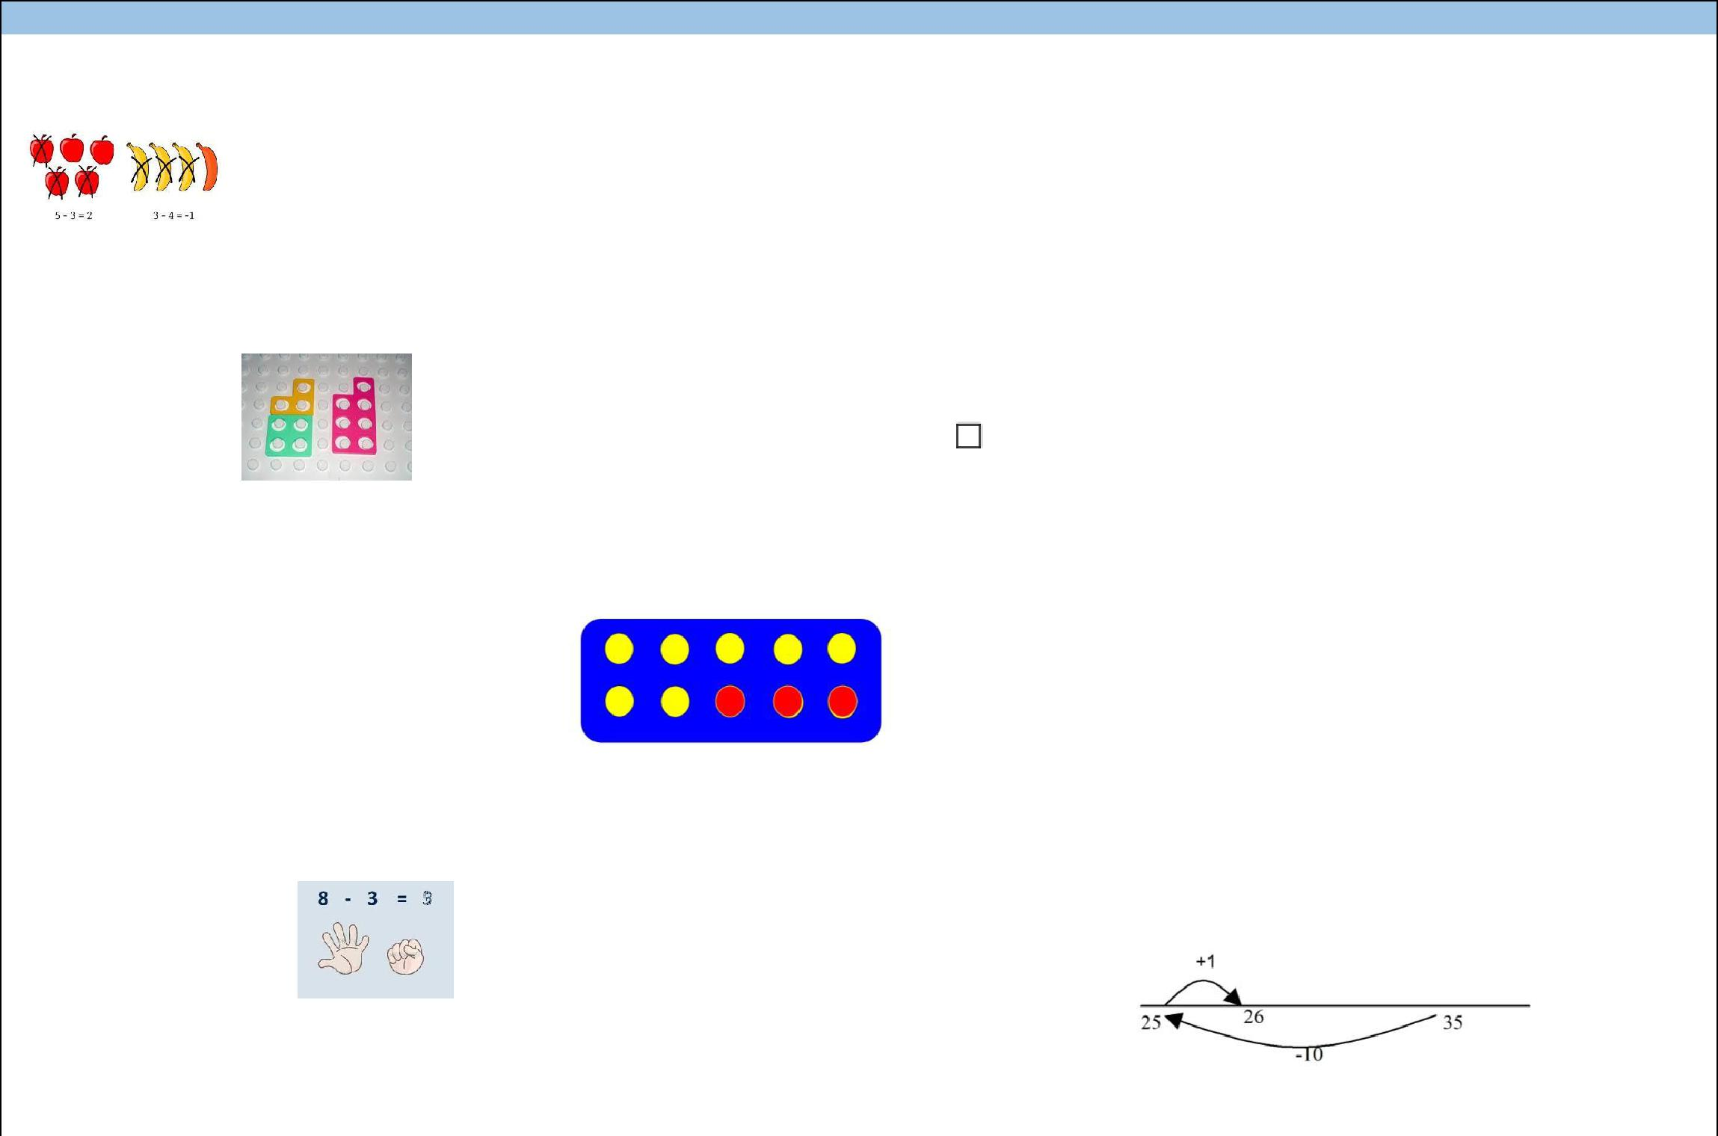
Subtraction
 | EYFS |  | Year 1 |  |  |  |  | Year 2
 | Children begin with mostly pictorial |  | Statutory Requirements |  |  |  | Statutory Requirement
 | representations
 |  |  | Read, write and interpret mathematical |  |  |  | Solve problems with subtraction:
 |  |  | statements involving subtraction (–) and |  |  |  | -using concrete objects and pictorial representations,
 |  |  | equals (=) signs |  |  |  | including those involving numbers, quantities and
 |  |  | Represent and use number bonds and |  |  |  | measures
 | Concrete apparatus is used to relate subtraction |  | related subtraction facts within 20 |  |  |  | -applying their increasing knowledge of mental and
 |  |  | Subtract one-digit and two-digit numbers |  |  |  | written methods
 | to taking away and counting how many objects are |  | to 20, including zero |  |  | • Recall and use subtraction facts to 20 fluently, and
 | left. Numicon is an ideal resource for this. |  | Solve one-step problems that involve |  |  |  | derive and use related facts up to 100
 |  |  |  |  |  | • Subtract numbers using concrete objects, pictorial
 |  |  | subtraction, using concrete objects and
 |  |  |  |  |  |  | representations, and mentally, including: a two-
 |  |  | pictorial representations, and missing
 |  |  |  |  |  |  | digit number and ones, a two- digit number and
 |  |  | number problems such as 7 = |  | – 9
 |  |  |  |  |  |  | tens, two two-digit numbers, adding three one-digit
 |  |  | Children should see addition and subtraction as |  |  |  | numbers
 | Construct number sentences verbally or using |  |  |  |  | • Show that addition of two numbers can be done in
 |  |  | related operations. E.g. 7 + 3 = 10 is related to 10
 | cards to go with practical activities |  |  |  |  |  | any order (commutative) and subtraction of one
 |  |  | – 3 = 7, understanding of which could be supported
 |  |  |  |  |  |  | number from another cannot.
 |  |  | by an image like this.
 | Children are encouraged to read number |  |  |  |  | • Recognise and use the inverse relationship between
 | sentences aloud in different ways “five subtract |  |  |  |  |  | addition and subtraction and use this to check
 | one leaves four” “four is equal to five subtract |  |  |  |  |  | calculations and solve missing number problems
 | one”
 | Children make a record in pictures, words or |  |  |  |  |  | Children should count regularly, on and back, in steps
 |  |  | Use bundles of straws and Dienes to model |  |  |  | of 2, 3, 5 and 10. Counting back in tens from any
 | symbols of subtraction activities already carried |  |  |  |  |  | number should lead to subtracting multiples of 10.
 |  |  | partitioning teen numbers into tens and ones.
 | out |  |  |  |  |  | Number lines should continue to be an important
 | Solve simple problems using fingers |  | Children should begin to understand subtraction |  |  |  | image to support thinking, for example to model how to
 |  |  |  |  |  |  | subtract 9 by adjusting.
 |  |  | as both taking away and finding the difference
 |  |  | between, and should find small differences by
 |  |  | counting on.
 | Number tracks and squares can be introduced to
 | count back and to find one less |  |  |  |  |  | Children should practice subtraction to 20 to become

7

Place value counters are used by children to help work out answers to equations.

20 – 16 = 4

Vocabulary

Games and songs can be a useful way to begin using vocabulary involved in addition e.g. “10 fat sausages”, and “5 Little Speckled Frogs”

Take (away), leave, one less, two less… ten less…, fewer, less than,

Number lines can then be used alongside number tracks and practical apparatus to solve subtraction calculations and word problems. Children subtract UNDER the number line and add ABOVE it
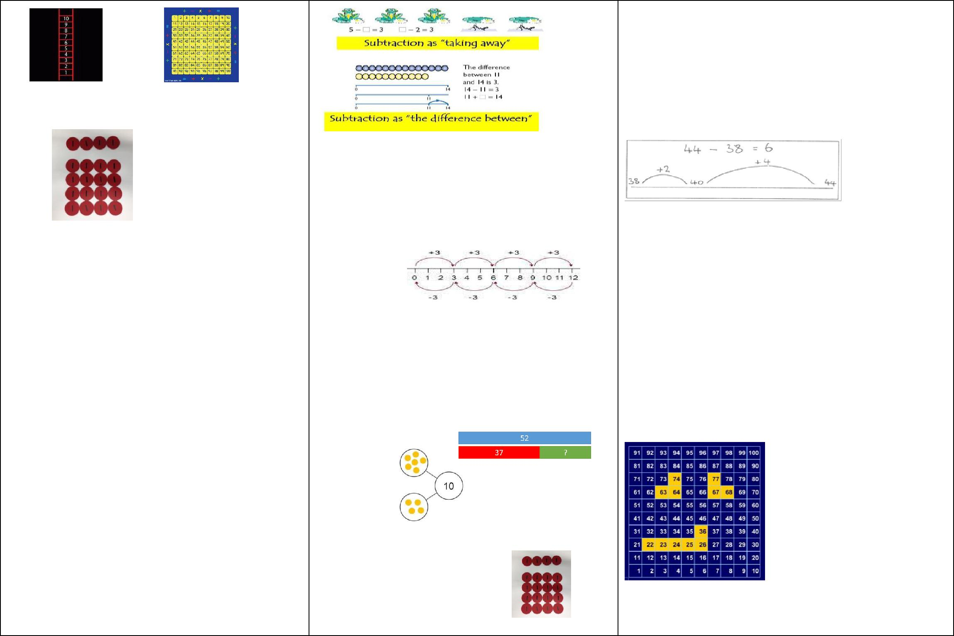

Children will also be taught to count on from the smaller number to the larger number when working out subtraction problems.

Concrete and Pictorial methods are taught to show children how subtraction and addition are related operations.
6 + 4 = 10
4 + 6 = 10
10 – 4 = 6

Place value counters are used by children to help work out answers to equations.

increasingly fluent. They should use the facts they know to derive others, e.g using 10 - 7 = 3 and 7 = 10 - 3 to calculate 100 - 70 = 30 and 70 = 100 - 30. Children will also be taught to count on from the smaller number to the larger number working out subtraction problems

As well as number lines, 100 squares could be used to model calculations such as 74 – 11, 77 – 9 or 36 – 14,

where partitioning or adjusting are used. On the example above, 1 is in the bottom left corner so that ‘up’ equates to ‘add’.

Children are also encouraged to exchange by partitioning numbers in different ways. By doing this children learn that a value remains the same, we have just partitioned in a different way.

i.e 72 = 70+2 = 60+12 = 50+22 etc.

Children should learn to check their calculations,

8

1 + 3
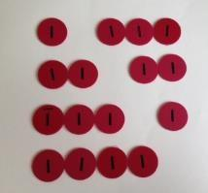

20 – 16 = 4 2 + 2

3 + 1

4 + 0

Vocabulary

Subtraction, subtract, take away, distance

between, difference between, more than, minus,

less than, equals = same as, most, least, pattern,

odd, even, digit,

including by adding to check.

They should continue to see subtraction as both take away and finding the difference, and should find a small difference by counting up.
They should use Dienes (base 10 resources) to model partitioning into tens and ones and learn to partition numbers in different ways e.g. 23 = 20 + 3 = 10 + 13.

Concrete and Pictorial methods are taught to show children how subtraction and addition are related operations.
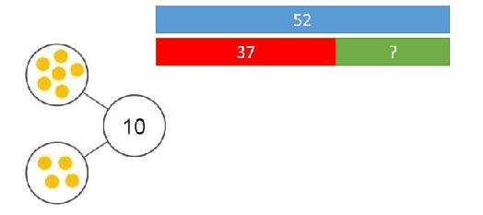
6 + 4 = 10
4 + 6 = 10
10 – 4 = 6

Vocabulary
Subtraction, subtract, take away, difference,
difference between, minus, Tens, ones, partition

Near multiple of 10, tens boundary, Less than, one less,

two less… ten less… one hundred less, More, one more,
two more... ten more... one hundred more

Recognise and use the inverse relationship between addition and subtraction and use this to check calculations and missing number problems. This understanding could be supported by images such as this.
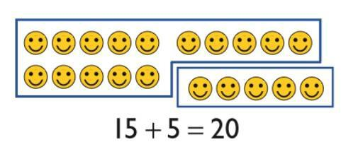

9

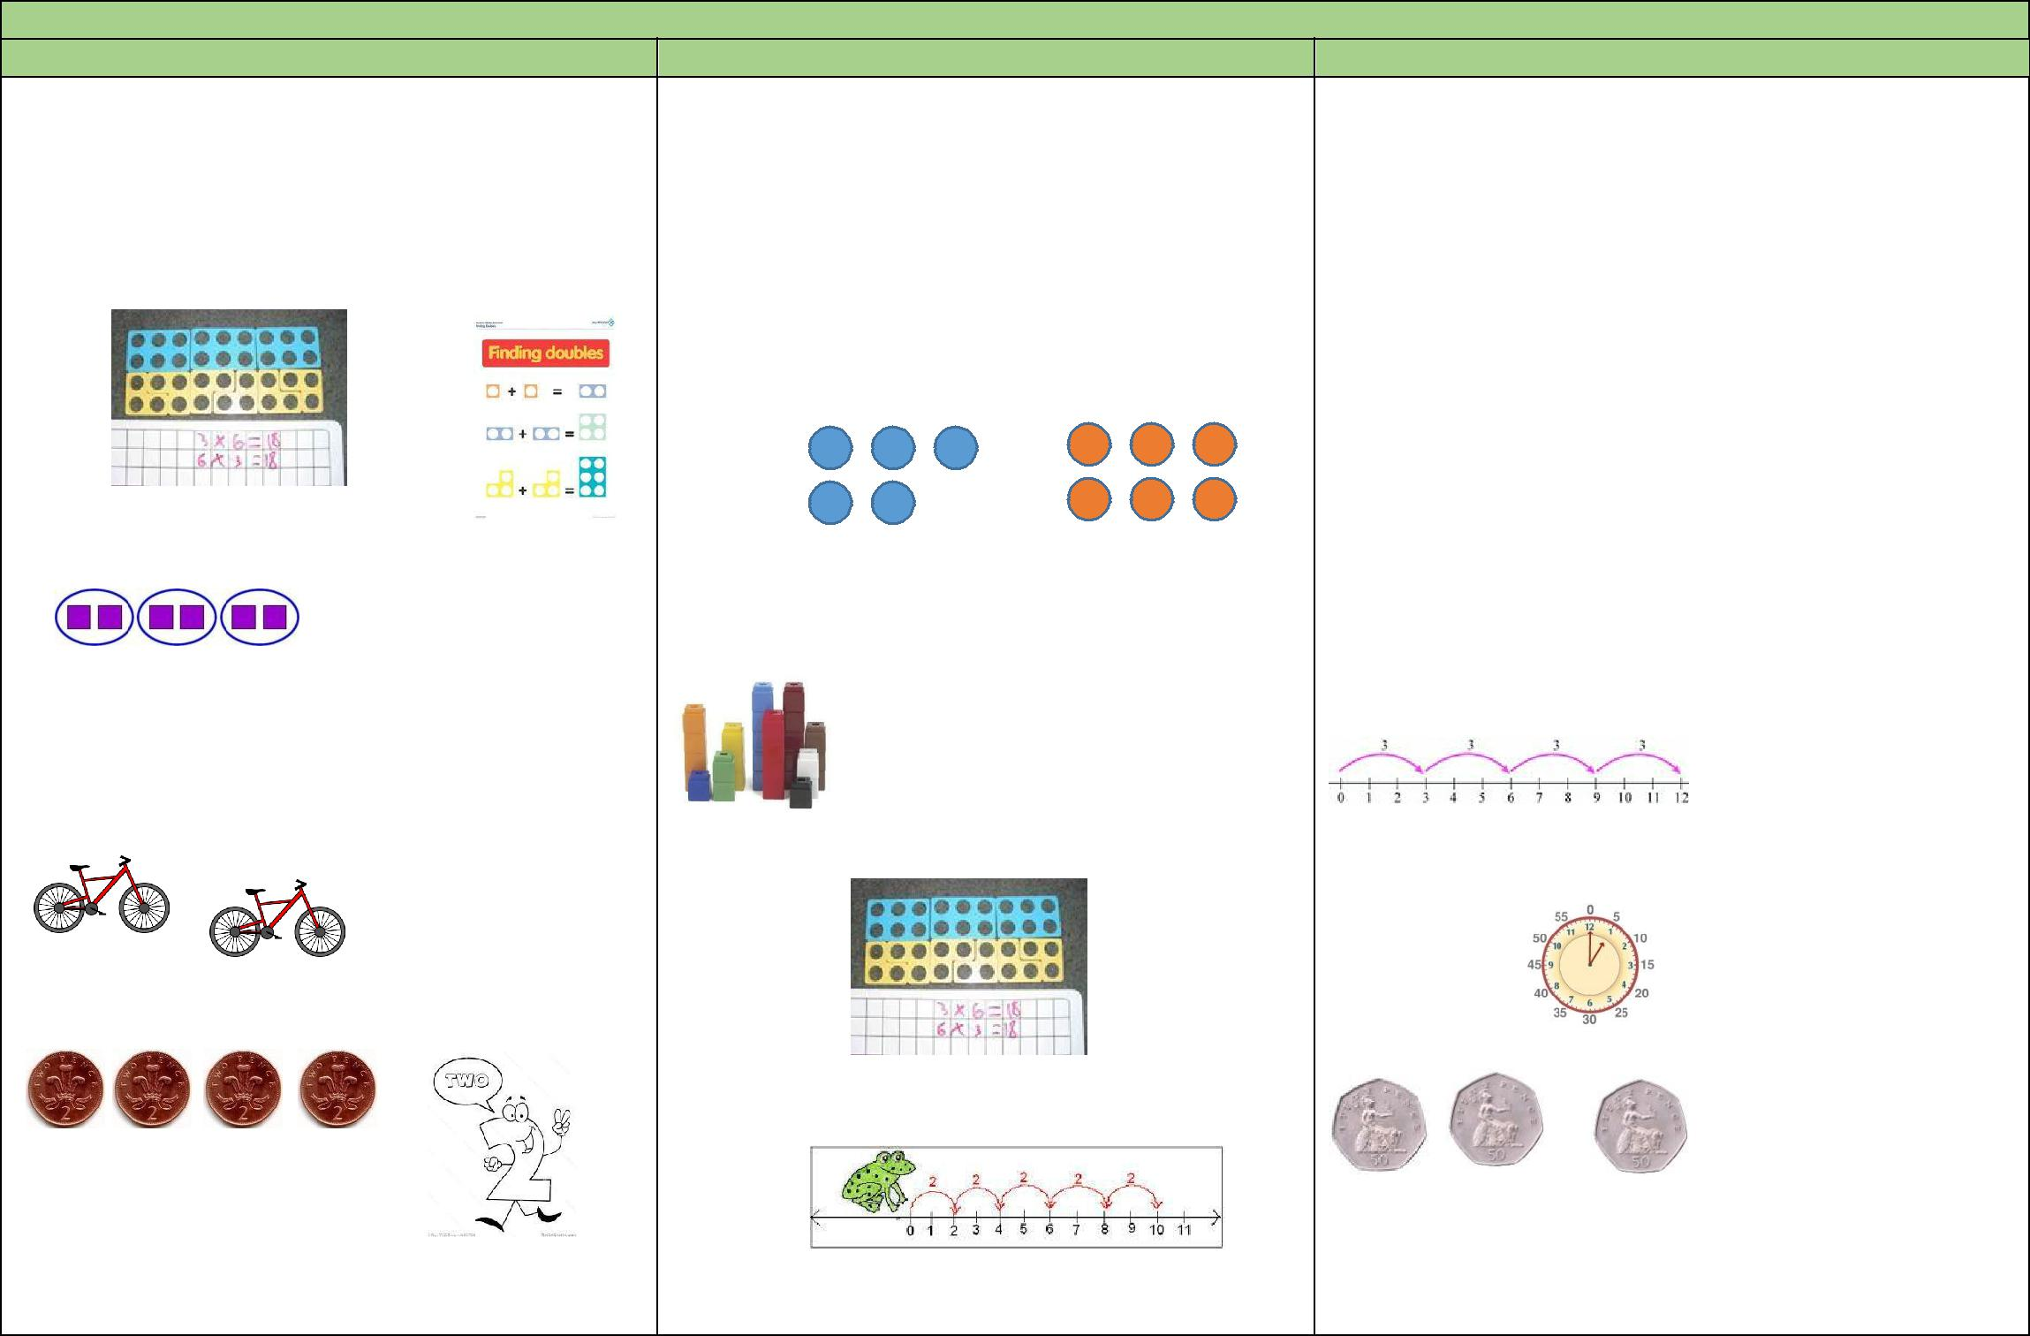
Multiplication
EYFS | Year 1 |  | Year 2
The link between addition and multiplication can | Statutory Requirements | Statutory Requirements
be introduced through doubling | Solve one-step problems involving multiplication, | • Recall and use multiplication facts for the 2, 5
Numicon is used to visualise the repeated adding | by calculating the answer using concrete objects, |  | and 10 multiplication tables, including
 | pictorial representations and arrays with the |  | recognising odd and even numbers
of the same number. These can then be drawn | support of the teacher. | • | Calculate mathematical statements for
around or printed as a way of recording
 |  |  | multiplication within the multiplication tables
 | Pupils should see ways to represent odd and even |  | and write them using the multiplication (×) and
 | numbers. This will help them to understand the |  | equals (=) signs
 | pattern in numbers. | • Show that multiplication of two numbers can
 |  |  | be done in any order (commutative) and
 |  |  | division of one number by another cannot
Children begin with mostly pictorial |  | • | Solve problems involving multiplication using
 |  |  | materials, arrays, repeated addition, mental
representations
 | Children should begin to understand multiplication as |  | methods, and multiplication facts, including
 | scaling in terms of double and half. (e.g. that tower |  | problems in contexts.
 | of cubes is double the height of the oth | Number lines should continue to be an important
How many groups of 2 are there? | tower)
 |  | image to support thinking, for example
Real life contexts and use of practical equipment |  |  | 3 x 4 = 12
to count in repeated groups of the same size:
 | Numicon is used in the teaching of multiplication | Use a clock face to support understanding of counting
 |  | in 5s.
How many wheels are there altogether?
 | facts | Use money to support counting in 2s, 5s, 10s, 20s, 50s
 | Number lines are introduced to show the link to
 | addition
How much do I have? |  | Arrays develop understanding that multiplication is
Count in twos, fives and tens both aloud and with | Place value counters are used to help children | commutative
 | understand counting in multiples

10

objects

Children are given multiplication problems set in a REAL LIFE context. Children are encouraged to visualise the problem
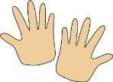

How many fingers on two hands?
How many legs on two ducks?
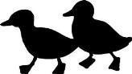

Children are encouraged to read number sentences aloud in different ways “five times two makes ten” “ten is equal to five times two”

Vocabulary

Lots of, groups of, times, multiply, multiplied by, multiple of, once, twice, three times…. Ten times, repeated addition, double

Vocabulary
Ones, groups, lots of, doubling repeated addition

groups of, lots of, times, columns, rows longer, bigger, higher etc times as (big, long, wide …etc)

Place Value counters can be used to support the teaching of commutativity
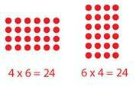
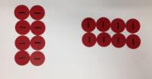

Teach the more formal ‘grid method’ where numbers are partitioned, multiplied together then totaled to find the answer to more complex calculations
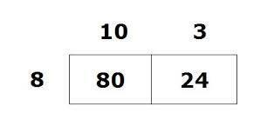

Vocabulary
multiple, multiplication array, multiplication tables / facts
groups of, lots of, times, columns, rows

11

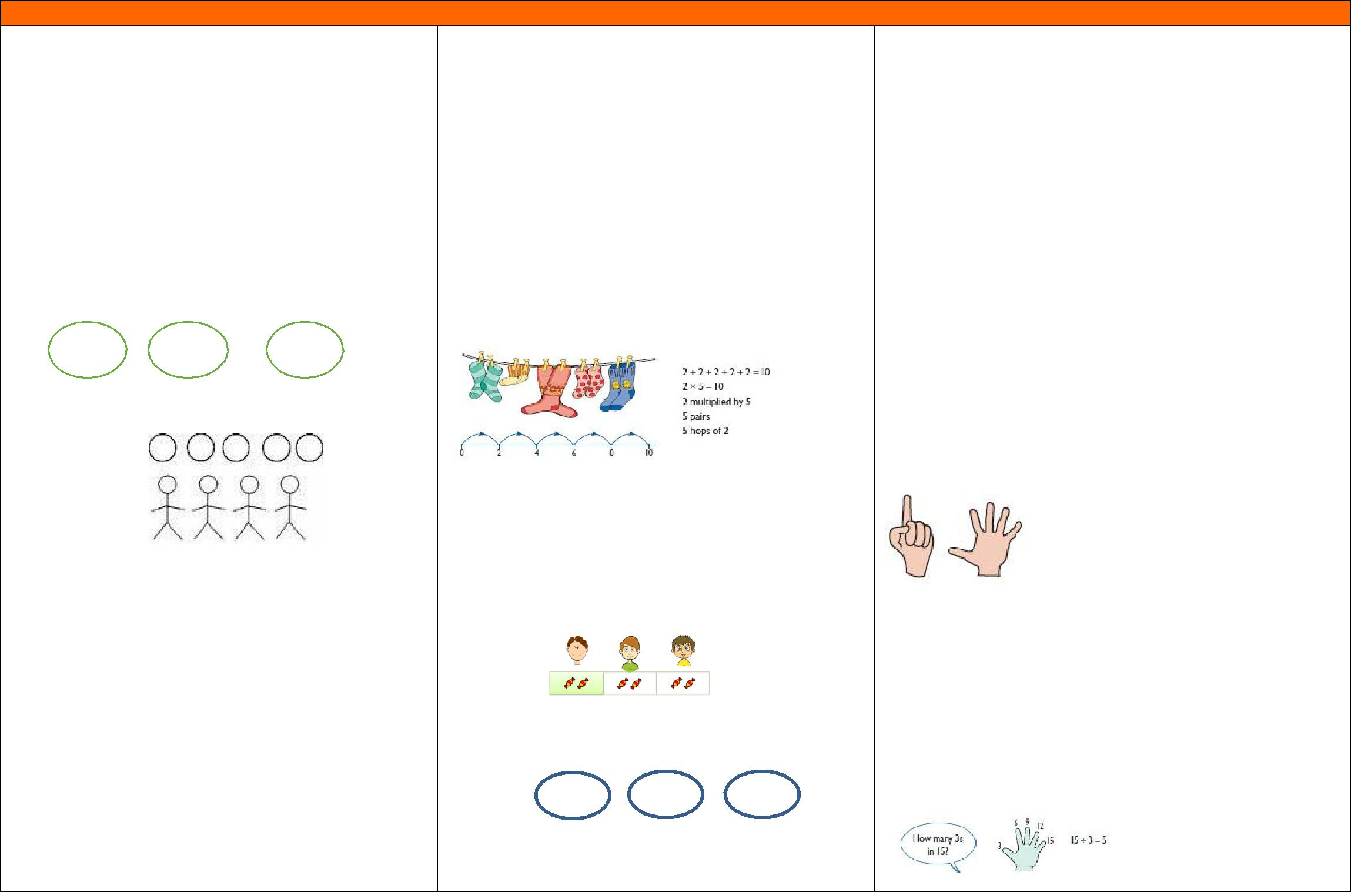
Division
 |  |  | EYFS |  |  |  | Year 1 |  |  |  |  |  | Year 2
 |  | The Early Learning Goal states that children |  |  |  |  | Statutory Requirements |  |  |  |  | Statutory Requirements
 |  | solve problems, including doubling, halving and
 |  |  |  |  |  |  | Solve one-step problems involving division, by |  |  |  | • Recall and use division facts for the 2, 5 and 10
 |  | sharing |  |  |  |  | calculating the answer using concrete objects, |  |  |  |  | multiplication tables, including recognising odd and
 |  | Children need to see and hear representations of |  |  |  |  | pictorial representations and arrays with the |  |  |  |  | even numbers
 |  | division as both grouping and sharing
 |  |  |  |  |  |  | support of the teacher. |  |  |  | • Calculate mathematical statements for division
 |  | Division can be taught through halving
 |  |  |  |  |  |  |  |  |  |  |  | within the multiplication tables and write them using
 |  | Children begin by mostly pictorial
 |  |  |  |  |  |  | They should begin to recognise the number of |  |  |  |  | the division (÷) and equals (=) signs
 |  | representations linked to real life contexts:
 |  |  |  |  |  |  | groups counted to support understanding of |  |  |  | • Show that multiplication of two numbers can be done
 |  | Grouping model – mum has 6 socks, she grouped |  |  |  |  | relationship between multiplication and division. |  |  |  |  | in any order (commutative) and division of one
 |  |  |  |  |  |  |  |  |  |  |  | number by another cannot
 |  | them into pairs – how many pairs did she make? |  |  |  |  | The use of a number line ALONGSIDE other
 |  |  |  |  |  |  |  |  |  |  | • Solve problems involving division, using materials,
 |  | L L | L L | L L |  |  | representations/ images is vital. |  |  |  |  | arrays, repeated addition, mental methods, and
 |  |  |  |  |  |  |  |  |  |  |  | multiplication and division facts, including problems
 |  | Sharing model – I have 5 sweets. I want to share |  |  |  |  |  |  |  |  |  | in contexts.
 |  | them with my 4 friends. How many will we have |  |  |  |  |  |  |  |  |  | Show the children how to hold out their fingers and
 |  |  |  |  |  |  | Children should continue to build upon their |  |  |  |  | count, touching each finger in turn. So for 2 × 6 (six
 |  |  |  |  |  |  |  |  |  |  |  | twos), hold up 6 fingers:
 |  |  |  |  |  |  | understanding of division as both sharing and
 |  | each? |  |  |  |  | grouping. |  |  |  |  |  | Touching the fingers in turn is a means of
 |  |  |  |  |  |  |  |  |  |  |  |  | keeping track of how far the children have gone
 |  | Children have a go at recording the calculation |  |  |  |  | Sharing – 6 sweets are shared between 2 people. |  |  |  |  |  | in creating a sequence of numbers. The physical
 |  |  |  |  |  |  |  |  |  |  |  |  | action can later be visualised without any actual
 |  | that has been carried out |  |  |  |  | How many do they have each? |  |  |  |  |  | movement.
 |  | Vocabulary
 |  |  |  |  |  |  |  |  |  |  |  | This can then be used to support finding out ‘How
 |  | Halve, share, share equally, one each, two each,
 |  |  |  |  |  |  |  |  |  |  |  | many 3’s are in 18?’ and children count along fingers in
 |  | three each, group in pairs, threes…, tens, equal
 |  |  |  |  |  |  |  |  |  |  |  | 3’s therefore making link between multiplication and
 |  | groups of, divide, divided by, divided into, left, |  |  |  |  |  
 |  |  |  |  |  |  |  |  |  |  |  | division.
 |  | left over |  |  |  | Grouping-
 |  |  |  |  |  |  | How many 2’s are in 6? |  |  |  |  | Children should continue to develop understanding of
 |  |  |  |  | .. |  |  | .. | ..
 |  |  |  |  |  |  |  |  |  |  |  | division as sharing and grouping.

They use objects to group and share amounts to
develop understanding of division in a practical
sense. E.g. using Numicon to find out how many 5’s

12

are in 30?

Vocabulary
share, share equally, one each, two each…, group,

groups of, lots of, array

15 pencils shared between 3 pots, how many in each pot?

Vocabulary

group in pairs, 3s … 10s, equal groups of, divide, ÷, divided by, divided into, remainder

13

Lower Key Stage 2

 |  | Addition
 |  | Year 3 |  |  |  |  |  |  | Year 4
 | Statutory Requirements |  |  | Statutory Requirements
 | Add numbers mentally, including: a three-digit number and ones , a |  |  |  |  | Add numbers with up to 4 digits using the formal written methods of
 | three-digit number and tens, a three-digit number and hundreds |  |  |  |  | columnar addition where appropriate
 | Add numbers with up to three digits, using formal written methods of |  |  |  |  | Estimate and use inverse operations to check answers to a calculation
 | columnar addition
 |  |  |  |  |  | Solve addition two-step problems in contexts, deciding which operations
 | Estimate the answer to a calculation and use inverse operations to check
 |  |  |  |  |  | and methods to use and why
 | answers |  |  |  |  | Add fractions with the same denominator
 | Solve problems, including missing number problems, using number facts,
 | place value, and more complex addition. |  |  | Concrete and Pictorial methods continue to be taught to show children how
 | Add fractions with the same denominator within one whole
 |  |  |  | subtraction and addition are related operations.
 | [for example, 5/7 + 1/7 = 6/7]
 |  |  | 6 + 4 = 10
 |  
 |  |  | 4 + 6 = 10
 | Concrete and Pictorial methods continue to be taught to show children how |  |  | 10 – 4 = 6
 | subtraction and addition are related operations.
6 + 4 = 10
4 + 6 = 10 |  |  |  | Children move from the expanded column addition method to the compact
 | 10 – 4 = 6
 |  |  |  | method, adding ones first, and ‘carrying’ numbers underneath the calculation.
 |  |  |  |  
 | Pupils will be introduced to formal written methods of columnar addition. This |  |  | Children add the two given numbers together. The teacher models the compact
 |  |  |  | method with carrying, asking children to discuss similarities and differences to
 | starts with an expanded column method first;
 |  |  |  | the expanded column method and how it is carried out.
 |  | Children add the ones first, in | 376
 |  | preparation for the compact method. |  |  | +289
 |  |  | 15 (9+6)
 |  | Children need to recognise the value of the | 150 (70+80)
 |  |  | 500 (300+200)
 |  | hundreds, tens and ones without recording the
 |  |  | 665
 |  | partitioning. They need to be able to add in columns.
 | Children need to be secure and confident adding three-digit numbers using the |  |  | Reinforce correct place value by reminding them the actual value is 5 hundreds
 |  |  |  | and 3 hundreds, not 5 add 3 for example. ‘Carry’ numbers underneath the
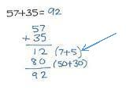
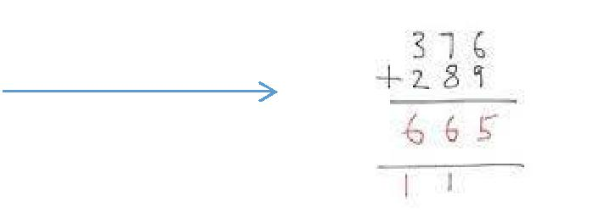
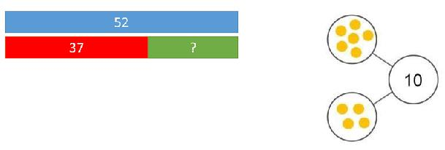

14

method above before they are taught the compact method. Children then progress onto the compact column method. They are introduced to carrying for the first time.
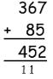
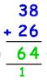

Children use place value counters to make the link between practical and these more formal methods. Two digit first, then three digit
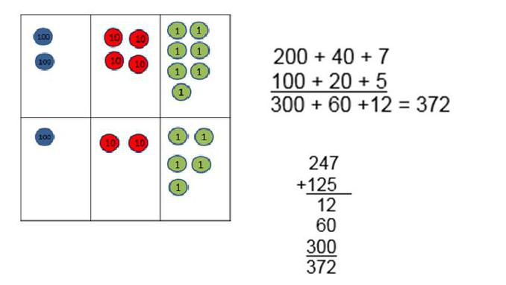

Vocabulary

Add, more, plus, make, altogether, total, equal to, equals, double, most, count on, number line, sum, tens, ones, partition, addition, column, boundary, hundreds, increase, vertical, carry, expanded, compact

bottom line.

 

Use and apply this method to money and measurement values too. Include decimals with up to one decimal place.
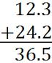

The decimal point should be aligned in the same way as the other place value columns, and must be in the same column as the answer.
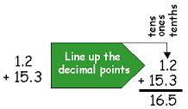

Concrete and Pictorial methods continue to be taught to show children how subtraction and addition are related operations.
6 + 4 = 10
4 + 6 = 10
10 – 4 = 6

Vocabulary

Add, more, plus, and, make, altogether, total, equal to, equals, double, most, count on, number line, sum, tens, ones, partition, addition, column, boundary, hundreds, increase, vertical, carry, expanded, compact, thousands, digits, inverse

15

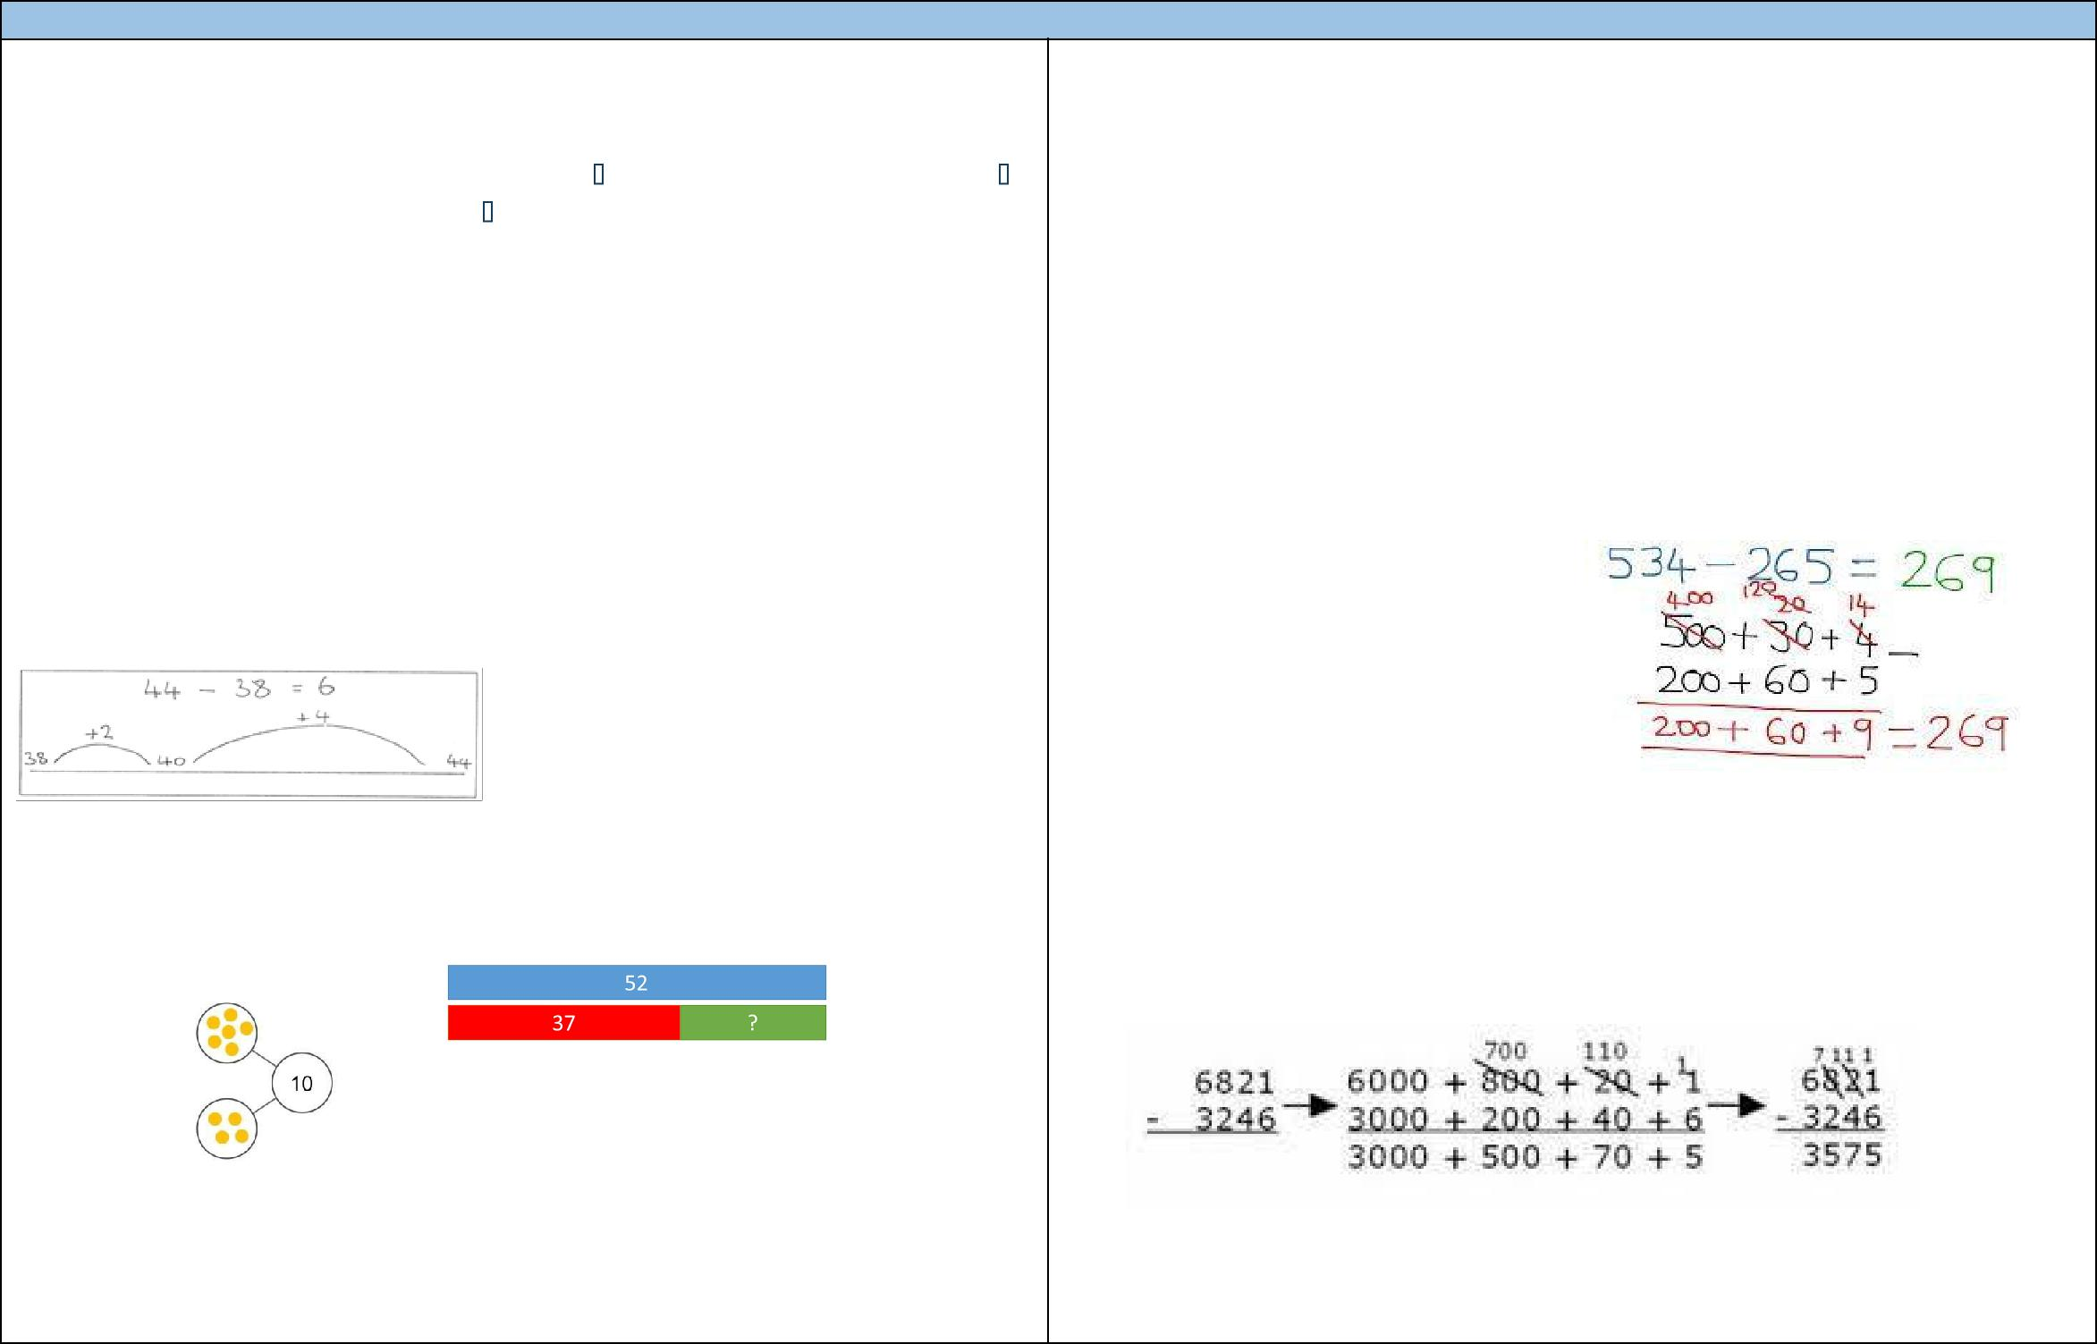
Subtraction
 |  |  | Year 3 |  | Year 4
 |  | Statutory Requirements |  | Statutory Requirements
 |  | Pupils should be taught to: |  | Children are taught to:
 |  | • Subtract numbers mentally, including: a three-digit number and ones, a |  | • Subtract numbers with up to 4 digits using the formal written
 |  | three-digit number and tens, a three-digit number and hundreds |  | methods of columnar subtraction where appropriate
 |  | • Subtract numbers with up to three digits, using formal written methods |  | • Estimate and use inverse operations to check answers to a
 |  | of columnar subtraction |  | calculation
 |  | • Estimate the answer to a calculation and use inverse operations to check |  | • Solve subtraction two-step problems in contexts, deciding which
 |  | answers |  | operations and methods to use and why
 |  | • Solve problems, including missing number problems, using number facts, |  | • Subtract fractions with the same denominator
 |  | place value, and more complex subtraction. |  | As introduced in year 3, partitioned column subtraction is consolidated but moves
 |  | • Subtract fractions with the same denominator within one whole [for
 |  | example [4/7 = 5/7 – 1/7] |  | towards more complex numbers and values. Place value resources are still used
 |  |  |  | to reinforce ‘exchanging’
 |  | Children consolidate strategies learnt in Year 2 whereby a number line is used
 |  | to count up from the smaller number to the larger to find the difference.

Concrete and Pictorial methods continue to be taught to show children how | To introduce the compact column subtraction method, ask children to perform a
subtraction and addition are related operations. | subtraction calculation with the familiar partitioned column subtraction then
6 + 4 = 10 | display the compact version for the calculation they have done. Ask pupils to
4 + 6 = 10
 | consider how it relates to the method they know, what is similar and what is
10 – 4 = 6
 | different, to develop an understanding of it.
 |  
 |  
 |  
Children are introduced to the partitioned column subtraction method. |  
 |  
 |  
 | Opportunities to apply this learning to money and measures will be provided.

16

Initially children are

introduced to this method

with no exchanging.

‘Exchanging’ is introduced through practical subtraction. Make the larger number with base 10, then subtract 47 from
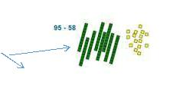

Before subtracting ‘8’ from the 95 blocks, they will need to exchange a row of 10 for ten ones. Then subtract 8, and subtract 5 tens

80 90 + 15
- 50 + 8
30 + 7

Once the children are secure with this method, they can use the partitioned expanded column method to subtract any two and three-digit numbers.
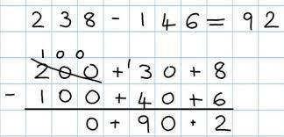

Monetary values and decimals can also be subtracted using this method

£2.38 - £1.46 = 92p

£2.00 + 30p + 8p

£1.00 + 40p + 6p

**Ensure children understand how a smaller number can be subtracted from a larger number to avoid misconceptions being formed**
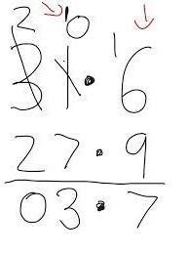

Vocabulary

Equal to, take, take away, less, minus, subtract, leaves, distance, between, how many more, fewer / less than, most, least, count back, how many left, how much

less is ? Difference, count on, strategy, partition, tens, ones, exchange decrease, hundreds, value, digit, inverse

17

Numicon can be used
to provide practical

support when

subtracting.

Children use place value counters to make the link between practical and more formal methods.
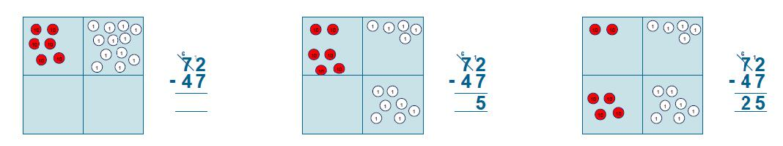

1

⁶ 1

Listening to you, working for you

to you, working for you | Listening to you, working for you |  | www.bexley.gov.uk
 | www.bexley.gov.uk

**Ensure children understand how a smaller number can be subtracted from a larger number to avoid misconceptions being formed**

Vocabulary

Equal to, take, take away, less, minus, subtract, leaves, distance between, how many more, how many fewer / less than, most, least, count back, how many left, how much less is _? Difference, count on, strategy, partition, tens, ones, exchange, decrease, hundreds, value, digit

1 1

6 | 1 | 6 | 1

18

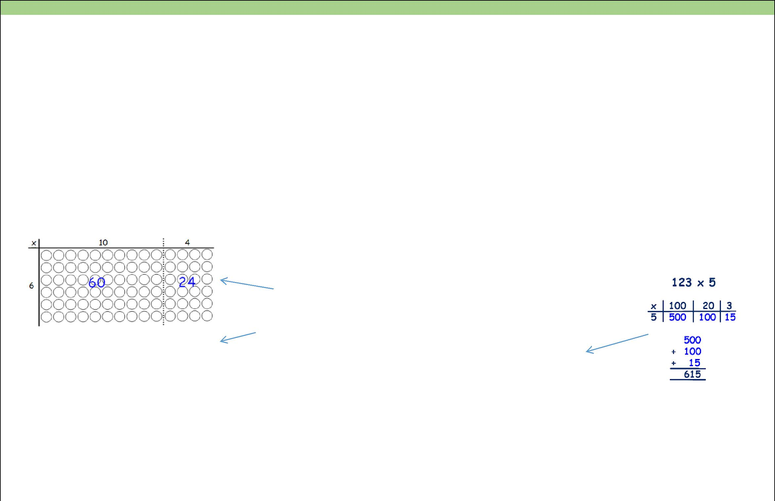
Multiplication
 |  |  |  |  |  |  | Year 3 |  |  |  |  |  |  | Year 4
 |  | Statutory Requirements |  |  |  |  |  |  |  |  |  | Statutory Requirements
 |  |  |  |  |  |  |  |  |  |  |  | • Recall multiplication and division facts for multiplication tables up to
 |  | • Recall and use multiplication facts for the 3, 4 and 8 multiplication tables |  |  |  |  |  |  |  |  | 12×12
 |  | • Write and calculate mathematical statements for multiplication using the |  |  |  |  |  |  |  |  |  | • Use place value, known and derived facts to multiply mentally, including:
 |  | multiplication tables that they know, including for two-digit numbers |  |  |  |  |  |  |  |  |  | multiplying by 0 and 1 and multiplying together three numbers
 |  | times one-digit numbers, using mental and progressing to formal written |  |  |  |  |  |  |  |  |  | • Recognise and use factor pairs and commutativity in mental calculations
 |  | methods |  |  |  |  |  |  |  |  |  | • Multiply two-digit and three-digit numbers by a one-digit number using
 |  | • Solve problems, including missing number problems, involving |  |  |  |  |  |  |  |  |  | formal written layout
 |  |  |  |  |  |  |  |  |  |  |  | • Solve problems involving multiplying and adding, including using the
 |  | multiplication and division, including positive integer scaling problems and
 |  |  |  |  |  |  |  |  |  |  |  | distributive law to multiply two digit numbers by one digit, integer scaling
 |  | correspondence problems in which n objects are connected to m objects.
 |  |  |  |  |  |  |  |  |  |  |  | problems and harder correspondence problems such as n objects are
 |  | Children are introduced to the grid method for multiplying two-digit by one-
 |  |  |  |  |  |  |  |  |  |  |  | connected to m objects.
 |  | digits. Children physically make an array to represent the calculation first
 |  | before translating to the grid method format. (e.g. make 8 lots of 23 with 10s |  |  |  |  |  |  |  |  |  | Vocabulary
 |  | and 1s place value resources), then translate this to grid method format.
 |  |  |  |  |  |  |  |  |  |  |  | Groups of, lots of, times, array, altogether, multiply, count, multiplied by,
 |  |  |  |  |  |  |  |  |  |  |  | repeated addition, column, row, commutative, sets of, equal groups, as big as,
 |  |  |  |  |  |  |  | 14 x 6 = 84 |  |  |  | once, twice, three times… partition, grid method, multiple, product, tens, ones,
 |  |  |  |  |  |  |  |  |  |  |  | value, inverse
 |  |  |  |  |  |  |  | array |  |  |  | Children continue to develop the grid method:
 |  |  |  |  |  |  |  | grid method |  |  |  | Encourage column addition to
 |  |  |  |  |  |  |  |  |  |  |  | add accurately.
 |  |  |  | X |  | 10 | 4
 |  |  |  | 6 |  | 120 | 24
 |  | Children must be able to partition into tens and ones confidently as well as
 |  | multiply multiples of ten by one-digit (e.g. 20x4) using their knowledge of |  |  |  |  |  |  |  |  |  | Pupils will move onto the short multiplication method if and when children are
 |  | multiplication facts and place value
 |  |  |  |  |  |  |  |  |  |  |  | confident and accurate multiplying two and three-digit numbers by a one-digit
 |  | Vocabulary |  |  |  |  |  |  |  |  |  | this way, and are already confident in ‘carrying’ for written addition.
 |  | Groups of, lots of, times, array, altogether, multiply, count, multiplied by, |  |  |  |  |  |  |  |  |  | Pupils need to begin to approximate before they calculate, and make this a
 |  | repeated addition, column, row, commutative, sets of, equal groups, as big as, |  |  |  |  |  |  |  |  |  | regular part of their calculating by going back to the approximation to check the
 |  | once, twice, three times… partition, grid method, multiple, product, tens, ones, |  |  |  |  |  |  |  |  |  | reasonableness of their answer. E.g. 346 x 9 is approximately 350 x 10 = 3500.
 |  | value
 |  |  |  |  |  |  |  |  |  |  | 19

 |  |  | Division
 |  |  | Year 3 |  | Year 4
 |  | Statutory Requirements |  | Statutory Requirements
 |  | • Recall and use division facts for the 3, 4 and 8 multiplication tables |  | • Recall division facts for multiplication tables up to 12 × 12
 |  | • Write and calculate mathematical statements for division using the |  | • Use place value, known and derived facts to divide mentally, including:
 |  | multiplication tables that they know, including for two-digit numbers |  | dividing by 1
 |  | times one-digit numbers, using mental and progressing to formal written |  | • Recognise and use factor pairs and commutativity in mental calculations
 |  | methods |  | • Solve problems involving increasingly harder fractions to calculate
 |  | • Solve problems, including missing number problems, involving |  | quantities, and fractions to divide quantities, including non-unit fractions
 |  | multiplication and division, including positive integer scaling problems and |  | where the answer is a whole number
 |  | correspondence problems in which n objects are connected to m objects.
 |  | Children continue to work out unknown division facts by grouping on a number line |  | Pupils will continue to develop their skills in short division. They will learn to
 |  | from zero. They are also now taught the concept of remainders, as in the |  | calculate remainders and use this short method to ‘carry’ remainders within the
 |  | example. This is introduced practically with arrays, as well as being translated |  | calculation process.
 |  | to a number line. |  | Pupils will then be taught to divide numbers with up to three-digits by a single
 |  |  |  | digit, problems and calculations provided should not result in a final answer with
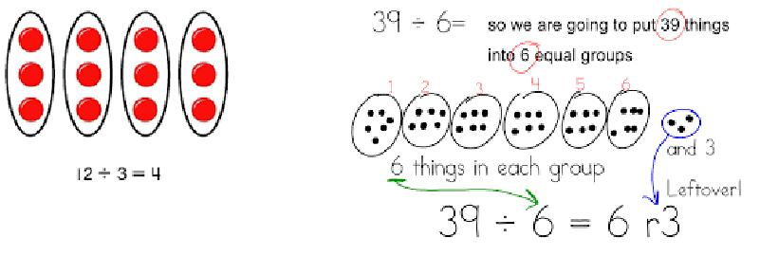
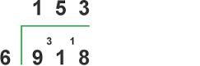

Children are introduced to the short division method, only when they are secure |  |  |  |  | remainders at this stage.
 |  |  |  |  | Vocabulary
with division as grouping and can demonstrate this using arrays and number lines.
 |  |  |  |  | Share, share equally, one each, two each…, group, equal groups of, lots of, array,
Initially, short division examples will include no carrying or remainders in the
 |  |  |  |  | divide, divided by, divided into, division, grouping, number line, left, left over,
final answer.
 |  |  |  |  | short division, inverse, carry, remainder, multiple
The method is shown alongside the array in order for pupils to compare.
Children need reminding of correct place value – that 48 is equal to 40 and 8.
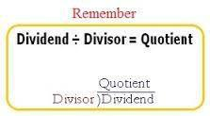

20

Once pupils can demonstrate a full understanding of the short division method
taught, they can now be taught how to use the method when remainders occur
within the calculation. (E.g. 72÷4) They are taught to ‘carry’ the remainder. If
needed, pupils use the number line to work out individual division facts that
occur when they are not yet able to recall mentally.

Pupils divide with a two-digit number by a single-digit number only at this stage.

Vocabulary

Share, share equally, one each, two each…, group, equal groups of, lots of, array,

divide, divided by, divided into, division, grouping, number line, left, left over,
short division, inverse, carry, remainder, multiple

21

Upper Key Stage 2

 |  |  |  |  |  |  |  |  |  | Addition
 |  |  |  | Year 5 |  |  |  |  |  |  |  |  |  |  |  |  | Year 6
 | Statutory Requirements |  |  |  |  |  |  |  |  |  |  | Statutory Requirements
 | • Add and whole numbers with more than 4 digits, including using formal |  |  |  |  |  |  |  |  |  |  | • Perform mental calculations, including with mixed operations and large
 | written methods (columnar addition) |  |  |  |  |  |  |  |  |  |  | numbers
 | • Add numbers mentally with increasingly large |  |  |  |  |  |  |  |  |  |  | • Use their knowledge of the order of operations to carry out calculations
 | numbers |  |  |  |  |  |  |  |  |  |  | involving addition
 | • Use rounding to check answers to calculations and determine, in the |  |  |  |  |  |  |  |  |  |  | • Solve addition multi-step problems in contexts, deciding which operations
 | context of a problem, levels of accuracy |  |  |  |  |  |  |  |  |  |  | to use and why
 | • Solve addition multi-step problems in contexts, deciding which operations |  |  |  |  |  |  |  |  |  |  | • Use estimation to check answers to calculations and determine, in the
 | and methods to use and why |  |  |  |  |  |  |  |  |  |  | context of a problem, levels of accuracy
 | The decimal point should be aligned in the same way as the other place value |  |  |  |  |  |  |  |  |  |  | Adding several |  |  | 23.361 |  |  |  |  | Empty decimal
 | columns, and must be in the same column as the answer. |  |  |  |  |  |  |  |  | Empty decimal |  | numbers with different |  |  | 9.08 |  |  |  |  | places can be filled
 |  |  |  |  |  |  |  |  |  |  |  | numbers of decimal |  |  | 59.77 |  |  |  |  | with zero to show
 |  |  |  | £19.01 |  |  |  |  |  | places can be filled |  | places (including |  |  | + 1.30 |  |  |  |  | there is no value
 |  | Say ‘3 tenths |  |  |  |  |  |  |  | with zero to show |  |  |  |  |  | 93.511
 |  |  |  | £ 3.65 |  |  |  |  |  |  |  | money and measures) |  |  |  |  |  |  |  | to add
 |  |  |  |  |  |  |  |  |  |  |  |  |  |  | 2 1 |  | 2
 |  | add 7 tenths’ to |  |  |  |  |  |  |  | the place value in
 |  |  |  | + £ |  | 0.7 | 0 |  |  |  |  | Tenths, hundredths and |  |  |  |  |  |  |  | thousandths should be correctly
 |  | reinforce place |  | £23.36 |  |  |  |  |  | each column.
 |  | value. |  |  | 1 1 |  |  |  |  |  |  | aligned, with the decimal point lined up vertically including in the answer row.
 | Vocabulary |  |  |  |  |  |  |  |  |  |  |  |  |  |  |  |  |  |  | Adding several
 | Add, more, plus, and, make, altogether, total, equal to, equals, double, most,
 |  |  |  |  |  |  |  |  |  |  |  |  |  |  |  |  |  |  |  | numbers with
 | count on, number line, sum, tens, ones, partition, addition, column, boundary,
 |  |  |  |  |  |  |  |  |  |  |  |  |  |  |  |  |  |  |  | more than four
 | hundreds, increase, vertical, carry, expanded, compact, thousands, digits,
 |  |  |  |  |  |  |  |  |  |  |  | Vocabulary |  |  |  |  |  |  |  | digits
 | inverse, decimal place, decimal point, tenths, hundredths, thousandths
 |  |  |  |  |  |  |  |  |  |  |  | Add, more, plus, and, make, altogether, total, equal to, equals, double, most,
 |  |  |  |  |  |  |  |  |  |  |  | count on, number line, sum, tens, ones, partition, addition, column, boundary,
 |  |  |  |  |  |  |  |  |  |  |  | hundreds, increase, vertical, carry, expanded, compact, thousands, digits,
 |  |  |  |  |  |  |  |  |  |  |  | inverse, decimal place, decimal point, tenths, hundredths, thousandths
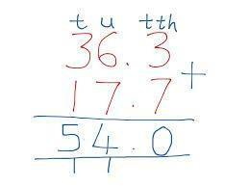
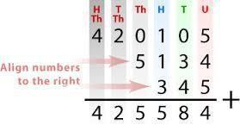

22

 |  |  |  | Subtraction
 |  |  | Year 5 |  |  | Year 6
 |  | Statutory Requirements |  |  | Statutory Requirements
 |  | • Subtract and whole numbers with more than 4 digits, including using |  |  | • Perform mental calculations, including with mixed operations and large
 |  | formal written methods (columnar subtraction) |  |  | numbers
 |  | • Subtract numbers mentally with increasingly large numbers |  |  | • Use their knowledge of the order of operations to carry out calculations
 |  | • Use rounding to check answers to calculations and determine, in the |  |  | involving subtraction
 |  | context of a problem, levels of accuracy |  |  | • Solve subtraction multi-step problems in contexts, deciding which
 |  | • Solve subtraction multi-step problems in contexts, deciding which |  |  | operations to use and why
 |  | operations and methods to use and why |  |  | • Use estimation to check answers to calculations and determine, in the
 |  |  |  |  | context of a problem, levels of accuracy
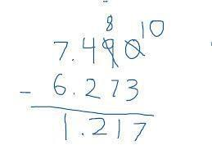
Children will us the compact column subtraction method with ‘exchanging’ including problems involving money, measures and decimals with up to two decimal places.
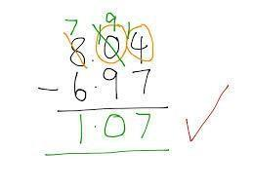
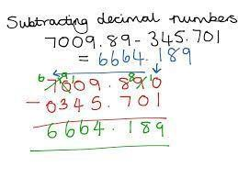

 |  |  |  | Vocabulary
Children will subtract with decimal values, including mixtures of integers and |  |  |  | Equal to, take, take away, less, minus, subtract, leaves, distance between, how
 |  |  |  | many more, how many fewer / less than, most, least, count back, how many left,
decimals up to two decimal places, aligning the decimal point.
 |  |  |  | how much less is ? Difference, count on, strategy, partition, tens, ones,
Children who are still not secure with number facts and place value will need to
 |  |  |  | exchange, decrease, hundreds, value, digit, inverse, decimal place, decimal point,
remain on the partitioned column method (or earlier methods) until ready for the
 |  |  |  | tenths, hundredths
compact method. **Ensure children understand a smaller number can be subtracted from a
larger number to avoid misconceptions being formed**
Vocabulary
Equal to, take, take away, less, minus, subtract, leaves, distance between, how
many more, how many fewer / less than, most, least, count back, how many left,
how much less is ? Difference, count on, strategy, partition, tens, ones,
exchange, decrease, hundreds, value, digit, inverse, decimal place, decimal point,
tenths, hundredths

23

Multiplication
 |  |  |  |  | Year 5 |  |  |  |  |  |  |  |  |  | Year 6
 |  | Statutory Requirements |  |  |  |  | Statutory Requirements
 |  | • Identify multiples and factors, including finding all factor pairs of a |  |  |  |  | • Multiply multi-digit numbers up to 4 digits by a two-digit whole number
 |  |  | number, and common factors of two numbers |  |  |  |  | using the formal written method of long multiplication
 |  | • Multiply numbers up to 4 digits by a one- or two-digit number using a |  |  |  |  | • Perform mental calculations, including with mixed operations and large
 |  |  | formal written method, including long multiplication for two-digit |  |  |  |  | numbers
 |  |  | numbers |  |  |  | • Identify common factors, common multiples and prime numbers
 |  | • Multiply numbers mentally drawing upon known facts |  |  |  |  | • Use their knowledge of the order of operations to carry out calculations
 |  | • Multiply whole numbers and those involving decimals by 10, 100 and |  |  |  |  |  | involving multiplication
 |  |  | 1000 |  |  |  | • Multiply simple pairs of proper fractions, writing the answer in its
 |  | • Recognise and use square numbers and cube numbers, and the notation |  |  |  |  |  | simplest form (e.g. ¼ X ½ = ⅛)
 |  |  | 2 |  | 3 |  | • Multiply one-digit numbers with up to two decimal places by whole
 |  |  | for squared ( ) and cubed ( ) |  |  |  |  | numbers
 |  | • | Solve problems involving multiplication including using their knowledge of
 |  |  |  |  |  |  | • Identify the value of each digit to three decimal places and multiply
 |  |  | factors and multiples, squares and cubes
 |  |  |  |  |  |  |  | numbers by 10, 100 and 1000 where the answers are up to three decimal
 |  | • Solve problems involving multiplication where large numbers are used by
 |  |  |  |  |  |  |  | places
 |  |  | decomposing them into their factors
 |  | • | Solve problems involving multiplication, including scaling by simple |  |  |  | Vocabulary
 |  |  | fractions and problems involving simple rates.
 |  |  |  |  |  |  | Groups of, lots of, times, array, altogether, multiply, count, multiplied by,
 |  | • Multiply proper fractions and mixed numbers by whole numbers
 |  |  |  |  |  |  | repeated addition, column, row, commutative, sets of, equal groups, as big as,
 |  |  | supported by materials and diagrams
 |  |  |  |  |  |  | once, twice, three times… partition, grid method, multiple, product, tens, ones,
 |  | Vocabulary |  |  |  |  | value, inverse, square, factor, integer, decimal, short/ long multiplication, carry,
 |  |  |  |  |  |  | tenths, hundredths, decimal place, decimal point
 |  | Groups of, lots of, times, array, altogether, multiply, count, multiplied by,
 |  | repeated addition, column, row, commutative, sets of, equal groups, as big as,
 |  | once, twice, three times… partition, grid method, multiple, product, tens, ones, |  |  |  |  | Long multiplication method is used to multiply numbers with at least four-digits
 |  | value, inverse, square, factor, integer, decimal, short/ long multiplication, carry, |  |  |  |  | by a two-digit number
 |  | tenths, hundredths, decimal place, decimal point |  |  |  |  | Long multiplication method is used to multiply numbers with at least four-digits
 |  | As the children learn to multiply using a column method, pupils are introduced to |  |  |  |  | by a two-digit number. It can be introduced alongside the grid method as
 |  | the short multiplication method by comparing it to a grid method example to see |  |  |  |  | before.
 |  | how the steps are related. There are less steps involved in the column method.
 |  |  |  |  |  |  |  | X |  | 2000 | 400 |  |  | 50 | 1
 |  |  |  |  |  |  |  | 60 |  | 120000 | 24000 |  |  | 3000 | 60 | 147,060
 |  | Short multiplication for multiplying by a single digit. |  |  |  |  |  | 3 |  | 6000 | 1200 |  |  | 150 | 3 | 7353

24

327
x 4
1308
 | 1 2
X |  | 300 |  | 20 | 7
4 |  | 1200 |  | 80 | 28

Children could be asked to

work out a given

calculation using the grid

and then compare it to the

column method.

2451 X 3 on the first row, numbers are carried

2451 X 60 on the next row.

Long multiplication method is used to multiply numbers with at least four-digits
by a two-digit number. It can be introduced alongside the grid method as

before.
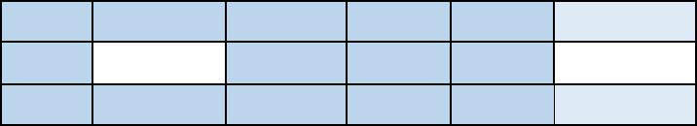

X | 2000 | 400 | 50 | 1
60 | 120000 | 24000 | 3000 | 60 | 147,060
3 | 6000 | 1200 | 150 | 3 | 7353
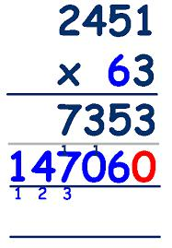

2451 X 3 on the first row, numbers are carried

2451 X 60 on the next row.

25

Division
 |  |  |  |  | Year 5 |  |  |  |  | Year 6
 |  | Statutory Requirements |  |  |  |  |  |  | Statutory Requirements
 |  | • Divide numbers mentally drawing upon known facts |  |  |  |  |  |  | • Use their knowledge of the order of operations to carry out calculations
 |  | • Divide numbers up to 4 digits by a one-digit number using the formal |  |  |  |  |  |  | involving division
 |  | written method of short division and interpret remainders appropriately |  |  |  |  |  |  | • Divide numbers up to four-digits by a two-digit whole number using the
 |  | for the context |  |  |  |  |  |  | formal written method of long division and interpret remainders as whole
 |  | • Divide whole numbers and those involving decimals by 10, 100 and 1000 |  |  |  |  |  |  | number remainders, fractions, or by rounding, as appropriate for the
 |  | • Solve problems involving division where large numbers are used by |  |  |  |  |  |  | context
 |  | decomposing them into their factors |  |  |  |  |  |  | • Divide numbers up to four digits by a two-digit number using the formal
 |  | • Know and use the vocabulary of prime numbers, prime factors and |  |  |  |  |  |  | written method of short division where appropriate, interpreting
 |  | composite (non- prime) numbers |  |  |  |  |  |  | remainders according to the context
 |  | • Establish whether a number up to 100 is prime and recall prime numbers |  |  |  |  |  |  | • Use estimation to check answers to calculations and determine, in the
 |  | up to 19 |  |  |  |  |  |  | context of a problem, levels of accuracy
 |  | • Solve problems involving addition, subtraction, multiplication and division |  |  |  |  |  |  | • Divide proper fractions by whole numbers (e.g. ⅓ ÷ 2 = ⅙)
 |  | and a combination of these, including understanding the meaning of the
 |  |  |  |  |  |  |  |  | • Identify the value of each digit to three decimal places and divide numbers
 |  | equals sign
 |  |  |  |  |  |  |  |  | by 10, 100 and 1000 where the answers are up to three decimal
 |  | • Solve problems involving division, including scaling by simple fractions and
 |  |  |  |  |  |  |  |  | places
 |  | problems involving simple rates
 |  |  |  |  |  |  |  |  | • Use written division methods in cases where the answer has up to two
 |  | Pupils continue to develop short division, including remainder answers. |  |  |  |  |  |  | decimal places
 |  |  |  |  |  |  |  |  | • Associate a fraction with division and calculate decimal fraction
 |  |  |  |  |  |  |  |  | equivalents (e.g. 0.375) for a simple fraction (e.g. ⅜)
 |  |  |  |  | The answer to 964 ÷ 7 could be
 |  |  |  |  | expressed as 137 and 5 sevenths, which |  |  |  | Pupils continue to develop short division, including answers as a decimal. They
 |  |  |  |  | could then be changed into a decimal
 |  |  |  |  |  |  |  |  | continue to use this method, but with numbers to at least four-digits and
 |  |  |  |  | (137.071) or rounded as appropriate.
 |  |  |  |  |  |  |  |  | understand how to express remainders as fractions, decimals, whole number
 |  |  |  |  |  |  |  |  | remainders or rounded numbers. Real life problem solving contexts need to be
 |  | Division needs to have a real |  |  |  |  | life
 |  |  |  |  |  |  |  |  | the starting point, where pupils have to consider the most appropriate way to
 |  | problem solving context, where pupils consider the meaning of the remainder and
 |  |  |  |  |  |  |  |  | express the remainder.
 |  | how to express it, i.e. as a fraction, a decimal, or as a rounded number or value,
 |  | depending upon the context of the problem.
 |  | Vocabulary
 |  | Share, share equally, one each, two each…, group, equal groups of, lots of, array,
 |  | divide, divided by, divided into, division, grouping, number line, left, left over,
 |  |  |  |  |  |  |  | 26

short division, inverse, carry, remainder, multiple, prime number, prime factors, composite number

Once pupils are confident and accurate in short division with remainders, pupils can then be introduced to short division with a decimal remainder and long division.

For two-digit divisors, the long division by chunking method is introduced. In the example below, finding out how many 36s are in 9722 the pupils are taught to subtract chunks of 36 until zero is reached (or until there is a remainder).
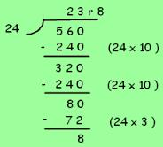

Pupils are taught to write a ‘useful list’ first of all at the side that will help them decide what ‘chunks’ to use, e.g. 24x10, 24x3. As pupils become more confident with the process, encourage more efficient chunks to get to the answer more quickly and expand their useful list.

Once pupils are confident and accurate move onto long division without chunking.
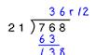

Vocabulary

Share, share equally, one each, two each…, group, equal groups of, lots of, array, divide, divided by, divided into, division, grouping, number line, left, left over, short division, inverse, carry, remainder, multiple, prime number, prime factors, composite number, common factor, long division, chunkin

