Risk assessment

School Name: | All Saints National Academy
URN Number: | 141410

Expectations as at the 1 June 2020

Year Group | Will you be providing provision from the 1 June 2020 (Y or N) | Predicted number of pupils/
Reception | N (8TH) | 12
Year 1 | N (4TH) | 12
Year 6 | N (4TH) | 14
What are your 3 most significant risks identified in your risk assessment? | Availability of space for the intended numbers  Vulnerability of key children with additional needs  Parents congregating at the gates and drop off and pick up times
Are there any additional issues you wish to flag with the LA in terms of your ability to re-open? | No
If you are not looking to extend provision from the 1 June what date have you discussed with your Governing Board as a possible date of extended opening? | Due to the requirement to share prepare staff on the policies and procedures relating to the re-opening of the academy June 1st will be an allocated training day to deliver this information to staff. The academy will then be open to key worker and vulnerable pupils on Tuesday 2nd June. Year 1 pupils and Year 6 pupils will return on June 4th and Reception on June 8th. This is to ensure that the site and staff are fully prepared for the return of pupils.
If you are not making a full offer, what provision is in place for pupils in these year groups? | Due to the current numbers requiring place in Reception and the available space and staff two separate bubbles have been created and pupils will be on site in two different allotted periods across the week.  Pod 1 – Monday Tuesday  Pod 2 – Thursday Friday
What factors, if any, are preventing you extending your offer to these year groups if you are not yet intending to open? | N/A
This risk assessment has been completed based on the national and local guidance at the time having taken account of the additional risks/hazards/controls specific to this school.
Signature: N. Baddeley Date: 19/5/20
The RESET Programme in Walsall

Coronavirus (COVID-19): Risk Assessment Action Plan for opening from 1st June 2020.

All Saints National Academy
Assessment conducted by: Nicky Baddeley | Job title: Principal | Covered by this assessment:  Whole academy
Date of draft assessment: 19/5/20 | Consultation date:- 20/5/20 | Reviewed by Knights Solictors:-22/5/20
Amended date: 23/5/20 | Approved date:- 25/5/20 | Date of next review: 05/6/20,12/6/20,17.6.20,26.6.20

AMENDMENTS
- For the purpose of this risk assessment, the term ‘coronavirus’ to refer to coronavirus disease 2019 (COVID-19).
- Schools must ensure that this risk assessment reflects the local setting and context of the school. Staff must be consulted with regard to this risk assessment.
- This risk assessment is not exhaustive and is issued to schools as a template to assist in the production of a comprehensive document that covers the particular circumstance of the setting – as such, the risks and risk controls should be deleted/amended/added-to to reflect the school.
- This should be viewed alongside relevant advice and guidance from the Department of Education and reflect any additional subsequent guidance issued to schools.
- Additional information and considerations for leaders is given in the ‘Reopening of Schools (Final)’ discussion document.
- For further reference, https://www.gov.uk/government/latest?departments%5B%5D=department-for-education, including the documents below, issued on the 11th of May 2020:
  - Coronavirus (COVID-19): guidance for schools and other educational settings
  - Details on phased wider opening of schools, colleges and nurseries
  - Coronavirus (COVID-19): implementing protective measures in education and childcare settings
  - Actions for educational and childcare settings to prepare for wider opening from 1 June 2020
  - What parents and carers need to know about schools and other education settings during the coronavirus outbreak
Staff will be allocated to classes in learning bubbles.

12.6.20 26.6.20

The sole purpose of this risk assessment is to support schools in preparing for the possibility of providing some face-to-face contact with pupils in year groups, in the first instance, Reception, Year 1 and Year 6, whilst reducing the risk of coronavirus transmission.
Key:
Level of risk prior to control | Identifies the risk before any steps to reduce the risk have been taken
Risk Description: | Outlines the area of concern. This list is not exhaustive and schools should add/amend/delete where appropriate e.g. risks for pupils with complex needs.
Risk Controls: | The measures that will be taken to minimise the risk. These are generic and should be adapted for the school context. Add <additional information>
Impact: | L/M/H.
Likelihood: | L/M/H
Responsible person: | The identified staff member(s) responsible for implementing the risk controls.
Date: | The date by which required plans for controls will be in place. ONGOING REFERS TO THIS ASPECT BEING REVISITED DAILY
Line Manager Check: | Sign off to ensure that the risk has been minimised as far as possible.
NAMED STAFF | NB – NICKY BADDELEY PRINCIPAL SLT – SENIOR LEADERS ONSITE MICHELLE SKIDMORE & JOSIE BAGLEY GM – GEMMA MEERS (AHT OFF SITE) MB – SITE SUPERVISOR MARK BRAZIER OM- OFFICE MANAGER TEACHING TEAM – TEACHERS & SUPPORT STAFF IN THEIR DESIGNATED BUBBLES

Expectations as at the 29th June 2020 As additional year groups are invited in

Year Group | Date Returning and Amount of Days | Predicted number of pupils/
Year 2 | 29.6.20 2 days (Mon, Tues) | 17
Year 3 | 2.7.20 2 days (Thurs,Fri) | 10
Year 4 | 6.7.20 | 15
Year 5 | 9.7.20 | 15

26.6.20 Although the government guidance has reduced social distancing measures to at least 1m, the academy will still follow the 2m guidance until the end of the academic year.
To welcome additional pupils in w/b 29.6.20 – no Y1 pupils will be on site. To welcome additional pupils on w/b 6.7.20 no Y6 pupils will be on site. Places will be still allocated for Keyworker and vuklnerable pupils in Y1 & 6 on both of those weeks.

Risk Description/Area of Concern | Level of risk prior to control | Risk Controls | Impact/  Severity | Likelihood | Responsible person | Planned Completion Date | Line Manager Check
The school lapses in following national guidelines and advice. | L | To ensure that all relevant guidance is followed and communicated:  - The school to keep up-to-date with advice issued by, but not limited to, DfE, NHS, Department of Health and Social Care and PHE.  - Information on the school website is updated.  - Pupils updated via classrooms/email/text as necessary.  - Any change in information to be shared with Chair of Governors and passed on to parents and staff by email.  As a result: The school has the most recent information from the government, and this is distributed throughout the school community. | H  H  H  H | L  L  L  L | NB  NB  MS/JB/GM  NB & SLT | ONGOING  ONGOING  ONGOING  ONGOING
Poor communication with parents and other stakeholders | L | - All staff/pupils aware of current actions and requirements and reminded frequently using school communication systems.  - Head teacher to share Risk Assessment with all staff.  - Parents notified of risk assessment plan and shared with parents via website.  As a result: All pupils and all staff working with pupils are adhering to current advice. | H  H  H | L  L  L | NB & SLT  NB  NB | ONGOING  22/5/20  22/5/20
Lack of awareness of policies and procedures. | L | - All staff, pupils and volunteers are aware of all relevant policies and procedures including, but not limited to, the following:  - Health and safety policy  - Infection control policy  - First aid policy  - Intimate care policy  - Behaviour policy  - All staff have regard to all relevant guidance and legislation including, but not limited to, the following:  - The Reporting of Injuries, Diseases and Dangerous Occurrences Regulations (RIDDOR) 2013  - The Health Protection (Notification) Regulations 2010  - Public Health England (PHE) (2017) ‘Health protection in schools and other childcare facilities’  - DfE and PHE (2020) ‘COVID-19: guidance for educational settings’  - The relevant staff receive any necessary training that helps minimise the spread of infection, e.g. infection control training.  - Staff are made aware of the school’s infection control procedures in relation to coronavirus via email.  - Parents are made aware of the school’s infection control procedures in relation to coronavirus via letter/social media/poster at entrance to school – they are informed that they must contact the school as soon as possible if they believe their child has been exposed to coronavirus  - Pupils are made aware of the school’s infection control procedures in relation to coronavirus via a coordinated programme of delivery from staff on the morning of the 1st of June. All are informed that they must tell a member of staff if they begin to feel unwell.  - Daily electronic briefing issued to staff.  As a result, all staff and pupils are aware of the policies and procedures in place to keep themselves safe in school. | H  H  H  H  H  H  H | L  L  L  L  L  L  L | NB  NB  NB  NB  NB  TEACHING STAFF  NB | 20/5/20  20/5/20  20/5/20  20/5/20  22/5/20  1/6/20  20/5/20 ONGOING
Poor hygiene practice in school. | M | - Posters are displayed around school and in every classroom reminding pupils of the hygiene practice required in school (e.g. washing hands before entering and leaving school).  - Pupils to wash their hands with soap before and after break times and lunchtimes for no less than 20 seconds.  - Teachers to reiterate key messages in class-time (when directed) to pupils to:  - Cover coughs and sneezes with a tissue,  - To throw all tissues in a bin  - To avoid touching eyes, nose and mouth with unwashed hands.  - Additional alcohol-based sanitiser (that contains no less than 60 percent alcohol) and tissues to be provided for the school reception area, dining hall, in classrooms and other key locations for staff and pupils.  - Infection control procedures are adhered to as much as possible in accordance with the DfE and PHE’s guidance.  - Sufficient amounts of soap (or hand sanitiser where applicable), clean water, paper towels, anti-bacterial wipes and waste disposal bins are supplied in all toilets and kitchen areas.  - Hand washing facilities are supervised by staff when pupils are washing their hands to avoid overcrowding in hand washing areas.  - Pupils and staff do not share cutlery, cups or food. Staff to bring in own cups and utensils.  - All utensils are thoroughly cleaned before and after use.  - Cleaners are employed by the school to carry out additional cleaning. Door handles, doors and toilets are cleaned during the day at break times, lunchtime and end of the day and paper/hand towels are refilled regularly twice daily  As a result, all pupils and staff are adhering to high standards of hygiene to minimise risk of transmission. | H  H  H  H  H  H  H  H  H  H | L  M  L  L  M  L  L  L  M  L | NB  MB  ALL STAFF  ALL STAFF  NB  NB& SLT  MB & TEACHING STAFF  TEACHING TEAM  TEACHING TEAM  CLEANING TEAM & TEACHING TEAM | 18/5/20  1/6/20 & ONGOING  1/6/20 & ONGOING  1/6/20 & ONGOING  1/6/20 & ONGOING  1/6/20 & ONGOING  1/6/20 & ONGOING  1/6/20 & ONGOING  1/6/20 & ONGOING
Suspected case/contact with someone with symptoms | M | Parents complete a declaration form that the pupil, or in the case of a member of staff or a visitor, to state that they have not show symptoms or come into contact with anyone who has shown symptoms.  - Any person that has come into contact with someone who is showing symptoms, academy to be contacted straight away  - Other members of the pupil bubble’s parents are contacted and go home  - Staff members go home  - Person who has shown symptoms to inform academy of outcome of test  - No pupils or staff to return until test confirmation  - If test is positive pupils and staff self-isolate for 14 days  - If test is negative staff and pupils return to academy on next working day | H | H | ALL STAFF  & PARENT COMMUNITY | 10/6/20
Ill health in school. | M | Staff are informed of the symptoms of possible coronavirus infection, e.g. a cough, difficulty in breathing and high temperature, and are kept up-to-date with national guidance about the signs, symptoms and transmission of coronavirus.  Appropriate PPE sourced and guidance on its location, use and disposal issued to staff in line with government guidance on what to do is a pupil or staff member becomes unwell.  All staff are informed of the procedure in school relating a pupil becoming unwell in school.  - Any pupil who displays signs of being unwell is immediately referred to Nicky Baddeley Principal  - Any staff member who displays signs of being unwell immediately refers themselves to Nicky Baddeley Principal and is sent home.  - Where the named person is unavailable, staff ensure that any unwell pupils are moved to an empty room whilst they wait for their parent to collect them. School admin team to contact parents. Parents advised to follow the COVID-19: Guidance for households, including accessing testing.  - Pupils and staff who have displayed symptoms in school, should be advised to be tested. If they test negative, they can return to school.  - If a pupil needs to go the bathroom, they should use a separate bathroom which will be cleaned after use.  - Pupils displaying symptoms of coronavirus do not come in to contact with other pupils and as few staff as possible, whilst still ensuring the pupil is safe. A facemask should be worn by the supervising adult if a distance of 2 metres cannot be maintained.  - If contact with a child or young person is necessary, then gloves, an apron and a face mask should be work by the supervising adult. If there is a risk of splashing, the eye protection should also be worn.  - The relevant member of staff calls for emergency assistance immediately if the pupil’s symptoms worsen.  - Unwell pupils who are waiting to go home are supervised in the academy meeting room in main reception where they can be at least two metres away from others  - Areas used by unwell pupils who need to go home are identified as out of bounds, thoroughly cleaned and disinfected once vacated.  As a result, any member of the school community who becomes unwell, is isolated quickly and appropriate action is taken to minimise the risk of infection. | H  H  H  H  H  H  H  H  H  H | M  M  M  M  M  M  M  M  M  M | TEACHING TEAM  ALL STAFF  ALL STAFF  NB  ALL STAFF  SUPERVISING ADULT  SUPERVISING ADULT  SUPERVISING ADULT  SUPERVISING ADULT  NB,MB, CLEANING TEAM | 4/6/20 & ONGOING  1/6/20 & ONGOING  1/6/20 & ONGOING  1/6/20 & ONGOING  1/6/20 & ONGOING  1/6/20 & ONGOING  1/6/20 & ONGOING  1/6/20 & ONGOING  1/6/20 & ONGOING  1/6/20 & ONGOING
A pupil or staff member is tested and has a confirmed case of coronavirus. | L | In line with government advice:  - The rest of the class/group should be advised to self-isolate for 14 days.  - The Headteacher will contact PHE. Then PHE’s local protection teams to conduct a rapid investigation and will advise school on appropriate action.  As a result, school leaders taken appropriate action in the event of a confirmed case of coronavirus. | H  H | M  M | NB  NB | 1/6/20 & ONGOING  1/6/20 & ONGOING
Poor practice leads to the spread of potential infection at the start of the school day. | L | In line with government advice:  - Issue information to young people, parents, carers and visitors not to enter the school if they display any symptoms of coronavirus.  - Issue information to parents about arrival and departure procedures, including safe drop-off and pick-up.  - Inform pupils and parents of their allocated times for the beginning and end of their school day.  - Inform pupils and their parents of the allocated entrance and exit points to school and where they should go on arrival.  - Inform pupils and parents of their allocated times for the start of their school day. R- 8.45 am Y1- 9am Y6 9am. KEY WORKER – PARENTS WILL INFORM THE WEEK BEFORE WHEN PLACE REQUESTED  Y2, 3,4&5 9am  Inform pupils and parents of the allocated exit points and pick up points. R & Y1 Y2, 3,– HIGH STREET EXIT, Y6, 4&5 WOLVERHAMPTON ROAD EXIT KEYWORKER & VULNERABLE – MAIN ENTRANCE  - Pupils to be supervised in accessing hand-washing facilities on arrival, ensuring that pupils queue maintaining social distancing as they wait for facilities.  - All staff to wash hands on arrival in school.  - Make it clear to parents and pupils that they cannot congregate at the front of school prior to the day beginning.  - Make parents and pupils aware of government recommendations with regard to transport. Inform parents and pupils of restrictions  - Issue information to pupils in relation to restrictions on their movement around the site.  - Sufficient supplies of hand-washing/sanitising supplies provided to accommodate this procedure at the start of the day.  - Issue information to parents regarding temperature checks made with all pupils prior to them entering the academy building. Parents to be present when this occurs  As a result, the risk of infection is reduced as pupils and staff arrive at school. | H  H  H  H  H  H  H  H  H  H  H | M  L  L  L  M  L  H  M  H  L  L | NB  NB  NB  NB  SUPERVISING ADULT  ALL STAFF  NB & SLT  NB  NB  MB  TEACHING TEAM | 25/5/20 & ONGOING  25/5/20 & ONGOING  25/5/20 & ONGOING  25/5/20 & ONGOING  1/6/20 & ONGOING  1/6/20 & ONGOING  1/6/20 & ONGOING  1/6/20 & ONGOING  26/5/20  1/6/20 & ONGOING  1/6/20 ONGOING
Poor management of pupil numbers reduces the ability of pupils and staff to practice social distancing. | L | - Leaders to identify and communicate clearly to parents and pupils who is to attend and the times they are to attend.  - Capacity calculations for designated classrooms completed by leaders. Classrooms allocated for provision and arranged so that pupils can remain 2 metres apart.  - Pupils restricted to blocks/classrooms to minimise movement around the school.  - Timetable reviewed and refreshed, and programme communicated to teachers and staff.  - Where possible, pupil movement to be limited to make social distancing easier and specialist teachers to move between allocated classrooms.  - Leaders to consider how best to supplement remote education with face-to-face support for students.  - Plan how provision for children of critical workers and vulnerable pupils will be delivered alongside provision for returning year groups.  As a result, staff and pupils are clear about where they should be, the times that they should be there and what they are delivering. | H  H  H  H  H  H  H | L  L  L  L  L  L  L | NB  NB  NB& SLT  NB  NB & SLT  NB & SLT  NB & SLT | 25/5/20  15/5/20  22/5/20  21/5/20  1/6/20  22/5/20  22/5/20
Insufficient staff to run face-to-sessions for pupils. | L | - Leaders to ensure that they have a complete list of shielded and vulnerable adults for their school.  - Protocols for staff to inform leaders if they need to self-isolate clearly in place.  - Teachers and support staff identified and rota in place for cover in the instance that planned staff have to self-isolate.  As a result, sufficient staff cover in place to provide the face-to-face support sessions for pupils. | M  M  M | L  L  L | NB  NB  NB | 21/5/20  25/5/20 ONGOING  21/5/20
Pupil movement between lesson, at breaktime and lunchtime increases the risk of infection. | L | - Staggered starts to be put in place for breaktime and lunchtime.  - One-way circulation to be put in place for pupils arriving and leaving shared lunch space/lessons.  - Allocated outdoor areas for pupils to be identified for breaktime.  - Lunchtime to be staggered for year groups.  - Pupils advised not to play contact games at breaktime or lunchtime. Ball games to be prohibited. Personal sports equipment provided to each pupil if requested (hoops, tennis racket etc,,, and cleaned after use)  - Pupils to be supervised in washing hands before and after lunch.  - Catering staff to maintain strict levels of hygiene in food preparation areas and follow whole staff guidance in reporting illness.  - All pupils to eat in classrooms to reduce movement and maintain social distancing.  As a result, the risk of infection during unstructured time is reduced. | H  M  M  M  H  H  H  H | L  M  L  L  L  M  L  L | NB  NB  NB  NB  NB  SUPERVISING ADULT  NB  SUPERVISING ADULT | 19/5/20  19/5/20  19/5/20  19/5/20  1/6/20 ONGOING  1/6/20 ONGOING  1/6/20  1/6/20
Spread of infection in classrooms/shared areas. |  | - All unnecessary items to be removed from classrooms and learning environments and stored elsewhere.  - All soft furnishings and items that are hard to clean to be removed.  - Pupils to be directed to specific seats in classrooms and to maintain seats during the day as far as possible.  - Class sizes reduced to ensure social distancing cane be adhered to. All desks 2m apart. Group size to not exceed 15 students.  - Tissues and hand sanitiser to be located in each classroom/learning space.  - Bins to be emptied at least twice daily in classrooms.  - Contact with communal surfaces, such as door handles etc to be minimised. Doors to be kept open.  - Where possible, windows to be opened to provide ventilation.  - Inform all the pupils that they must not bring any equipment to school (stationary, calculators etc) to reduce the risk of infection. Sealed named stationary bags will be provided for each child  - Shared teaching resources (such as science equipment) to be cleaned prior to and after use. The use of practical equipment in PE, Science, DT, Food etc to be minimised. For D&T staff, guidance on practical work shared through the link http://dt.cleapss.org.uk/Resource-File/GL344-Guidance-on-practical-work-in-a-partially-reopened-school-in-DT.pdf  - Paper towels to be used in toilet areas and not hand driers  - Staff toilet areas to have cleaning equipment (anti-bac wipes) so that each person cleans before and after use  - Older pupils/staff to clean IT equipment (esp. keyboards) with anti-bacterial wipes before and after each use  - Shared telephone handsets to be cleaned with anti-bacterial wipes before and after each use  - Guidance issued to staff on the use of the staff room and staff toilet area, including maximum numbers at any one time (TOILETS 1 STAFF ROOM 3). Staff to be reminded to adhere to social distancing at all times.  - Hand sanitiser and cleaning wipes to be in place at photocopiers/shared keyboards/telephones etc.  - Staff must wash and dry their own cups, plates and utensils.  - Staff must make their own drinks and complete own food preparations  As a result, the risk of infection to staff and pupils in classrooms is reduced. | H  H  H  H  H  H  H  M  M  M  M  M  H  M  M  M  M  M | L  L  L  L  L  L  M  L  M  L  M  L  M  L  M  M  L  M | TEACHING TEAM  TEACHING TEAM  TEACHING TEAM  NB  NB  TEACHING TEAM  TEACHING TEAM  TEACHING TEAM  TEACHING TEAM  TEACHING TEAM  ALL STAFF & SUPERVISING ADULTS  TEACHING TEAM  ADMIN TEAM  ALL STAFF  ALL STAFF  ALL STAFF  ALL STAFF  ALL STAFF | 22/5/20  22/5/20  1/6/20 ONGOING  19/5/20  1/6/20  ONGOING  1/6/20 ONGOING  1/6/20 ONGOING  1/6/20 ONGOING  1/6/20 ONGOING  1/6/20 ONGOING  1/6/20 ONGOING  1/6/20 ONGOING  1/6/20 ONGOING  1/6/20 ONGOING  1/6/20 ONGOING
Poor practice leads to the spread of potential infection at the end of the school day. | L | - Issue information to parents about departure procedures, including safe pick-up.  - Inform pupils and parents of their allocated times for the end of their school day. R- 2.30PM Y1- 2.45PM Y6 3PM. KEY WORKER – PARENTS WILL INFORM THE WEEK BEFORE WHEN PLACE REQUESTED  Y2, 3,4&5 2.45pm  Inform pupils and parents of the allocated exit points and pick up points. R & Y1 Y2, 3,4&5 – HIGH STREET EXIT, Y6- WOLVERHAMPTON ROAD EXIT KEYWORKER & VULNERABLE – MAIN ENTRANCE  - Make it clear to parents and pupils that they cannot congregate at the entrances to the academy prior to the end of the day. If waiting to collect pupils.  - Make parents and pupils aware of government recommendations with regard to transport.  As a result, the risk of infection is reduced as pupils and staff leave school. | H  M  M  H  H | L  L  M  H  H | NB  NB  NB  NB & SLT  NB | 26/5/20  26/5/20  26/5/20  26/5/20  26/5/20
Poor pupil behaviour increases the risk of the spread of infection. | M | - Pupils are reminded of the behaviour policy on their return to school.  - Sanctions (and how they will be applied in the context of social distancing) are clearly communicated to pupils and parents. Behaviour policy temporarily adjusted as consequence.  - Pupils’ individual behaviour plans are reviewed, and specific control measures identified and shared with pupils and staff where necessary.  - Individual risk assessments put in place following support and guidance from SEND Walsall team for specific pupils and these shared with CEO and Chair of LAC  As a result, pupils understand the behaviour policy in context. | M  M  H  H | M  M  M  H | TEACHING TEAM  NB  GM  GM | 1/6/20 ONGOING  1/6/20 ONGOING  26/5/20  26/5/20
Pupils with complex needs are not adequately prepared for a return to school or safely supported | L | - Leaders and staff should review individual pupils’ handling plans, including the use of PPE  - Additional advice should be sought from external agencies where appropriate in relation to moving and handling (physiotherapy, occupational therapy)  - Review individual communication plans where close proximity is expected e.g. on-body signing  - Plans should be understood, shared and followed consistently by all staff working with those pupils  - Prepare additional social stories to support pupils with autism / learning difficulties (highlighting changes to classrooms/arrangements/use of PPE, for example) and share with parents and pupils prior to pupils returning to school.  As a result, pupils with complex needs are well supported. | H  H  H  H  H | H  H  M  M  H | GM  GM  GM  GM  GM | 26/5/20  26/5/20  26/5/20  1/6/20  27/5/20
Vulnerable pupils and pupils with SEND do not receive appropriate support. | H | - Appropriate planning in place to support the mental health of pupils returning to school.  - Agree what returning support is available to pupils with SEND in conjunction with families and other agencies.  As a result, pupils with SEND and those concerned about returning to school are supported. | H  H | L  H | NB  GM | 19/5/20  22/5/20
Increased number of safeguarding concerns reported following lockdown. | H | - Agree safeguarding provision to be put in place to support returning children.  - Ensure that key staff (DSL & Deputies) have capacity to deal with arising concerns.  - If referrals made by staff, these are followed up appropriately and swiftly and social distancing practice maintained.  As a result, safeguarding remains of the highest priority and practice | H  H  H | H  H  H | NB  NB  NB | 25/5/20  25/5/20  25/5/20
Emergency evacuation due to fire etc | H | - Lockdown, fire and emergency evacuation procedures to be reviewed so that social distancing can be maintained.  - Leaders to communicate procedures to all staff.  - Staff to communicate emergency evacuation procedures to pupils at the beginning of each day.  - A fire drill, applying social distancing to take place at the earliest opportunity.  As a result, social distancing is maintained in the event of an emergency evacuation. | H  H  H  H | L  L  L  L | NB  NB  TEACHING TEAM  NB | 27/5/20  1/6/20  1/6/20  5/6/20 & 8/6/20
Poor hygiene practice in office spaces increases the risk of infection. | L | - For any administrative staff, start and end times for work are staggered to support social distancing.  - Tissues/sanitiser to be placed in office locations.  - Staff to wash hands in line with government advice on arrival.  - Everyone is responsible for wiping down own desk/place of work before and after use.  As a result, office practice in office spaces limits the risk of the spread of any infection. | H  H  H  H | L  L  L  L | NB  NB  ADMIN TEAM | 1/6/20  1/6/20  1/6/20
Poor hygiene practice at school entrance/reception increases the risk of infection. | L | - Clear signage in place re social distancing  - Barriers/screens to be used by reception staff when dealing with any parents/contractors/visitors.  - Any touched areas wiped down.  - Parents discouraged from visiting the school.  - Rearrange furniture in reception to facilitate social distancing.  As a result, reception staff are protected. | H  H  H  H  H | L  L  L  M  L | NB  NB  ADMIN TEAM  NB  ADMIN TEAM | 19/5/20  19/5/20  1/6/20 ONGOING  25/5/20ONGOING  19/5/20
Cleaning is not sufficiently comprehensive. | L | - Ensure that all cleaning and associated health and safety compliance checks have been undertaken prior to opening.  - A nominated member of staff monitors the standards of cleaning in school and identifies any additional cleaning measures.  - Where possible, additional cleaning staff employed (or given additional hours) to increase the regularity of cleaning.  - Whilst pupils are at breaktime/lunchtime ta clean tables/door handles with a disinfectant spray. Gloves to be work during this and hands washed afterwards.  - Disposable gloves/wipes/sprays next to photocopiers/printers etc  - Cleaners to act upon guidance normally linked to ‘deep cleans’ as part of their daily procedures (i.e. a focus on door handles, toilets, changing room, toys in the EY, etc) – pupils to clean IT equipment (esp. keyboards) with anti-bacterial wipes after use.  As a result, high standards of cleanliness are maintained in school. | H  H  H  H  H  H | L  L  M  H  L  L | NB & MB  MS  NB  TEACHING TEAM  NB  MB  TEACHING TEAM | 22/5/20  1/6/20 ONGOING  IF AND WHEN REQUIRED  1/6/20 ONGOING  22/5/20  1/6/20 ONGOING
Contractors, deliveries and visitors increase the risk of infection | H | - All contractors to be checked to ensure that they are essential prior to entry to school.  - Contractors to come onto site/leave site at staggered times so as not to have contact with pupils or staff.  - All contractors/visitors to wash hands prior to entry to school site.  - All visitors to the site sign a declaration form to say they have not shown any signs or symptoms or come into contact with anyone who has shown signs or symptoms  - Additional hand-washing facilities made available to contractors and visitors.  - Any contractors who feel unwell on site to report ALISON SMITH OM and leave the site immediately. Advice from PHE sought.  - All areas in which contractors work are cleaned in line with government guidance.  - Contractors to bring own food/drink and all utensils onto site.  - Staff who receive deliveries to the school to wash hands in line with government guidance after handling.  - Where possible, delivery drivers to leave post/parcels and packages in a safe location (MEETING ROOM) with coming into contact with staff or pupils. Drivers not to enter school premises when making deliveries.  - Packages and any doors touched to be cleaned down after delivery to the academy with anti-bacterial spray. Staff to wear gloves and other PPE (masks,visors)  - If it is unavoidable and drivers must enter the school site, they are advised to follow most up to date government advice on social distancing. Drivers to hand wash/sanitise hands before entering school buildings. Surfaces to be cleaned after the deliveries have been made.  - Poster displayed in main entrance and on main door to make delivery drivers aware of these expectations  As a result, any external visitors/contractors are kept safe and the risk to other members of the school is minimised. | H  H  H  H  H  H  H  H  H  H  H  H | H  L  H  L  M  H  M  H  H  H  H  H | NB  NB  ADMIN TEAM  ADMIN TEAM  AS  NB  NB  ADMIN TEAM  ADMIN TEAM  ADMIN TEAM  ADMIN TEAM  NB | 1/6/20 ONGOING  AS AND WHEN APPROPRIATE  1/6/20 ONGOING  1/6/20 ONGOING  1/6/20 ONGOING  AS AND WHEN APPROPRIATE  AS AND WHEN APPROPRIATE  AS AND WHEN APPROPRIATE  AS AND WHEN APPROPRIATE  AS AND WHEN APPROPRIATE  22/5/20

15.6.20 – Contractors on site from William Gough. – Own Risk Assessment shared with NB & Concept Education Services Ltd All contractoes sign a declaration form as per other onsite visitors.
Contractors to not have direct access into the academy and stay located in the gym area – own entrance and exit in.
Welfare facilities available within this area.
No staff or pupil access within this area – this will be sealed off.

Useful links:
- Safeguarding: https://www.gov.uk/government/publications/covid-19-safeguarding-in-schools-colleges-and-other-providers/coronavirus-covid-19-safeguarding-in-schools-colleges-and-other-providers
- Remote learning: https://www.gov.uk/guidance/safeguarding-and-remote-education-during-coronavirus-covid-19
- Attendance: https://www.gov.uk/government/publications/coronavirus-covid-19-attendance-recording-for-educational-settings
- Premises: https://www.gov.uk/government/publications/managing-school-premises-during-the-coronavirus-outbreak/managing-school-premises-which-are-partially-open-during-the-coronavirus-outbreak
- Prevention and control- https://www.gov.uk/government/publications/guidance-to-educational-settings-about-covid-19/guidance-to-educational-settings-about-covid-19
- Advice: https://www.gov.uk/government/collections/coronavirus-covid-19-list-of-guidance
- Vulnerable: https://www.gov.uk/government/publications/coronavirus-covid-19-guidance-on-vulnerable-children-and-young-people/coronavirus-covid-19-guidance-on-vulnerable-children-and-young-people
- Extremely vulnerable: https://www.gov.uk/government/publications/guidance-on-shielding-and-protecting-extremely-vulnerable-persons-from-covid-19
- SEND - https://www.gov.uk/government/publications/coronavirus-covid-19-send-risk-assessment-guidance/coronavirus-covid-19-send-risk-assessment-guidance
- Home learning support: https://www.gov.uk/government/publications/coronavirus-covid-19-online-education-resources
- Remote support: https://www.gov.uk/guidance/get-help-with-technology-for-remote-education-during-coronavirus-covid-19
- Accountability measures: https://www.gov.uk/government/publications/coronavirus-covid-19-school-and-college-performance-measures/coronavirus-covid-19-school-and-college-accountability
- Pupils’ mental health support/pastoral care at home: https://www.gov.uk/government/publications/covid-19-guidance-on-supporting-children-and-young-peoples-mental-health-and-wellbeing/guidance-for-parents-and-carers-on-supporting-children-and-young-peoples-mental-health-and-wellbeing-during-the-coronavirus-covid-19-outbreak#helping-children-and-young-people-cope-with-stressParents: https://www.gov.uk/guidance/supporting-your-childrens-education-during-coronavirus-covid-19
- Parents with pupils with SEND: https://www.gov.uk/guidance/help-children-with-send-continue-their-education-during-coronavirus-covid-19
- Supporting parents: https://www.gov.uk/government/publications/covid-19-school-closures/guidance-for-schools-about-temporarily-closing#working-with-parents
- Financial support: https://www.gov.uk/government/publications/coronavirus-covid-19-financial-support-for-education-early-years-and-childrens-social-care/coronavirus-covid-19-financial-support-for-education-early-years-and-childrens-social-care
- Exceptional costs: https://www.gov.uk/government/publications/coronavirus-covid-19-financial-support-for-schools/school-funding-exceptional-costs-associated-with-coronavirus-covid-19-for-the-period-march-to-july-2020
- Reducing burdens: https://www.gov.uk/government/publications/coronavirus-covid-19-reducing-burdens-on-educational-and-care-settings/reducing-burdens-on-educational-and-care-settings
- Social distancing: https://www.gov.uk/government/publications/coronavirus-covid-19-implementing-social-distancing-in-education-and-childcare-settings/coronavirus-covid-19-implementing-social-distancing-in-education-and-childcare-settings
- PPE: https://www.gov.uk/government/collections/coronavirus-covid-19-personal-protective-equipment-ppe

- Public health England https://www.gov.uk/government/organisations/public-health-england
- NHS: https://www.nhs.uk/conditions/coronavirus-covid-19/what-to-do-if-you-or-someone-you-live-with-has-coronavirus-symptoms/
- Government advice: https://www.gov.uk/government/publications/covid-19-stay-at-home-guidance
- DfE https://www.gov.uk/government/publications/guidance-to-educational-settings-about-covid-19/guidance-to-educational-settings-about-covid-19
- A detailed checklist and key guidance for action for health and safety is available at: www.gov.uk/government/publications/managing-school-premises-during-the-coronavirus-outbreak/managing-school-premises-which-are-partially-open-during-the-coronavirus-outbreak
- Information re testing: https://www.gov.uk/guidance/coronavirus-covid-19-getting-tested

I fully understand the RA and have been given the opportunity to review it, raise questions and add any omissions or oversights
I agree that these are reasonable measures to be taken to reduce the risk posed to staff, children and our families and therefore agree to coming into work as of June 1st.
I understand that the risks will be continually monitored, that I will be able to raise any concerns, if noticed, and decisions will be taken with due regard for all our safety.

Signed: ___________________________________________________________________ Date: ________________________________

Appendix 1 Signage around the academy site

This risk assessment is supported by a video compiled to inform staff, parents and children of some of the measures put into place and this is available on the academy website – www.asna.walsall.sch.uk

- Poster in the academy corridors and classrooms
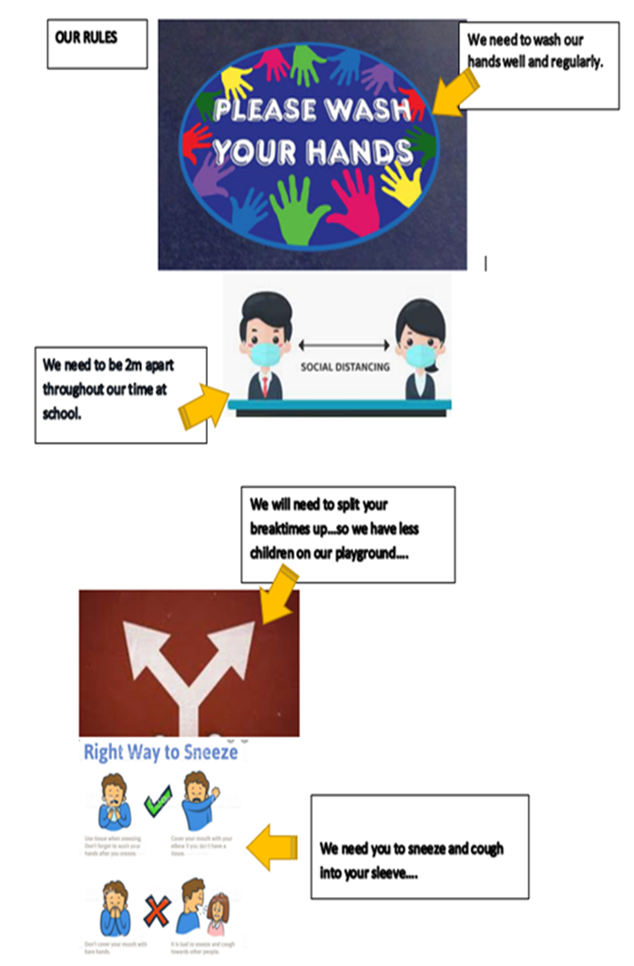

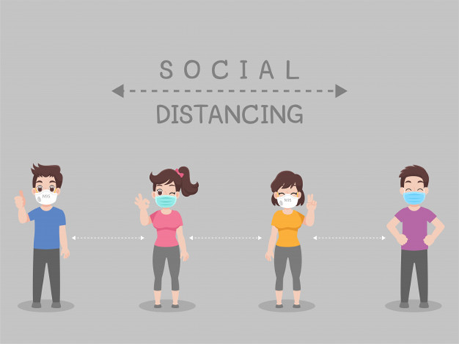

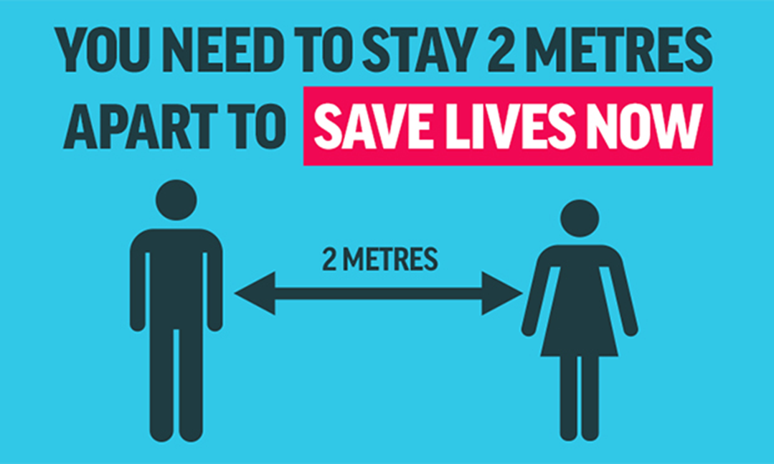
Tissue Disposal Signage for Designated Bins

Appendix 2 Signage outside of the academy to support social distancing and delivery expectations

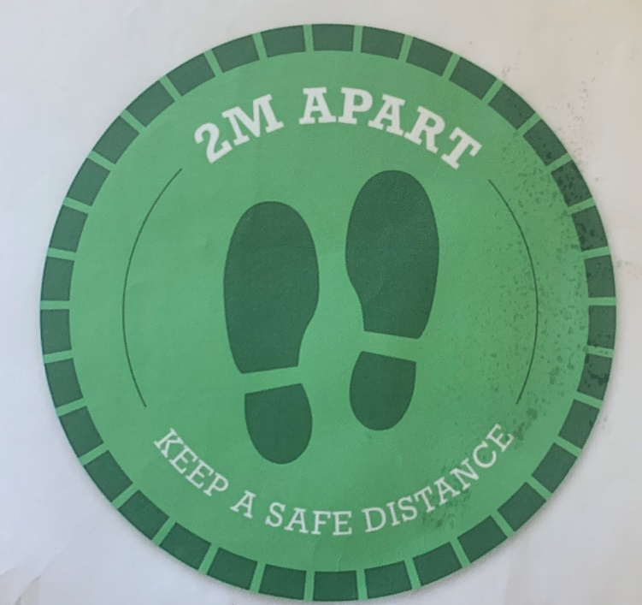

Social Distance Markers on External Fencing

Signage on main entrance door
Appendix 3 Letter sent to parents to share academy expectations

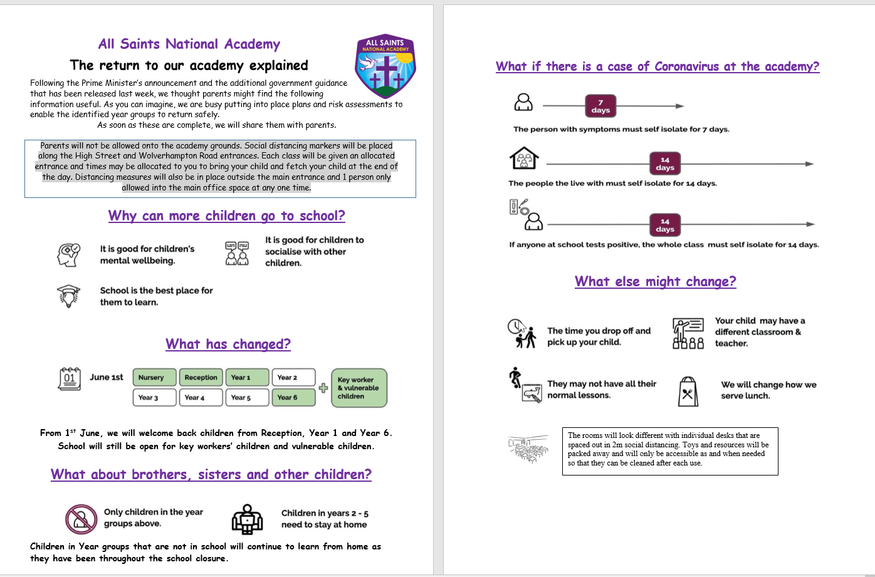

Appendix 4 External Map to show Designated Entrance and Exit Points
Reception entrance.
Queue to the right towards the park.

Barrier where staff will stand to welcome the children.
Barrier where staff will stand to welcome the children.
Year 4,5 &6 entrance. Queue to the right towards the academy staff car park
Key Worker and Vulnerable pupils enter via the academy Main Entrance, using the designated one- way system.

Year 1,2&3
Queue to the left towards the academy main entrance

