Learning Project Week beginning 12.10.20

Year 3/4
Weekly Maths Tasks (Aim to do 1 per day) | Weekly Reading Tasks (Aim to do 1 per day)
●Go to https://www.timestables.co.uk/multiplicationtables-check/ and choose the difficulty level.  Have a go at the Multiplication tables check.  This could be your mental starter for each day.  Can you improve your score over the week?  - Play the place value chart game.  Y3 – Look at the hundreds, tens and one.  Y4 - Look at thousands, hundreds, tens and ones. https://www.topmarks.co.uk/place-value/place-value-charts  - Play place value basketball. You need to recognise the Dienes base ten blocks and match to numbers up to three digits on the basketballs. https://www.topmarks.co.uk/learning-to-count/place-value-basketball  - Answer the place value problems below. Remember to select the right year group.  - Can you order these numbers on this maths times table game?  Y3 – 3 digit numbers  Y4 – 4 digit numbers  http://ictgames.com/rangeArranger/  - Answer the ordering numbers math problems below. Remember to choose your correct year group. | - Listen to ‘How to Wash a Woolly Mammoth,’ https://www.youtube.com/watch?v=pnO7W3tAlik  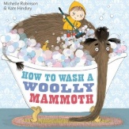  - What was the last step to the mammoth’s bath time routine?  - What was your favourite part of the story? Why?  - Can you summarise the story in a few sentences?  - Look at the set of instructions below and answer these questions.  - How much milk chocolate do you need?  - How long should you leave the apples in the fridge for?  - Why do you think the ingredients are placed before the method?  - Which organisational feature is used to structure the text?  - What does ‘devour’ mean? Can you use it in your own sentence?  - Listen to your child read and encourage them to read with expression and intonation.  - With your child, look in magazines, newspapers and books for new vocabulary they are unfamiliar with. They could find out the meanings using a dictionary or the internet.  - Pick a descriptive word from the text you are reading, write it down and using a thesaurus find five synonyms and antonyms for that word.
Weekly Spelling Tasks (Aim to do 1 per day) | Weekly Writing Tasks (Aim to do 1 per day)
- Practise reading and writing the Year 3/4 for Common Exception words.  (http://www.canonburrows.co.uk/serve_file/2 94727)  - Recap of Year 1/2 Spelling Rule.  Adding the suffixes ‘-ed’ and ‘-ing’ to these verbs which end in an ‘e’ and have a consonant before them: hike, hope, like, ride, shine, take, make, bake. Do they all follow the same rule?  - Find out about words like chef and machine, where the 'sh' sound is spelt with the letters 'ch'. Watch the video and play the activity below  https://www.bbc.co.uk/bitesize/topics/zt62mnb/articles/z8f3qhv | - Learn about imperative verbs by watching this video and trying the activities below. https://www.bbc.co.uk/bitesize/articles/zv98jhv  - Learn about fronted adverbials by watching the video and trying the activities below.  https://www.bbc.co.uk/bitesize/topics/zwwp8mn/articles/zp937p3  - Learn about prepositions by watching this video and trying the activities below.  https://www.bbc.co.uk/bitesize/articles/zh8nscw  - Read the set of instructions below and list all the features it has. For example, a title.  - Write your own set of instructions for your favourite game or recipe. Use the example instructions to help you. Try to include examples of imperative verbs, fronted adverbials and prepositions from the earlier tasks.

Learning Project - to be done throughout the week
Read the information on the following slides and sort the animals below.
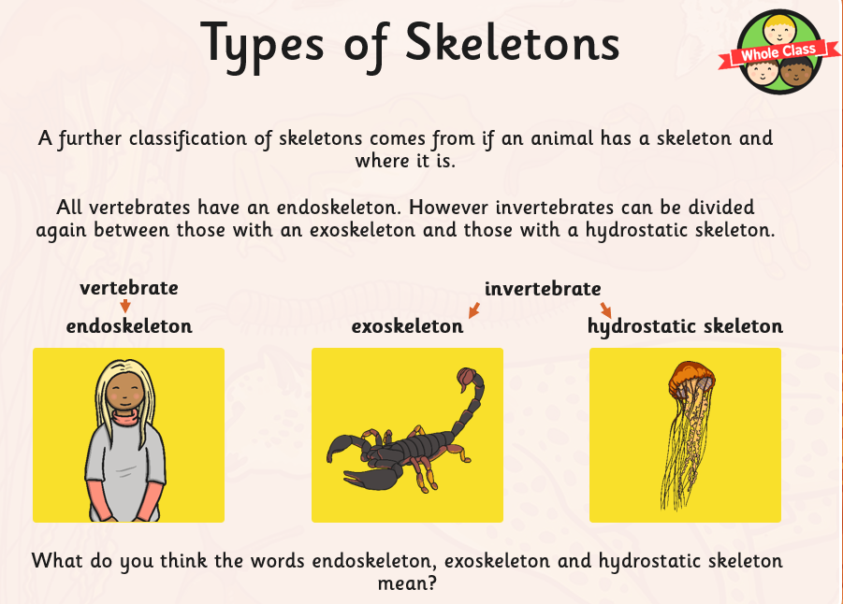
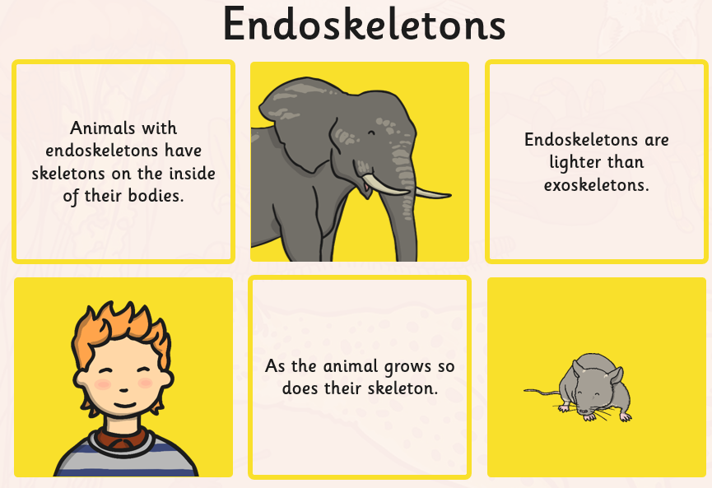
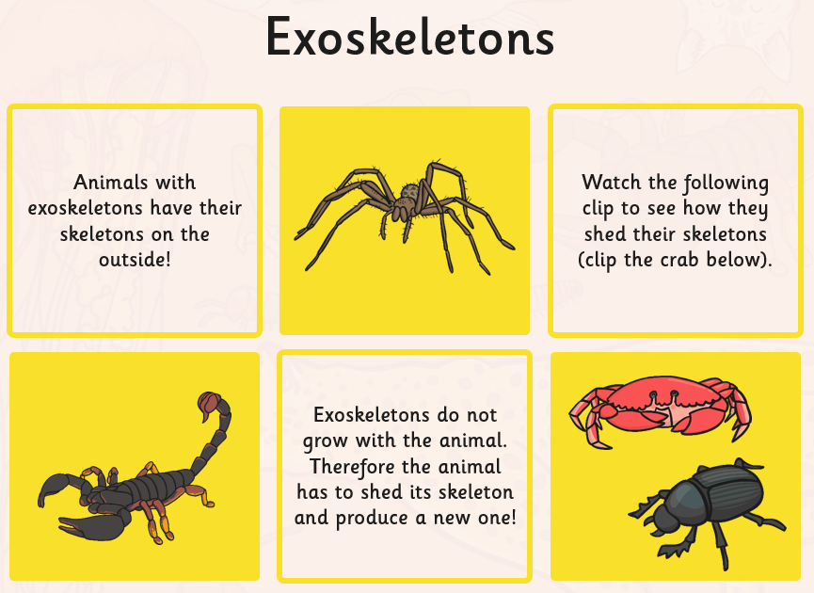
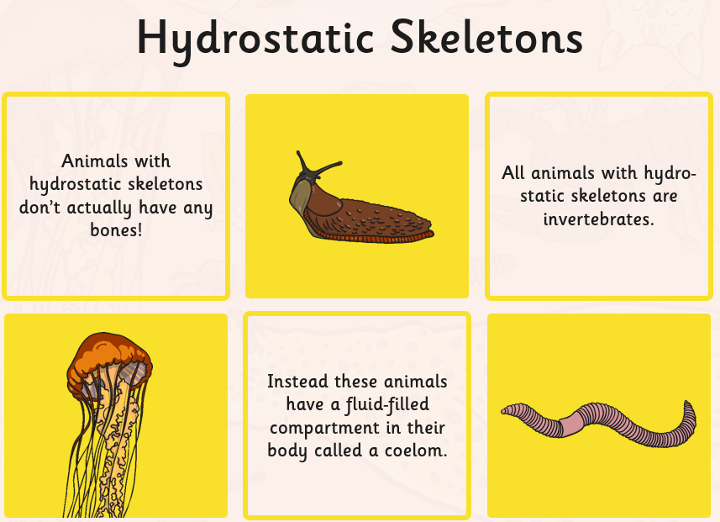
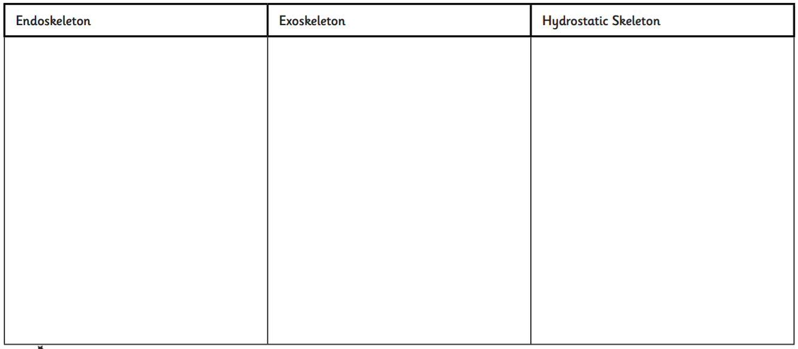

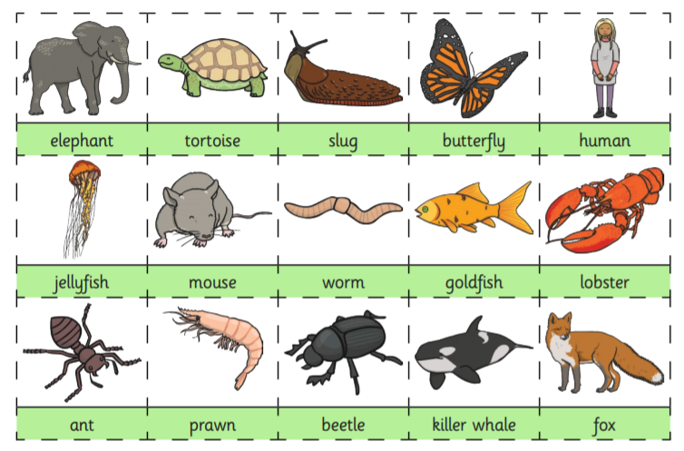

History – Read the slides and what can you deduce from these artefacts
Then watch the video on stone age tools. 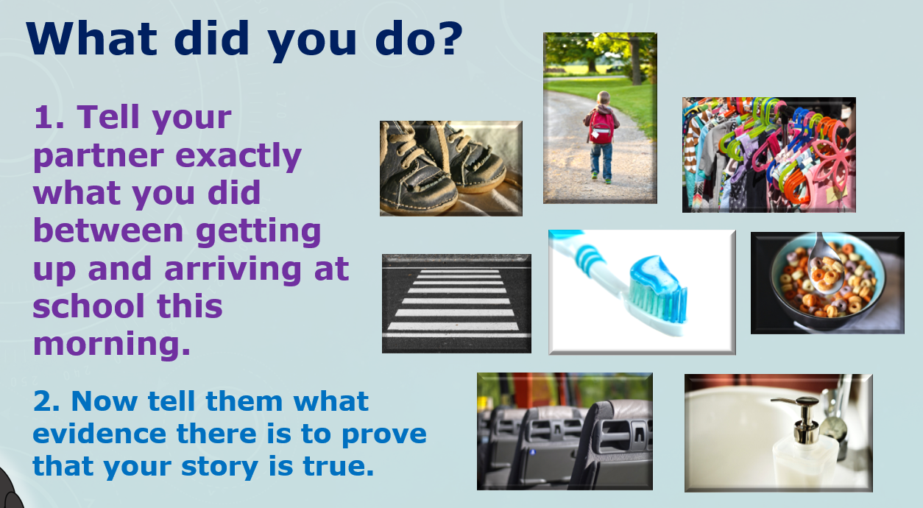
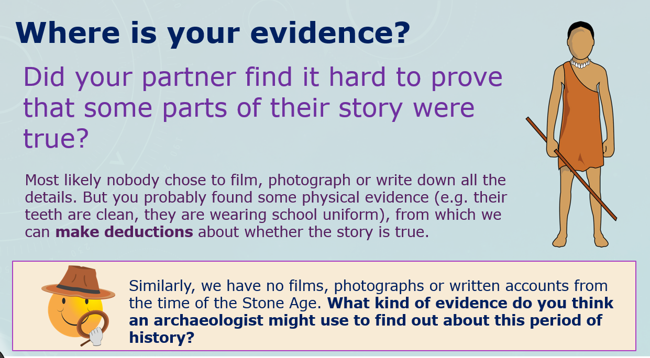
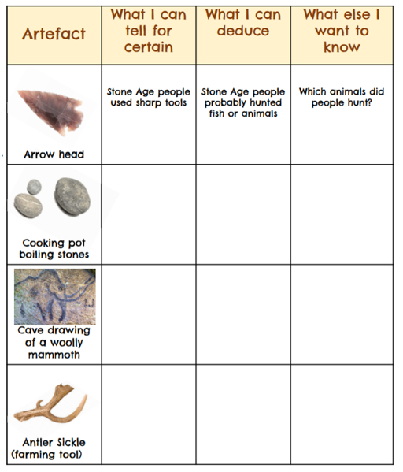

https://podcast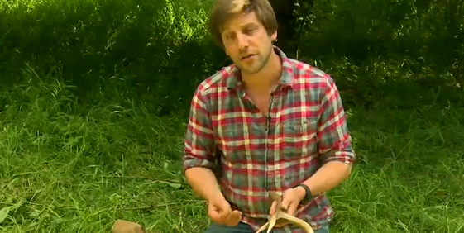s.ox.ac.uk/stone-tools
https://podcasts.ox.ac.uk/stone-tools

RE – listen to the creation story. Can you retell this to a member of your household? Draw a picture of what you think is wonderful in God’s world.
https://www.youtube.com/watch?v=WA7wQT4AdKs

Mind-blowing, chocolate-covered apples

Do you love Halloween? Do you love playing games such as apple bobbing? Arguably one of the best parts of Halloween is getting the chance to devour chocolate-covered apples. Follow this recipe to make the delicious, tangy tasty treats.
You will need:
- 6 juicy, golden delicious apples
- 200g smooth, milk chocolate
- 25g mind-blowing popping candy
- A kettle
- One medium-sized pan
- A glass bowl
- A wooden spoon
- 6 wooden lollipop sticks
Method
- Firstly, wash your hands.
- Next, gather all of your ingredients and equipment and lay them out onto a clean surface.
- Using boiling water from the kettle, pour it into the pan and turn the heat on low.
- Break the chocolate up into pieces and put them in the glass bowl.
- Carefully, place the glass bowl into the pan. After a few seconds, the chocolate will begin to melt (keep stirring using the wooden spoon).
- Whilst the chocolate is melting, stick the lollipop sticks into the top of the apples (one stick per apple).
- Once the chocolate has thoroughly melted, dunk the apple into the chocolate (hold it by the stick) so that there is a smooth, even layer all over.
- Immediately after that, dip roughly 1/4 of your chocolate-covered apple into the popping candy.
- Without dripping it everywhere, put the apple onto a clean plate and repeat steps 6-8 until all apples are done.
- Once they are all covered, place the plate in the fridge for 30 minutes - to set the chocolate.
- After it has set, you can take them out of the fridge and enjoy!

Place Value Problems
Year 3 | Year 4
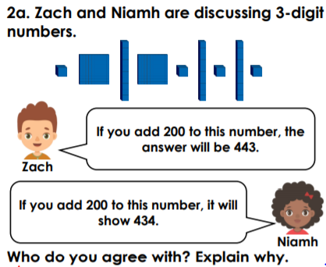  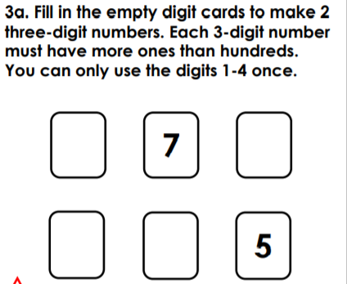 | 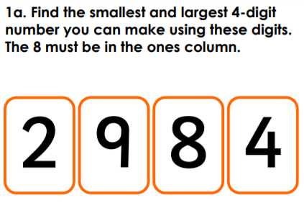  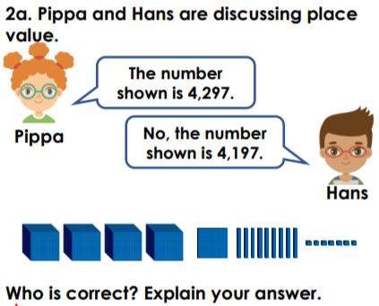

Ordering Problems
Year 3 | Year 4
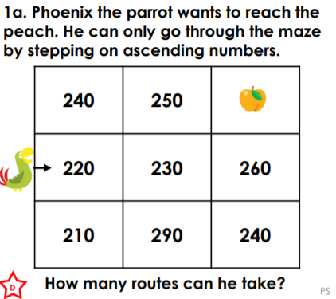  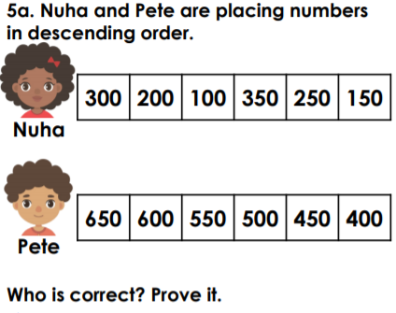 | 