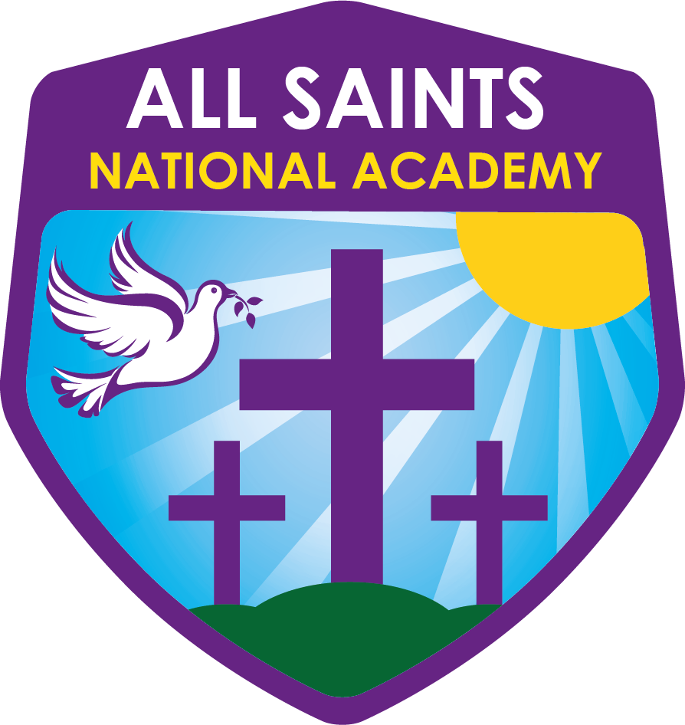

29th MAY 2020 UPDATE
(for proposed reopening of schools, and for children continuing home-learning)

COVID-19 ALL SAINTS NATIONAL ACADEMY SAFEGUARDING AND CHILD PROTECTION POLICY UPDATE
(This is an interim safeguarding and child protection appendix, it is under regular review and will continue to be updated as required)
This appendix should be read in conjunction with the following:
- Schools Child Protection and Safeguarding policy
- Keeping Children Safe in Education 2019
- Coronavirus (COVID-19): safeguarding in schools, colleges and other providers
- Safeguarding and remote education during coronavirus (COVID-19)
At all times - the safety and well-being of pupils must remain our highest priority, but balanced at the same time with the well-being and health of all staff
Contents:- Page
Walsall Safeguarding Partnership 3
Purpose 3
Vulnerable children and you people 3
Health and Safety 4
Procedures for managing child concerns 4
Potential Absence of Designated Safeguarding Lead/Deputy DSL 5
Online Safety 5
Interacting with pupils online that are not present in school 6
Peer on Peer Abuse 6
Domestic abuse 7
Concerns about an adult 7
Safeguarding training 8
Safer recruitment/volunteers and movement of staff 8
Monitoring attendance 9
Supporting children in school 9
Mental health 9
Key Contacts for Safeguarding and Child Protection 10
Helpline numbers 11
Links to associated school policies and procedures 11

Walsall Safeguarding Partnership
Walsall Safeguarding Partnership continue to provide in informed and effective leadership. As a reminder, they would like to reiterate the Government and NHS guidelines about maintaining good hygiene and social distancing.
Purpose
Safeguarding and promoting the welfare of children remains everyone’s responsibility. Consequently, everyone who comes into contact with our children, whether it is those in our settings during this ‘time of closure’ or those students working from home, has a role to play in safeguarding and child protection. In doing so, all staff and volunteers should make sure their approach is child centred. This means that they should consider, at all times, what is in the best interests of the child.
From the week commencing 1 June, we expect to be able to welcome back more children to school. A high proportion of our children will still receive their education remotely; this policy includes all children and young people and sets out what arrangements and requirements are in place to keep children safe; in school and those not physically attending the school, especially online and how concerns about these children should be progressed
It is important to remember whether our school is open or not staff should still follow the guidance of their local multi-agency safeguarding arrangements (MASH) and our DSL’s will ensure that all staff are aware of those issues and systems for reporting and provide local safeguarding updates.
In accordance with relevant law and guidance this policy sets out our procedures for safeguarding and child protection during the Covid 19 emergency response. It applies to all staff.
The principles in Keeping Children Safe in Education (KCSIE) continue to apply. It is our responsibility to continue to provide a safe environment, keep children safe and ensure staff and volunteers have been appropriately checked and risk assessments carried out as required.
Vulnerable children and young people
Vulnerable is identified as: children who have a social worker and those children and young people up to the age of 25 with education, health and care (EHC) plans. A child may also be deemed to be vulnerable if they have been assessed as being in need or otherwise meet the definition in section 17 of the Children Act 1989.
Attending education settings is known as a protective factor for children receiving the support of a social worker. It is right that we prioritise support for those who will benefit the most. We are balancing this carefully with the urgent need to reduce social contact right across society to support the work to reduce the spread of coronavirus (COVID-19).
Our leaders and especially designated safeguarding leads know our most vulnerable children best, and will offer additional places to those on the edges of receiving children’s social care support based upon risk assessments and need. Eligibility for free school meals in and of itself should not be the determining factor in assessing vulnerability.
It is important to note that some children that have not been ‘at risk’ previously become more at risk in this new COVID-19 context; the expected rise in domestic abuse is evident and we must respond by considering who should be offered places in our school provision and by keeping in contact with the child’s home. Children potentially suffering from domestic abuse, neglect, abuse, child criminal exploitation or child sexual exploitation will be elevated to the daily contact list to ensure that a referral can be made as soon as there is a concern raised. During the ongoing Covid 19 measures the majority of our student population will not be seen by our school, therefore it is essential that everyone is observant and listening to the voice of the child during any contact.
We are clear in our understanding and practice that staff and volunteers may identify new safeguarding concerns about individual children as they see them in person following partial school closures. Our school system for recording and monitoring children who are vulnerable remains accurate. Our schools safeguarding team will ask parents and carers to advise them of any changes regarding welfare, health and wellbeing that they should be aware of before a child returns.
We will continue to work with and support children’ social workers to help protect vulnerable children. This includes working with and supporting children’s social workers and the local authority virtual school head (VSH) for looked-after and previously looked-after children in line with the safeguarding partners detailed in the safeguarding and child protection policy.
Health and Safety
It is vital that wider opening risk assessments to prepare for opening on 1st June 2020 are appropriately linked to our safeguarding and child protection policy. All of our staff are aware of the required health and safety risk assessments and we understand the association between safeguarding and health and safety.
For information on health and safety and/or advice we will access Government advice as below, in addition to our internal policy and procedures.
Actions for education and childcare settings to prepare for wider opening from 1 June 2020
Managing school premises during the coronavirus outbreak
Health and Safety Executive
Procedures for managing child concerns
Early contact and close liaison with partner agencies is regarded as essential by our academy.
Our Designated Safeguarding Lead (DSL) is responsible for ensuring that children are identified, and the appropriate agency involved if there are actual or suspected case of child abuse by adults, parents, or any other adult.
For all children coming into our school from another school, with a known safeguarding or child protection need, a summary of needs and interventions MUST be provided by the ‘sending’ school DSL team. Access must be given to Child Protection Plans, Child in Need Plans, ECHPs, or for looked after children their personal education plan and any other formal, relevant information. The name and contact details of the social worker must be provided for every vulnerable child and the name and contact details of the virtual head responsible for any looked after child.
Our Designated Safeguarding Lead (DSL) will attend any reviews called by the Local Authority by Skype or other means of social distancing and may call on appropriate members of staff for reports.
A separate ‘Child Safeguarding’ file will be maintained for each child, all reports of concerns, details of contacts, referrals and actions will be recorded within this file. Where the Host school uses an electronic system such as CPOMS/My Concern and the student is from the Host School – the student file will be maintained on the CPOMS/My Concern system.
Where pupils attend a hub school in another setting the safeguarding file will be held on paper and stored in a locked cabinet. As soon as is possible the record should be transferred securely to the pupils host school.
Potential Absence of Designated Safeguarding Lead/Deputy DSL
Our optimal scenario is to have a trained DSL or deputy available on site. Where this is not the case a trained DSL or deputy will be available to be contacted via phone or online video (for example when they are working from home). Where possible though our school will seek to include a DSL/DDSL in each shift in the rota.
Whatever the scenario, it is important that all staff and volunteers have access to a trained DSL or deputy. On each day, staff on site will be made aware of that person is and how to speak to them if the DSL or DDSL is not on site.
Where a trained DSL or deputy is not on site, in addition to the above, one of our senior leaders will assume responsibility for co-ordinating safeguarding on site and will contact Seona Baker (Child Safeguarding Coordinator) or failing that, contact the Local Authority. The senior leader will liaise with the offsite DSL (or deputy) and as required liaise with children’s social workers where they require access to children in need and/or to carry out statutory assessments in school.
We recognise that DSLs (and deputies) will need to have more time to support staff and children regarding new concerns (and referrals as appropriate) as more children return.
Online Safety
As more of our children return it is important that we continue to provide a safe online environment for those who remain at home.
It is essential that children are safeguarded from potentially harmful and inappropriate communications and online material. As such, our school will ensure appropriate procedures, filters and monitoring systems are in place in accordance with the following policies:
• E-Safety
• Web Filtering and Device Monitoring.
Where students are using school equipment at home, the ability to filter access is limited. Filtering will be provided to the extent that is possible within the technological constraints the current crisis allows.
Pupils should be reminded of Internet Safety rules and parents will be expected to manage their children’s safety whilst at home.
Staff delivering teaching online should listen for any cues that indicate a safeguarding concern and report these to the DSL as soon as possible. These cues might include:
- Comments or questions about child abuse or neglect
- Inadequate supervision at home
- The impact of food poverty
- The health status in a family and any young caring responsibilities children have
An essential part of the online planning process will be ensuring children who are being asked to work online have very clear reporting routes in place so they can raise any concerns whilst online. As well as reporting routes back to our academy we will also signpost children to age appropriate practical support from the likes of:
Childline for support
UK Safer Internet Centre - to report and remove harmful online content
CEOP - for advice on making a report about online abuse
Internet Matters - may help us, and our governing bodies understand more about the potential increased risks some groups of children can face online
NSPCC - provides us with useful support and training opportunities
We understand the importance of continued support to parents or carers for children who are not returning to school. We will provide parents and carers with regular advice support and guidance on how to keep their children safe online. We have listed some support websites for staff to swiftly access should support/guidance requested by families.
Think U Know - provides advice from the National Crime Agency (NCA) on staying safe online
Parent Info - collaboration between Parentzone and the NCA providing support and guidance for parents from leading experts and organisations
Childnet - offers a toolkit to support parents and carers of children of any age to start discussions about their online life, to set boundaries around online behaviour and technology use, and to find out where to get more help and support
Internet Matters - provides age-specific online safety checklists, guides on how to set parental controls on a range of devices, and a host of practical tips to help children get the most out of their digital world
London Grid for Learning - has support for parents and carers to keep their children safe online, including tips to keep primary aged children safe online
Net Aware - has support for parents and carers from the NSPCC and O2, including a guide to social networks, apps and games
Lets Talk About It - has advice for parents and carers to keep children safe from online radicalisation

Interacting with pupils online that are not present in school
It is important that all staff who interact with children, including online, continue to look out for signs that the child may be at risk of harm or experiencing harm. Any such concerns should be dealt with as per our recording and sharing of concerns guidance within our Child Protection and Safeguarding policy and where appropriate referrals should still be made to children’s social care and as required the police.
Online teaching should follow the same principles as set out in the staff code of conduct.
We will ensure any use of online learning tools and systems is in line with privacy and data protection/GDPR requirements.
When we are in contact with parents and careers, communications will additionally be used to reinforce the importance of children being safe online. It will be especially important for parents and carers to be aware of what their children are being asked to do online, including the sites they will asked to access.
Peer on Peer Abuse
Our school recognises that during the closure a revised process may be required for managing any report of such abuse and supporting victims. Where our school receives a report of peer on peer abuse, we will follow the principles as set out in part 5 of KCSIE and of those outlined within the All Saints Child Protection Policy. Our school will listen and work with the young person, parents/carers and any multiagency partner required to ensure the safety and security of that young person.
Concerns and actions will be recorded appropriate referrals made.
Domestic Abuse
Our academy staff are aware and stay alert to domestic abuse, and that the potential for domestic abuse and violence to go unseen is high. We know that many victims will have reduced or limited opportunities to share what is happening to them. We are mindful that some children, whether returning to school, or remaining at home, will have suffered the impact of domestic abuse and we will be vigilant in our professional curiosity and ask those additional questions.
There are a range of resources available to support victims and those working with victims, Walsall Safeguarding Partnership website is being updated regularly and has lots of information on domestic abuse
Concerns about an adult
Where staff are concerned about an adult working with children in school, they should continue to refer their concern to the head. Concerns about the head should be directed to the Chair of Governors. If any of these people are unavailable due to the Covid-19 context then colleagues must refer the matter to Michelle Pinnock-Ouma LADO). The matter will then follow usual safeguarding procedures.
We will continue to follow the legal duty to refer to the DBS anyone who has harmed or poses a risk of harm to a child or vulnerable adult. Full details can be found at paragraph 163 of KCSIE.
We will continue to consider and make referrals to the Teaching Regulation Agency (TRA) as per paragraph 166 of KCSIE and the TRA’s ‘Teacher misconduct advice for making a referral.
During the COVID-19 period all referrals should be made by emailing Misconduct.Teacher@education.gov.uk
Safeguarding Training
For the period COVID-19 measures are in place, a DSL (or deputy) who has been trained will continue to be classed as a trained DSL (or deputy) even if they miss their refresher training. However, where the training does lapse it will be necessary to refresh DSL training as soon as possible after the Covid 19 situation is deemed over.
All existing staff have had safeguarding training and have read part 1 of Keeping Children Safe in Education (2019). Our Designated Safeguarding Lead will communicate with staff about any new local arrangements and ensure that they know what to do if they are worried about a child.
Where new staff are recruited, or new volunteers enter our school, they will continue to be provided with a safeguarding induction including signing to say that they have read and understood relevant document.
The existing workforce may move between educational settings on a temporary basis in response to COVID-19. If we receive staff from another setting, we will judge, on a case-by-case basis, the level of safeguarding induction required. The minimum will include health and safety related to our school, contacts for the DSL/DDSL and leadership team and how to make a referral. Our school will seek assurance that the member of staff has received appropriate safeguarding training and undergone appropriate safer recruitment checks by checking their photo identification from their school.
Safer recruitment/volunteers and movement of staff
It remains essential that people who are unsuitable are not allowed to enter the children’s workforce or gain access to children. When recruiting new staff, we will continue to follow the relevant safer recruitment processes, including, as appropriate, relevant sections in part 3 of KCSIE.
In response to COVID-19, the Disclosure and Barring Service (DBS) has made changes to its guidance on standard and enhanced DBS ID checking to minimise the need for face-to-face contact. Our Human Resources provider will support and advise on how to keep records of where non-face to face checks have taken place so that they can be followed up when the Covid-19 context is no longer relevant.
Where we are utilising volunteers, we will continue to follow the checking and risk assessment process as set out in paragraphs 167 to 172 of KCSIE. Under no circumstances will a volunteer who has not been checked be left unsupervised or allowed to work in regulated activity.
Whilst acknowledging the challenge of the current environment, it is essential from a safeguarding perspective that our school, on any given day, know which staff/volunteers will be in school, and that appropriate checks have been carried out, especially for anyone engaging in regulated activity. As such, our school will continue to keep the single central record (SCR) up to date as outlined in paragraphs 148 to 156 in KCSIE. We ensure that “loan staff” are entered on to our single central record.
Following DfE guidance there is currently no requirement to obtain a new DBS check for our returning staff who have continued to be employed but have not been working in regulated activity during partial school closures. However if our school leaders have concerns about the any member of staff we may obtain a new check in the usual way.

Monitoring attendance
The DfE has a daily online attendance form to keep a record of children of critical workers and vulnerable children who are attending school. This allows for a record of attendance for safeguarding purposes and allows our school to provide accurate, up-to-date data to the department on the number of children taking up places
We will follow our attendance processes to follow up on non-attendance, where a child was expected to attend school, and did not attend, we will phone the relevant parent or carer to establish that the child is safe and well and the reason for non-attendance. This will be recorded in the ‘safe and well check’ part of our procedures.
To ensure the above we will communicate with parents and carers to re-confirm emergency contact numbers are correct and ask for any additional emergency contact numbers where they are available.
The DSL (DDSL) is responsible for overseeing that pupil attendance is monitored and safe and well checks are in place to allow timely safeguarding referrals to be made or actions taken, should they be required.
In all circumstances where a child categorised as vulnerable (see above) does not take up their place in our school, or discontinues after a period of attendance, we will notify their social worker and virtual head.
Supporting children in school
ALL SAINTS NATIONAL ACADEMY is committed to ensuring the safety and wellbeing of all its pupils. Our pupils will continue to be a safe space for all children to attend and flourish. Our Governors and Head Teacher will ensure that appropriate staff are on site and staff to pupil ratio numbers are appropriate, to maximise safety.
ALL SAINTS NATIONAL ACADEMY will refer to the Government guidance for education and childcare settings on how to implement social distancing and continue to follow the advice from Public Health England on handwashing and other measures to limit the risk of spread of COVID19. They will ensure that where we care for children of critical workers and vulnerable children on site, we ensure appropriate support is in place for them.
Mental Health
Negative experiences and distressing life events, such as the current circumstances, can affect the mental health of pupils and their parents. Our staff are made aware of this when considering the setting and expectations of pupils’ work where they are at home or are returning to school on or after 1st June 2020. Where they have children of critical workers and vulnerable children on site, and/or more children returning to school from 1 June onwards we ensure appropriate support is in place for them.
The DfE’s guidance on mental health and behaviour in schools sets out how mental health issues can bring about changes in a young person’s behaviour or emotional state which can be displayed in a range of different ways, and that can be an indication of an underlying problem. Support for pupils and students in the current circumstances can include existing provision in school (although this may be delivered in different ways, for example over the phone) or from specialist staff or support services. You can read the guidance on mental health and behaviour in schools here.
For wider information about context please try here:
Mental health related to the Covid-19
Mentally Healthy Schools
Supporting pupils wellbeing
Black Country Healthcare NHS Foundation Trust has launched a 24-7 support line for adults, older adults, and children and young people requiring urgent mental health support during the Covid-19 pandemic - 0345 646 0827
We are aware that Health and Social Care colleagues have reported an increase in service users reporting feelings of anxiety.
USEFUL CONTACT NUMBERS
Key Contacts for Safeguarding and Child Protection
Head: Nicky Baddeley
Contact email: principal@asna.walsall.sch.uk
Telephone: 01922 710210 – staff will redirect

Designated safeguarding lead:
Contact email: mbassi@asna.walsall.sch.uk & gmeers@asna.walsall.sch.uk
Telephone: 01922 710210 – staff will redirect

Deputy designated safeguarding lead:
Contact email: mskidmore@asna.walsall.sch.uk jbagley@asna.walsall.sch.uk
Telephone: 01922 710210 – staff will redirect

Local Authority Designated Officer (LADO): Michelle Pinnock-Ouma
Contact email: michelle.pinnock-ouma@walsall.gov.uk
Telephone: 07432 422205

Local Authority Social (MASH):
Contact email: MASH@walsall.gov.uk
Telephone: 0300 555 2866
0300 555 2836 (out of hours service)
Virtual Head: Lorraine Thompson
Contact email: Lorraine.thompson@walsall.gov.uk
Telephone: 07825 860581

Helpline numbers
NSPCC Adults Helpline 0808 800 5000 help@nspcc.org.uk
Refuge 24-hour National Domestic Abuse Helpline 0808 2000 247
NSPCC Childline 0800 1111 https://www.childline.org.uk/
Find your nearest foodbank Trussell Trust

Links to associated school policies and procedures

Links to:
- Safeguarding and Child Protection Policy  - Staff Code of Conduct  - Behaviour Policy  - Safer Recruitment/DBS policy  - E-safety Policy  - Safe Handling policy/procedure | - SEND policy  - Allegations Against Staff (Staff Disciplinary Policy and Procedures)  - Anti-Bullying Policy  - Acceptable Use Policy  - Health and Safety  - First Aid

Links to DfE guidance

Covid 19 - Managing safeguarding in schools, colleges and other education providers
Corona Virus – Covid 19, Guidance on Vulnerable Children and Young People

Covid 19 – Guidance for Schools about Temporary Closing

Coronavirus (COVID-19): attendance recording for educational settings

This note is about managing social isolation

Keeping Children Safe Online

Staying Safe Online

Safeguarding and remote education during coronavirus (COVID-19)

