Risk assessment

School Name: | All Saints National Academy
URN Number: | 141410
What are your 3 most significant risks identified in your risk assessment? | Availability of space for the intended numbers  Vulnerability of key children with additional needs  Parents congregating at the gates and drop off and pick up times
Are there any additional issues you wish to flag with the LA in terms of your ability to re-open? | No
This risk assessment has been completed based on the national and local guidance at the time having taken account of the additional risks/hazards/controls specific to this school.
Signature: N. Baddeley Date: 28/8/20
The RESET Programme in Walsall

Coronavirus (COVID-19): Risk Assessment Action Plan for opening from 1st June 2020.

All Saints National Academy
Assessment conducted by: Nicky Baddeley | Job title: Principal | Covered by this assessment:  Whole academy
Date of draft assessment: 19/5/20 | Consultation date:- 20/5/20 | Reviewed by Knights Solictors:-22/5/20
Amended date: 23/5/20 | Approved date:- 25/5/20 | Date of next review: 11/9/20,18/9/20.25/9/20.2/10/20,12/10/20,2/11/20  Ammended Date : 28/8/20

AMENDMENTS
- For the purpose of this risk assessment, the term ‘coronavirus’ to refer to coronavirus disease 2019 (COVID-19).
- Schools must ensure that this risk assessment reflects the local setting and context of the school. Staff must be consulted with regard to this risk assessment.
- This risk assessment is not exhaustive and is issued to schools as a template to assist in the production of a comprehensive document that covers the particular circumstance of the setting – as such, the risks and risk controls should be deleted/amended/added-to to reflect the school.
- This should be viewed alongside relevant advice and guidance from the Department of Education and reflect any additional subsequent guidance issued to schools.
- Additional information and considerations that is specific to our local area can be found at: https://go.walsall.gov.uk/covid-19_information/covid-19_-_i_want_to_know/outbreak_management_plan
- For further reference, https://www.gov.uk/government/latest?departments%5B%5D=department-for-education, including the documents below:
  - https://www.gov.uk/government/publications/safe-working-in-education-childcare-and-childrens-social-care/safe-working-in-education-childcare-and-childrens-social-care-settings-including-the-use-of-personal-protective-equipment-ppe?utm_source=27%20August%202020%20C19&utm_medium=Daily%20Email%20C19&utm_campaign=DfE%20C19
  - coronavirus (COVID-19) home testing kits.
  - https://www.gov.uk/government/publications/covid-19-stay-at-home-guidance
Staff will be allocated to classes in learning bubbles.

28/8/20 . 4/9/20 , 2/10/20, 12/10/20 3/11/20. 3/1/21 8/3/21
The sole purpose of this risk assessment is to support schools in preparing for the possibility of providing some face-to-face contact with pupils in year groups, whilst reducing the risk of coronavirus transmission.

Key:
Level of risk prior to control | Identifies the risk before any steps to reduce the risk have been taken
Risk Description: | Outlines the area of concern. This list is not exhaustive and schools should add/amend/delete where appropriate e.g. risks for pupils with complex needs.
Risk Controls: | The measures that will be taken to minimise the risk. These are generic and should be adapted for the school context.
Impact: | L/M/H.
Likelihood: | L/M/H
Responsible person: | The identified staff member(s) responsible for implementing the risk controls.
Date: | The date by which required plans for controls will be in place. ONGOING REFERS TO THIS ASPECT BEING REVISITED DAILY
Line Manager Check: | Sign off to ensure that the risk has been minimised as far as possible.
NAMED STAFF | NB – NICKY BADDELEY PRINCIPAL SLT – SENIOR LEADERS ONSITE MICHELLE SKIDMORE & JOSIE BAGLEY GM – GEMMA MEERS (PART TIME ON SITE W,T,F) MB – SITE SUPERVISOR MARK BRAZIER OM- OFFICE MANAGER SCT – ST CHAD’S TRUST  TEACHING TEAM – TEACHERS & SUPPORT STAFF IN THEIR DESIGNATED BUBBLES

COMMUNICATION INTERNALLY WILL BE ACTIONED VIA WALKIE TALKIE SYSTEM. ROLL CALL COMPLETED AT START OF DAY TO ENSURE COMMUNICATION STREAMS ARE CLEAR

Risk Description/Area of Concern | Level of risk prior to control | Risk Controls | Impact/  Severity | Likelihood | Responsible person | Planned Completion Date | Line Manager Check
The academy is closed due to a local or national lockdown | M | To ensure provision is made for Key Worker and Vulnerable pupils on- site  - Reduction in number of staff and pupils on site  - Class Bubbles created and rotas completed to cover the pupils requiring a space  - Parents only access an onsite place for pupils if no other provision is available  - Rotas of staff on site to support KW & V pupils, these are allocated on a weekly base and created and reviewed in line with pupil demand  - Parents are requested to contact Mrs Skidmore on mskidmore@asna.walsall.sch.uk if they require a place on site if they are a keyworker or vulnerable family  - Contact the Catering team to organise lunches for the allocated pupils  To ensure effective provision is made for staff for their own protection  - Rotas of leadership team and office team in order to keep bubbles in the event of a positive case.  - Staff allocated on a weekly rota basis for child facing sessions and remote learning provision  - Staff all received a 1:1 session prior to lockdown and those who are within vulnerable groups have been allocated remote learning roles  - All staff to wear a face covering at all times when in the academy  To ensure that effective online remote learning is created for all learners  - Staff upload work onto Google Classroom daily for pupils  - Work is created that meets the needs of pupils  - SEND pupils receive work that is matched to their needs and in relation to parents additional support is offered either on or off site  - Paper packs of work are created weekly (Thursday) and quarantined ready for collection by parents on the following Monday  - Packs are sealed and available from the main reception area  - Pupils who have no access to a device have been allocated a laptop and support provided to access the platform  - A Remote Learning Strategy is created and shared with all stakeholders  - Acceptable Use Policies are reissued to all stakeholders and they agree and adhere to the content  - Support is offered to both staff and parents in relation to the new portal where work will be uploaded for pupils – Google Classroom  - Attendance of Key Worker and Vulnerable children is monitored and the registers are completed on a daily basis. If children are due on site but fail to attend and a message is not received from their parents the attendance policy will be followed and safe and well checks completed  - Regular safe and well telephone calls will be made to our vulnerable families | H | H | NB & SLT | AS AND WHEN INSTRUCTED
The school lapses in following national guidelines and advice. | L | To ensure that all relevant guidance is followed and communicated:  - The school to keep up-to-date with advice issued by, but not limited to, DfE, NHS, Department of Health and Social Care and PHE.  - Information on the school website is updated.  - Pupils updated via classrooms/email/text as necessary.  - Any change in information to be shared with Chair of Governors and passed on to parents and staff by email.  As a result: The school has the most recent information from the government, and this is distributed throughout the school community. | H  H  H  H | L  L  L  L | NB  NB  MS/JB/GM  NB & SLT | ONGOING  ONGOING  ONGOING  ONGOING
Poor communication with parents and other stakeholders | L | - All staff/pupils aware of current actions and requirements and reminded frequently using school communication systems.  - Principal to share Risk Assessment with all staff.  - Parents notified of risk assessment plan and shared with parents via website.  As a result: All pupils and all staff working with pupils are adhering to current advice. | H  H  H | L  L  L | NB & SLT  NB  NB | ONGOING  28/8/20  28/8/20
Lack of awareness of policies and procedures. | L | - All staff, pupils and volunteers are aware of all relevant policies and procedures including, but not limited to, the following:  - Health and safety policy  - Infection control policy  - First aid policy  - Intimate care policy  - Behaviour policy  - All staff have regard to all relevant guidance and legislation including, but not limited to, the following:  - The Reporting of Injuries, Diseases and Dangerous Occurrences Regulations (RIDDOR) 2013  - The Health Protection (Notification) Regulations 2010  - Public Health England (PHE) (2017) ‘Health protection in schools and other childcare facilities’  - DfE and PHE (2020) ‘COVID-19: guidance for educational settings’  - The relevant staff receive any necessary training that helps minimise the spread of infection, e.g. infection control training.  - Staff are made aware of the school’s infection control procedures in relation to coronavirus via email.  - Parents are made aware of the school’s infection control procedures in relation to coronavirus via letter/social media/poster at entrance to school – they are informed that they must contact the school as soon as possible if they believe their child has been exposed to coronavirus  - Pupils are made aware of the school’s infection control procedures in relation to coronavirus via a coordinated programme of delivery from staff on the morning of the 2nd of September. All are informed that they must tell a member of staff if they begin to feel unwell.  - WEEKLY updates issued to staff.  As a result, all staff and pupils are aware of the policies and procedures in place to keep themselves safe in school. | H  H  H  H  H  H  H | L  L  L  L  L  L  L | NB  NB  NB  NB  NB  TEACHING STAFF  NB | 20/5/20  20/5/20  20/5/20 updated on 1/9/20  20/5/20 updated on 1/9/20  22/5/20 updated on 1/9/20  2/9/20  1/9/20 ONGOING
Poor hygiene practice in school. | M | - Posters are displayed around school and in every classroom reminding staff and pupils of the hygiene practice required in school (e.g. washing hands before entering and leaving school).  - Pupils to wash their hands with soap before and after break times and lunchtimes for no less than 20 seconds.  - Teachers to reiterate key messages in class-time (when directed) to pupils to:  - Cover coughs and sneezes with a tissue,  - To throw all tissues in a bin  - To avoid touching eyes, nose and mouth with unwashed hands.  - Additional alcohol-based sanitiser (that contains no less than 60 percent alcohol) and tissues to be provided for the school reception area, dining hall, in classrooms and other key locations for staff and pupils.  - Infection control procedures are adhered to as much as possible in accordance with the DfE and PHE’s guidance.  - Sufficient amounts of soap (or hand sanitiser where applicable), clean water, paper towels, anti-bacterial wipes and waste disposal bins are supplied in all toilets and kitchen areas.  - Hand washing facilities are supervised by staff when pupils are washing their hands to avoid overcrowding in hand washing areas.  - Pupils and staff do not share cutlery, cups or food. Staff to bring in own cups and utensils.  - All utensils are thoroughly cleaned before and after use.  - Cleaners are employed by the school to carry out additional cleaning. Door handles, doors and toilets are cleaned during the day at break times, lunchtime and end of the day and paper/hand towels are refilled regularly twice daily  As a result, all pupils and staff are adhering to high standards of hygiene to minimise risk of transmission. | H  H  H  H  H  H  H  H  H  H | L  M  L  L  M  L  L  L  M  L | NB  MB  ALL STAFF  ALL STAFF  NB  NB& SLT  MB & TEACHING STAFF  TEACHING TEAM  TEACHING TEAM  CLEANING TEAM & TEACHING TEAM | 28/8/20  2/9/20 & ONGOING  2/9/20 & ONGOING  2/9/20 & ONGOING  1/9/20 & ONGOING  1/9/20 & ONGOING  2/9/20 & ONGOING  2/9/20 & ONGOING  1/9/20 & ONGOING
The event of a local lockdown | M | The government has made its position clear that schools may not necessarily close during local outbreaks or local lockdowns  Locally the decision to close schools will be made by the Director of Public Health, Stephen Gunther, following consultation with partners, including Children Services.  Principals will be told as soon as possible via communication streams from the Local Authority  In line with the guidance provided in the event of a local lockdown the academy will act accordingly and swiftly to put measures in place.  All communications with stakeholders will follow the process as in full lockdown back in March | H | M | LA, Principal & SCT | 1/9/20 & ONGOING
Suspected case/contact with someone with symptoms | M | Parents complete a declaration form that the pupil, or in the case of a member of staff or a visitor, to state that they have not shown symptoms or come into contact with anyone who has shown symptoms.  - Any person that has come into contact with someone who is showing symptoms, academy to be contacted straight away  - Other members of the pupil bubble’s parents are contacted and children go home and await to be contacted regarding the test result  - Staff members go home and await to be contacted regarding the test result  - Staff testing link for priority access https://www.gov.uk/get-coronavirus-test  - Testing centre information provided via the link below https://www.nhs.uk/conditions/coronavirus-covid-19/  and where necessary a home testing kit will be provided if the principal deems by providing one will significantly increase the likelihood of them getting tested.  Advice will be provided alongside these kits.  Guidance on how to administer including a video can be found at :-  https://www.gov.uk/guidance/coronavirus-covid-19-getting-tested#how-to-arrange-a-test  Additional translations of this material can be gained where parents have English as an additional language and staff will provide translated material where applicable  - Person who has shown symptoms to inform academy of outcome of test  - No pupils or staff to return until test confirmation  - If test is positive pupils and staff self-isolate for 14 days  - If test is negative staff and pupils return to academy on next working day  Positive test result  - A positive result means you had coronavirus when the test was done.  - If your test is positive, you must self-isolate immediately.  - If you had a test because you had symptoms, keep self-isolating for at least 10 days from when your symptoms started.  - If you had a test but have not had symptoms, self-isolate for 10 days from when you had the test.  - Anyone you live with, and anyone in your support bubble, must self-isolate for 14 days from when you start self-isolating.  Negative test result  - A negative result means the test did not find coronavirus.  You do not need to self-isolate if your test is negative, as long as:  - everyone you live with who has symptoms tests negative  - everyone in your support bubble who has symptoms tests negative  - you were not told to self-isolate for 14 days by NHS Test and Trace – if you were, see what to do if you've been told you've been in contact with someone who has coronavirus  - you feel well – if you feel unwell, stay at home until you’re feeling better  - If you have diarrhoea or you’re being sick, stay at home until 48 hours after they've stopped. | H | H | ALL STAFF  & PARENT COMMUNITY | 1/9/20 & ONGOING
Ill health in school. | M | Staff are informed of the symptoms of possible coronavirus infection, e.g. a cough, difficulty in breathing and high temperature, and are kept up-to-date with national guidance about the signs, symptoms and transmission of coronavirus.  Appropriate PPE sourced and guidance on its location, use and disposal issued to staff in line with government guidance on what to do is a pupil or staff member becomes unwell.  All staff are informed of the procedure in school relating a pupil becoming unwell in school.  - Any pupil who displays signs of being unwell is immediately referred to Nicky Baddeley Principal or Michelle Skidmore Vice Principal in her absence  - Any staff member who displays signs of being unwell immediately refers themselves to Nicky Baddeley Principal or Michelle Skidmore Vice Principal in her absence and is sent home.  - Where the named person is unavailable, staff ensure that any unwell pupils are moved to an empty room whilst they wait for their parent to collect them. School admin team to contact parents. Parents advised to follow the COVID-19: Guidance for households, including accessing testing.  - Pupils and staff who have displayed symptoms in school, should be advised to be tested. If they test negative, they can return to school.  - If a pupil needs to go the bathroom, they should use a separate bathroom which will be cleaned on a scheduled cleaning rota  - Each class and key areas such as – main office, staff room, dining room, gym to have COVID PPE PACK in the event of a pupil or member of staff being taken ill or showing symptoms on site. Clear instructions are provided on the front of what actions to be made  - Pupils displaying symptoms of coronavirus do not come in to contact with other pupils and as few staff as possible, whilst still ensuring the pupil is safe. A facemask should be worn by the supervising adult if a distance of 2 metres cannot be maintained.  - If contact with a child or young person is necessary, then gloves, an apron and a face mask should be work by the supervising adult. If there is a risk of splashing, the eye protection should also be worn.  - The relevant member of staff calls for emergency assistance immediately if the pupil’s symptoms worsen.  - Unwell pupils who are waiting to go home are supervised in the academy meeting room in main reception where they can be at least two metres away from others  - Areas used by unwell pupils who need to go home are identified as out of bounds, thoroughly cleaned and disinfected once vacated.  As a result, any member of the school community who becomes unwell, is isolated quickly and appropriate action is taken to minimise the risk of infection. | H  H  H  H  H  H  H  H  H  H | M  M  M  M  M  M  M  M  M  M | PRINCIPAL  PRINCIPAL  TEACHING TEAM  ALL STAFF  ALL STAFF  NB  ALL STAFF  SUPERVISING ADULT  SUPERVISING ADULT  SUPERVISING ADULT  SUPERVISING ADULT  NB,MB, CLEANING TEAM | 1/9/20 & ONGOING  1/9/20 & ONGOING  1/9/20 & ONGOING  1/9/20 & ONGOING
A pupil or staff member is tested and has a confirmed case of coronavirus. | L | In line with government advice:  ALL STAFF , UNLESS THEY HAVE REQUESTED TO OPT OUT WILL COMPLETE LFD TESTING TWICE A WEEK – SUN & WED  - All tests will be reported to NB & MS and to the gov.uk  - Any positive tests are to also be reported to the gov.uk and a PCR test booked. The member of staff will need to self-isolate  - Any staff who are classed as CEV need to provide proof to the Principal and arrangements will be made for them to shield and work remotely  - Those living with someone with CEV can still attend work  - The rest of the class/group should be advised to self-isolate for 10 days.  - The person is to contact the Principal via telephone as soon as the case is known  - The Principal will contact the DFE PHE Walsall and Walsall School Nursing Team and NHS track and trace https://contact-tracing.phe.gov.uk/ - . Then PHE’s local protection teams to conduct a rapid investigation and will advise school on appropriate action.  As stated previously important steps to take if a positive or negative test is issued.  As a result, school leaders taken appropriate action in the event of a confirmed case of coronavirus.  The room in which the member of staff is allocated is sealed off and not deep cleaned until 72 hours has passed. | H  H | M  M | NB  NB | 1/9/20 & ONGOING
Poor practice leads to the spread of potential infection at the start of the school day. | L | In line with government advice:  - Doors and windows in communal areas will be opened for a period of 15 minutes prior to pupils arriving  - Issue information to young people, parents, carers and visitors not to enter the school if they display any symptoms of coronavirus.  - Inform pupils and parents of their allocated times for the start, end of their school day and exit points to school and where they should go on arrival.  - R 8.45 – 2.45 HIGH STREET  - Y1 8.50 – 2.50 HIGH STREET  - Y2 8.40 – 2.40 HIGH STREET  - Y3 8.50 – 2.50 WOLVERHAMPTON ROAD  - Y4 8.40-2.40 WOLVERHAMPTON ROAD  - Y5 8.35-2.35 WOLVERHAMPTON ROAD  - Y6 8.30 – 2.30 CAR PARKROAD  - Pupils to be supervised in accessing hand-washing facilities on arrival, ensuring that pupils queue maintaining social distancing as they wait for facilities.  - All staff to wash hands on arrival in school.  - Make it clear to parents and pupils that they cannot congregate at the front of school prior to the day beginning.  - 2m social distancing to be adhered to at drop off and collection  - Make parents and pupils aware of government recommendations with regard to transport. Inform parents and pupils of restrictions  - Parents advised to wear face masks at drop off and collection  - Staff to wear face coverings at the start and end of day  - Issue information to pupils in relation to restrictions on their movement around the site.  - Sufficient supplies of hand-washing/sanitising supplies provided to accommodate this procedure at the start of the day.  As a result, the risk of infection is reduced as pupils and staff arrive at school. | H  H  H  H  H  H  H  H | M  L  L  L  M  H  L  L  M | NB  NB  SUPERVISING ADULT  ALL STAFF  NB & SLT  NB  NB & STAFF  MB | 1/9/20 & ONGOING  15/7/20 & ONGOING  2/9/20 & ONGOING  1/9/20 ONGOING  15/7/20 & ONGOING  15/7/20 & ONGOING  2/9/20 & ONGOING  1/9/20 ONGOING
Poor management of pupil numbers reduces the ability of pupils and staff to practice social distancing. | L | - Leaders to communicate clearly and swiftly to parents regarding the return and requirement of attendance.  - Classroom designs altered to front facing, 2m distance marker for teacher  - Pupils restricted to CLASS bubbles to minimise movement around the academy apart from lunchtime sessions.  - Timetable reviewed and refreshed, and advise on requirement for timings/comfort breaks communicated to teachers and staff to support re-establishing learning stamina for pupils .  - Where possible, pupil movement to be limited to make social distancing easier  - Staff to remain in class bubbles and not to move between year groups during the day including specialist staff  - Pupils to remain in class bubbles other than lunch and break times whereby they will be outdoors and in year group bubbles  - Staff not to car share to and from the academy  As a result, staff and pupils are clear about the times for their year groups and a clear timetable of daily events | H  H  H  H  H  H | L  L  L  L  L  L | NB  NB  NB& SLT  NB  NB & SLT  NB & SLT | 8/7/20  8/7/20  2/9/20  15/7/20  2/9/20  1/9/20
Insufficient staff to run face-to-sessions for pupils. | L | - Leaders to ensure that they have a complete list of shielded and vulnerable adults for their school.  - Protocols for staff to inform leaders if they need to self-isolate clearly in place.  - Teachers and support staff identified and rota in place for cover in the instance that planned staff have to self-isolate.  As a result, sufficient staff cover in place to provide the face-to-face support sessions for pupils. | M  M  M | L  L  L | NB  NB  NB | 1/8/20 and  ONGOING  1/8/20 and  ONGOING  1/9/20 and ONGOING
Pupil movement between lesson, at breaktime and lunchtime increases the risk of infection. | L | - Staggered starts to be put in place for breaktime and lunchtime.  - One-way circulation to be put in place for pupils arriving and leaving shared lunch space/lessons.  - Allocated outdoor areas for pupils to be identified for breaktime.  - Lunchtime to be staggered for year groups and split into two Teams  - Only 1 year group in dining room at any one time.  - When year groups are not accessing dining room, they have lunch in their classrooms  - Reception children have lunch within their class space  - Pupils advised not to play contact games at breaktime or lunchtime. Ball games to be prohibited. Personal sports equipment provided to each pupil if requested (hoops, tennis racket etc,,, and cleaned after use)  - Pupils to be supervised in washing hands before and after lunch.  - Catering staff to maintain strict levels of hygiene in food preparation areas and follow whole staff guidance in reporting illness.  - All lunchtime staff allocated to a year group bubble and remain with that bubble.  - BREAKTIME TIMINGS  Y1& 6 – 10.15-10.30  Y5&3 – 10.30-10.45  Y2&4 – 10.45-11  - LUNCH TIMINGS  Y5& 6 – 11.45-12.30  Y1&3 – 12.05-12.50  Y2&4 – 12.30-1.15  As a result, the risk of infection during unstructured time is reduced. | H  M  M  M  M  H  M  M  M  H  M | L  M  L  L  L  M  L  L  M  L  L | NB  NB  NB  NB  NB  SUPERVISING ADULT  SUPERVISING ADULT  SUPERVISING ADULT  SUPERVISING ADULT  CATERING LEAD  NB | 2/9/20  2/9/20  2/9/20  2/9/20 & ONGOING  2/9/20 & ONGOING  2/9/20 & ONGOING  2/9/20 & ONGOING  2/9/20 & ONGOING  2/9/20 & ONGOING  2/9/20 & ONGOING  2/9/20 & ONGOING
Spread of infection in classrooms/shared areas. |  | - All unnecessary items to be removed from classrooms and learning environments and stored elsewhere.  - All soft furnishings and items that are hard to clean to be removed.  - Pupils to be directed to specific seats in classrooms and to maintain seats during the day as far as possible.  - Desks front facing and 2m distance marker from teacher  - Tissues and hand sanitiser to be located in each classroom/learning space.  - Bins to be emptied at least twice daily in classrooms.  - Contact with communal surfaces, such as door handles etc to be minimised. Doors to be kept open.  - Staff to wear face coverings within communal areas and classrooms whilst teaching  - Windows and external doors to be opened to provide ventilation prior to the start of the day and at lunchtime  - Inform all the pupils that they must keep personal equipment to a minimum to school to reduce the risk of infection. Staff stationary baskets provided for each desk and items to remain in school  - Sealed named stationary bags will be provided for each child  - Shared teaching resources (such as science equipment) to be cleaned prior to and after use. The use of practical equipment in PE, Science, DT, Food etc to be minimised. For D&T staff, guidance on practical work shared through the link http://dt.cleapss.org.uk/Resource-File/GL344-Guidance-on-practical-work-in-a-partially-reopened-school-in-DT.pdf  - Paper towels to be used in toilet areas and not hand driers  - Children’s coats will remain on the back or under their chair or in a designated area within the class bubble area  - Staff toilet areas to have cleaning equipment (anti-bac wipes) so that each person cleans before and after use  - Older pupils/staff to clean IT equipment (esp. keyboards) with anti-bacterial wipes before and after each use  - Shared telephone handsets to be cleaned with anti-bacterial wipes before and after each use  - Guidance issued to staff on the use of the staff room and staff toilet area, including maximum numbers at any one time (MAIN STAFF ROOM 3 TOILETS 1). Staff to be reminded to adhere to social distancing at all times.  - PPA/MEETING SPACES allocated to ensure no cross bubbling of staff teams  - PPA limited to class bubble in allocated rooms  - Hand sanitiser and cleaning wipes to be in place at photocopiers/shared keyboards/telephones etc.  - Staff must wash and dry their own cups, plates and utensils.  - Staff must make their own drinks and complete own food preparations  - Allocated toilets for each year group bubble and staff team members and communicated to pupils  Reception – use own bathrooms  Y1,Y2AP & 2LA all children use boys bathrooms by nurture  Y5DB 5YU & 4VL all children use girls bathrooms by PPA room  Y3/4CJ & 3AR to use the disabled toilet in the corridor by their rooms  Staff to continue to use bathroom as normal – Gents to use bathroom allocated to their area  Office staff to use disabled toilet  SLT who work upstairs use upstairs bathrooms  - Marking of books will be undertaken by staff on site only. Staff to follow the academy marking policy to ensure marking is effectively executed whilst remaining safe.  - Pupil water bottles labelled with pupil’s names  - Water bottle cleaning schedule to be followed  - SLT designated areas to Marshal and will check these areas during the day to ensure staff and pupils are adhering to the guidance and risk assessment  - Doors and windows will be opened to allow ventilation during lunchtime and break time periods  - Children should limit their distance between each other and staff  - Large gatherings of pupils and/or staff will not take place such as worship, staff training  As a result, the risk of infection to staff and pupils in classrooms is reduced. | H  H  H  H  H  H  H  M  M  M  M  M  H  M  M  M  M  M  M  M  M | L  L  L  L  L  L  M  L  M  L  M  L  M  L  M  M  L  M  M  M  M  M | TEACHING TEAM  TEACHING TEAM  TEACHING TEAM  NB  NB  TEACHING TEAM  TEACHING TEAM  TEACHING TEAM  TEACHING TEAM  TEACHING TEAM  ALL STAFF &  SUPERVISING ADULTS  TEACHING TEAM  ADMIN TEAM  ALL STAFF  ALL STAFF  ALL STAFF  ALL STAFF  ALL STAFF& PUPILS  TEACHING TEAM  ALL STAFF | 1/9/20  1/9/20  2/9/20 ONGOING  2/9/20  ONGOING  2/9/20 ONGOING  2/9/20 ONGOING  1/9/20 ONGOING  1/9/20 ONGOING  1/9/20 ONGOING  1/9/20 ONGOING  1/9/20 ONGOING  1/9/20 ONGOING  1/9/20 ONGOING  1/9/20 ONGOING  1/9/20 ONGOING  1/9/20 ONGOING  1/9/20 ONGOING  1/9/20 ONGOING  2/9/20 ONGOING  2/9/20 ONGOING
Poor practice leads to the spread of potential infection at the end of the school day. | L | - Issue information to parents about departure procedures, including safe pick-up. As previously listed above  - Inform pupils and parents of their allocated times for the end of their school day. As previously listed above  - Parents asked to wear face coverings as per the start of the day and to keep their 2m distancing  - Make it clear to parents and pupils that they cannot congregate at the entrances to the academy prior to the end of the day. If waiting to collect pupils.  - Make parents and pupils aware of government recommendations with regard to transport.  - Any families with children in a variety of classes can drop off their children at the latest entry time and collect at the earliest exit time  - Staff to wear face coverings at the end of the day when dismissing pupils  - Staff to remain in class bubbles when dismissing, to remain at a 2m distance and not to mix with colleagues  As a result, the risk of infection is reduced as pupils and staff leave school. | H  M  M  H | L  L  M  H | NB  NB  NB  NB & SLT | 15/7/20 & ONGOING  15/7/20 & ONGOING  2/9/20 & ONGOING
Poor pupil behaviour increases the risk of the spread of infection. | M | - Pupils are reminded of the behaviour policy on their return to school.  - Sanctions (and how they will be applied in the context of social distancing) are clearly communicated to pupils and parents. Behaviour policy temporarily adjusted as consequence.  - Pupils’ individual behaviour plans are reviewed, and specific control measures identified and shared with pupils and staff where necessary.  - Individual risk assessments put in place following support and guidance from SEND Walsall team for specific pupils and these shared with CEO and Chair of LAC  As a result, pupils understand the behaviour policy in context. | M  M  H  H | M  M  M  H | TEACHING TEAM  NB  GM  GM | 2/9/20 ONGOING  2/9/20 ONGOING  15/8/20  2/9/20 ONGOING
Pupils with complex needs are not adequately prepared for a return to school or safely supported | L | - Any pupils that are classed as CEV and cannot attend, a copy of the letter will be required to be seen by the Principal and remote learning will be provided for them  - Parents of pupils with additional medical needs will have 1:1 meetings with the Principal on w/b 1st March 2021 to review current medical situations and any additional support  - Leaders and staff should review individual pupils’ handling plans, including the use of PPE  - Additional advice should be sought from external agencies where appropriate in relation to moving and handling (physiotherapy, occupational therapy)  - Review individual communication plans where close proximity is expected e.g. on-body signing  - Plans should be understood, shared and followed consistently by all staff working with those pupils  - Prepare additional social stories to support pupils with autism / learning difficulties (highlighting changes to classrooms/arrangements/use of PPE, for example) and share with parents and pupils prior to pupils returning to school.  - Additional contact via online systems to support transition of pupils with additional needs  As a result, pupils with complex needs are well supported. | H  H  H  H  H | H  H  M  M  H | GM  GM  GM  GM  GM | 2/9/20 ONGOING  2/9/20 ONGOING  2/9/20 ONGOING  2/9/20 ONGOING  8/7/20 ONGOING
Vulnerable pupils and pupils with SEND do not receive appropriate support. | H | - Appropriate planning in place to support the mental health of pupils returning to school.  - Agree what returning support is available to pupils with SEND in conjunction with families and other agencies.  As a result, pupils with SEND and those concerned about returning to school are supported. | H  H | L  H | NB  GM | 8/7/20 & ongoing communication  8/7/20 & ongoing 25/5/20  communication
Increased number of safeguarding concerns reported following lockdown. | H | - Agree safeguarding provision to be put in place to support returning children.  - Ensure that key staff (DSL & Deputies) have capacity to deal with arising concerns. Additional capacity & training completed and actioned for Pastoral team  - If referrals made by staff, these are followed up appropriately and swiftly and social distancing practice maintained.  As a result, safeguarding remains of the highest priority and practice | H  H  H | H  H  H | NB  NB  NB | 15/7/20  2/9/20 & ongoing communication
Emergency evacuation due to fire etc | H | - Lockdown, fire and emergency evacuation procedures to be reviewed so that social distancing can be maintained.  - Leaders to communicate procedures to all staff.  - Staff to communicate emergency evacuation procedures to pupils at the beginning of each day.  - A fire drill, applying social distancing to take place at the earliest opportunity.  As a result, social distancing is maintained in the event of an emergency evacuation. | H  H  H  H | L  L  L  L | NB  NB  TEACHING TEAM  NB | 1/9/20  1/9/20  2/9/20  4/9/20
Poor hygiene practice in office spaces increases the risk of infection. | L | - For any administrative staff social distancing in place within office space  - Tissues/sanitiser to be placed in office locations.  - Staff to wash hands in line with government advice on arrival.  - Everyone is responsible for wiping down own desk/place of work before and after use.  As a result, office practice in office spaces limits the risk of the spread of any infection. | H  H  H  H | L  L  L  L | NB  NB  ADMIN TEAM | 1/9/20  1/9/20  1/9/20
Poor hygiene practice at school entrance/reception increases the risk of infection. | L | - Clear signage in place re social distancing  - Barriers/screens to be used by reception staff when dealing with any parents/contractors/visitors.  - Any touched areas wiped down.  - Parents discouraged from visiting the school.  - Rearrange furniture in reception to facilitate social distancing.  - Staff not to walk through office space at any point unless in admin building bubble  - Staff to enter and exit via main building and sign in  As a result, reception staff are protected. | H  H  H  H  H | L  L  L  M  L | NB  NB  ADMIN TEAM  NB  ADMIN TEAM | 1/9/20  1/9/20  1/9/20 ONGOING  1/9/20ONGOING  1/9/20
Cleaning is not sufficiently comprehensive. | L | - Ensure that all cleaning and associated health and safety compliance checks have been undertaken prior to opening.  - A nominated member of staff monitors the standards of cleaning in school and identifies any additional cleaning measures.  - Where possible, additional cleaning staff employed (or given additional hours) to increase the regularity of cleaning.  - Whilst pupils are at breaktime/lunchtime ta clean tables/door handles with a disinfectant spray. Gloves to be work during this and hands washed afterwards.  - Disposable gloves/wipes/sprays next to photocopiers/printers etc  - Cleaners to act upon guidance normally linked to ‘deep cleans’ as part of their daily procedures (i.e. a focus on door handles, toilets, changing room, toys in the EY, etc) – pupils to clean IT equipment (esp. keyboards) with anti-bacterial wipes after use.  - Outdoor play equipment – frequently touched areas are sprayed down with a bleach solution after each bubble has finished using the piece of equipment  As a result, high standards of cleanliness are maintained in school. | H  H  H  H  H  H | L  L  M  H  L  L | NB & MB  MS  NB  TEACHING TEAM  NB  MB  TEACHING TEAM | 1/9/20  1/9/20 ONGOING  IF AND WHEN REQUIRED  1/9/20 ONGOING  1/9/20 ONGOING  1/9/20 ONGOING
Contractors, deliveries and visitors increase the risk of infection | H | - All contractors to be checked to ensure that they are essential prior to entry to school.  - Contractors to come onto site/leave site at staggered times so as not to have contact with pupils or staff.  - All contractors/visitors to wash hands prior to entry to school site.  - All visitors to the site sign a declaration form to say they have not shown any signs or symptoms or come into contact with anyone who has shown signs or symptoms  - Visitors are to wear PPE when on site, and must wear face coverings during their visits  - Visitors are not to cross bubble within a morning or afternoon session and where viable do not enter the classroom spaces  - Additional hand-washing facilities made available to contractors and visitors.  - Any contractors who feel unwell on site to report ALISON SMITH OM and leave the site immediately. Advice from PHE sought.  - All areas in which contractors work are cleaned in line with government guidance.  - Contractors to bring own food/drink and all utensils onto site.  - Staff who receive deliveries to the school to wash hands in line with government guidance after handling.  - Where possible, delivery drivers to leave post/parcels and packages in a safe location (MEETING ROOM) with coming into contact with staff or pupils. Drivers not to enter school premises when making deliveries.  - Packages and any doors touched to be cleaned down after delivery to the academy with anti-bacterial spray. Staff to wear gloves and other PPE (masks,visors) if applicable  - If it is unavoidable and drivers must enter the school site, they are advised to follow most up to date government advice on social distancing. Drivers to hand wash/sanitise hands before entering school buildings. Surfaces to be cleaned after the deliveries have been made.  - Poster displayed in main entrance and on main door to make delivery drivers aware of these expectations  As a result, any external visitors/contractors are kept safe and the risk to other members of the school is minimised. | H  H  H  H  H  H  H  H  H  H  H  H | H  L  H  L  M  H  M  H  H  H  H  H | NB  NB  ADMIN TEAM  ADMIN TEAM  AS  NB  NB  ADMIN TEAM  ADMIN TEAM  ADMIN TEAM  ADMIN TEAM  NB | 1/9/20 ONGOING  AS AND WHEN APPROPRIATE  1/9/20 ONGOING  ONGOING  1/9/20 ONGOING  1/9/20 ONGOING  AS AND WHEN APPROPRIATE  AS AND WHEN APPROPRIATE  AS AND WHEN APPROPRIATE  AS AND WHEN APPROPRIATE  AS AND WHEN APPROPRIATE  1/9/20 ONGOING

Useful links:
- DFE: https://www.gov.uk/government/publications/guidance-for-parents-and-carers-of-children-attending-out-of-school-settings-during-the-coronavirus-covid-19-outbreak
- DFE: https://www.gov.uk/government/publications/actions-for-schools-during-the-coronavirus-outbreak/guidance-for-full-opening-schools
- Attendance: https://www.gov.uk/government/publications/coronavirus-covid-19-attendance-recording-for-educational-settings
- Premises: https://www.gov.uk/government/publications/managing-school-premises-during-the-coronavirus-outbreak/managing-school-premises-which-are-partially-open-during-the-coronavirus-outbreak
- Advice: https://www.gov.uk/government/collections/coronavirus-covid-19-list-of-guidance
- Extremely vulnerable: https://www.gov.uk/government/publications/guidance-on-shielding-and-protecting-extremely-vulnerable-persons-from-covid-19
- SEND - https://www.gov.uk/government/publications/coronavirus-covid-19-send-risk-assessment-guidance/coronavirus-covid-19-send-risk-assessment-guidance
- Home learning support: https://www.gov.uk/government/publications/coronavirus-covid-19-online-education-resources
- Remote support: https://www.gov.uk/guidance/get-help-with-technology-for-remote-education-during-coronavirus-covid-19
- Accountability measures: https://www.gov.uk/government/publications/coronavirus-covid-19-school-and-college-performance-measures/coronavirus-covid-19-school-and-college-accountability
- Pupils’ mental health support/pastoral care at home: https://www.gov.uk/government/publications/covid-19-guidance-on-supporting-children-and-young-peoples-mental-health-and-wellbeing/guidance-for-parents-and-carers-on-supporting-children-and-young-peoples-mental-health-and-wellbeing-during-the-coronavirus-covid-19-outbreak#helping-children-and-young-people-cope-with-stress
- Parents: https://www.gov.uk/guidance/supporting-your-childrens-education-during-coronavirus-covid-19
- Parents with pupils with SEND: https://www.gov.uk/guidance/help-children-with-send-continue-their-education-during-coronavirus-covid-19
- Supporting parents: https://www.gov.uk/government/publications/covid-19-school-closures/guidance-for-schools-about-temporarily-closing#working-with-parents
- Financial support: https://www.gov.uk/government/publications/coronavirus-covid-19-financial-support-for-education-early-years-and-childrens-social-care/coronavirus-covid-19-financial-support-for-education-early-years-and-childrens-social-care
- Reducing burdens: https://www.gov.uk/government/publications/coronavirus-covid-19-reducing-burdens-on-educational-and-care-settings/reducing-burdens-on-educational-and-care-settings
- Social distancing: https://www.gov.uk/government/publications/coronavirus-covid-19-implementing-social-distancing-in-education-and-childcare-settings/coronavirus-covid-19-implementing-social-distancing-in-education-and-childcare-settings
- PPE: https://www.gov.uk/government/collections/coronavirus-covid-19-personal-protective-equipment-ppe
- Public health England https://www.gov.uk/government/organisations/public-health-england
- NHS: https://www.nhs.uk/conditions/coronavirus-covid-19/what-to-do-if-you-or-someone-you-live-with-has-coronavirus-symptoms/
- Government advice: https://www.gov.uk/government/publications/covid-19-stay-at-home-guidance
- A detailed checklist and key guidance for action for health and safety is available at: www.gov.uk/government/publications/managing-school-premises-during-the-coronavirus-outbreak/managing-school-premises-which-are-partially-open-during-the-coronavirus-outbreak
- Information re testing: https://www.gov.uk/guidance/coronavirus-covid-19-getting-tested
- NHS Track and Trace: https://www.nhs.uk/conditions/coronavirus-covid-19/testing-and-tracing/

I fully understand the RA and have been given the opportunity to review it, raise questions and add any omissions or oversights
I agree that these are reasonable measures to be taken to reduce the risk posed to staff, children and our families and therefore agree to coming into work as of September 1st.
I understand that the risks will be continually monitored, that I will be able to raise any concerns, if noticed, and decisions will be taken with due regard for all our safety.

Signed: ___________________________________________________________________ Date: _____________________________

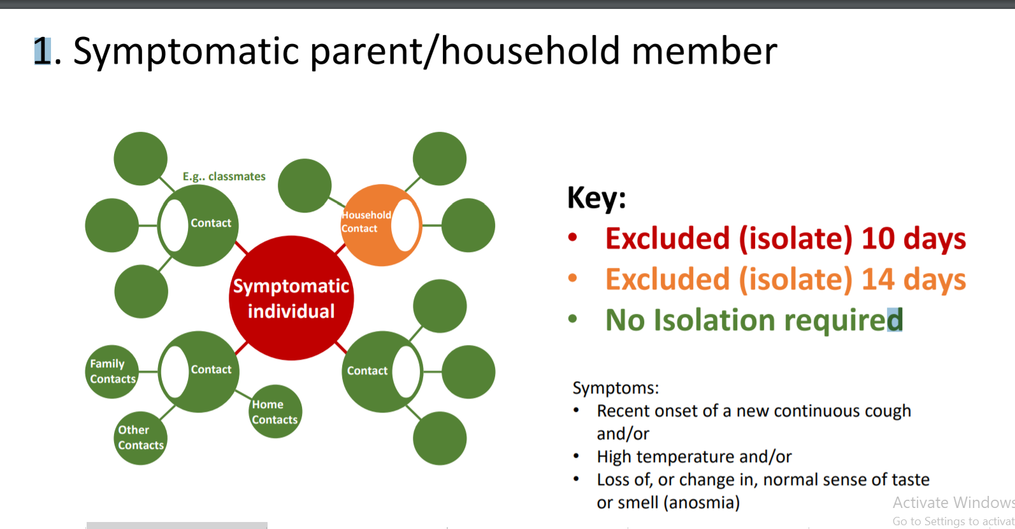

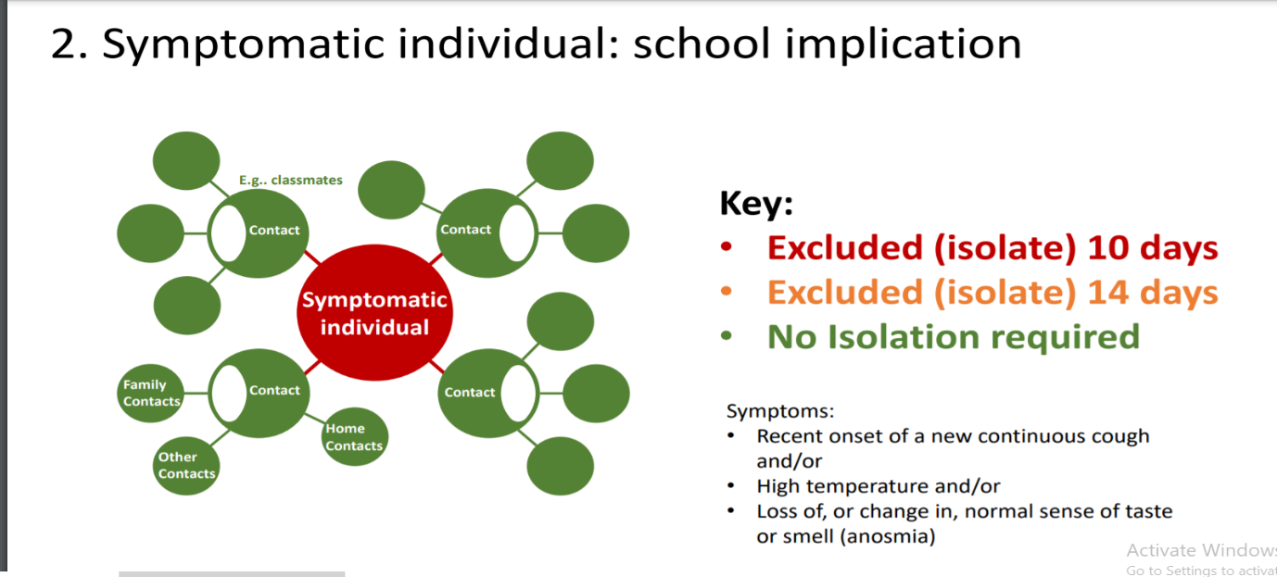

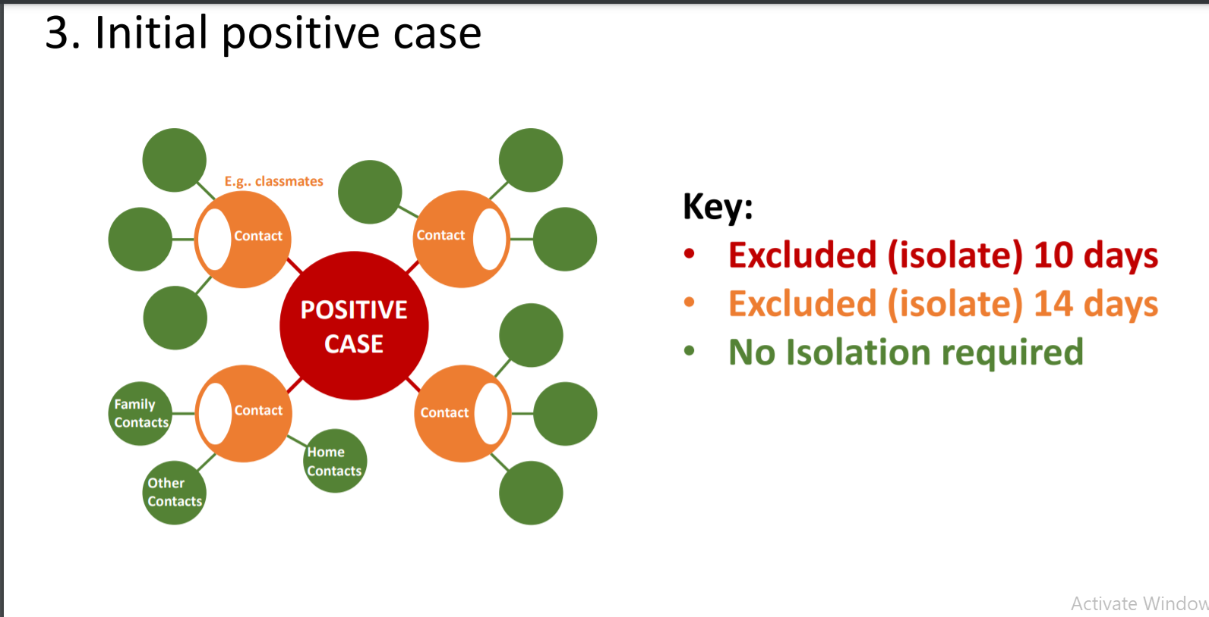

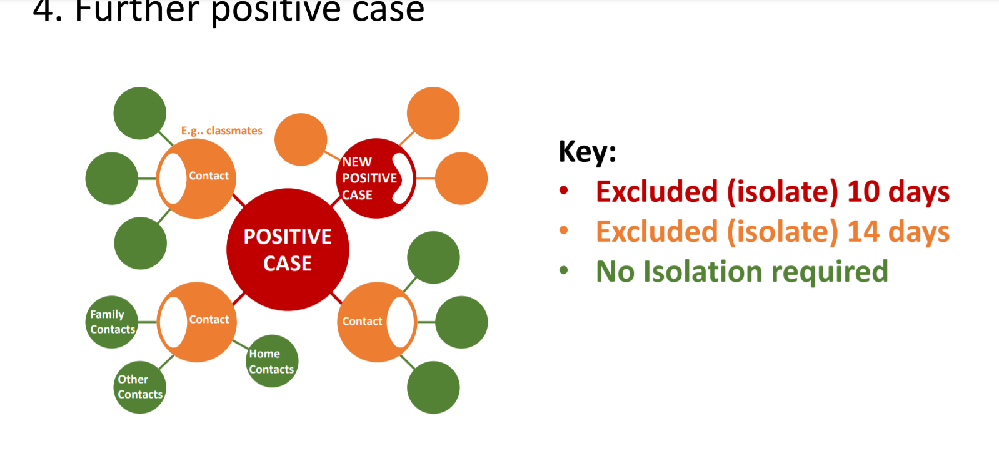

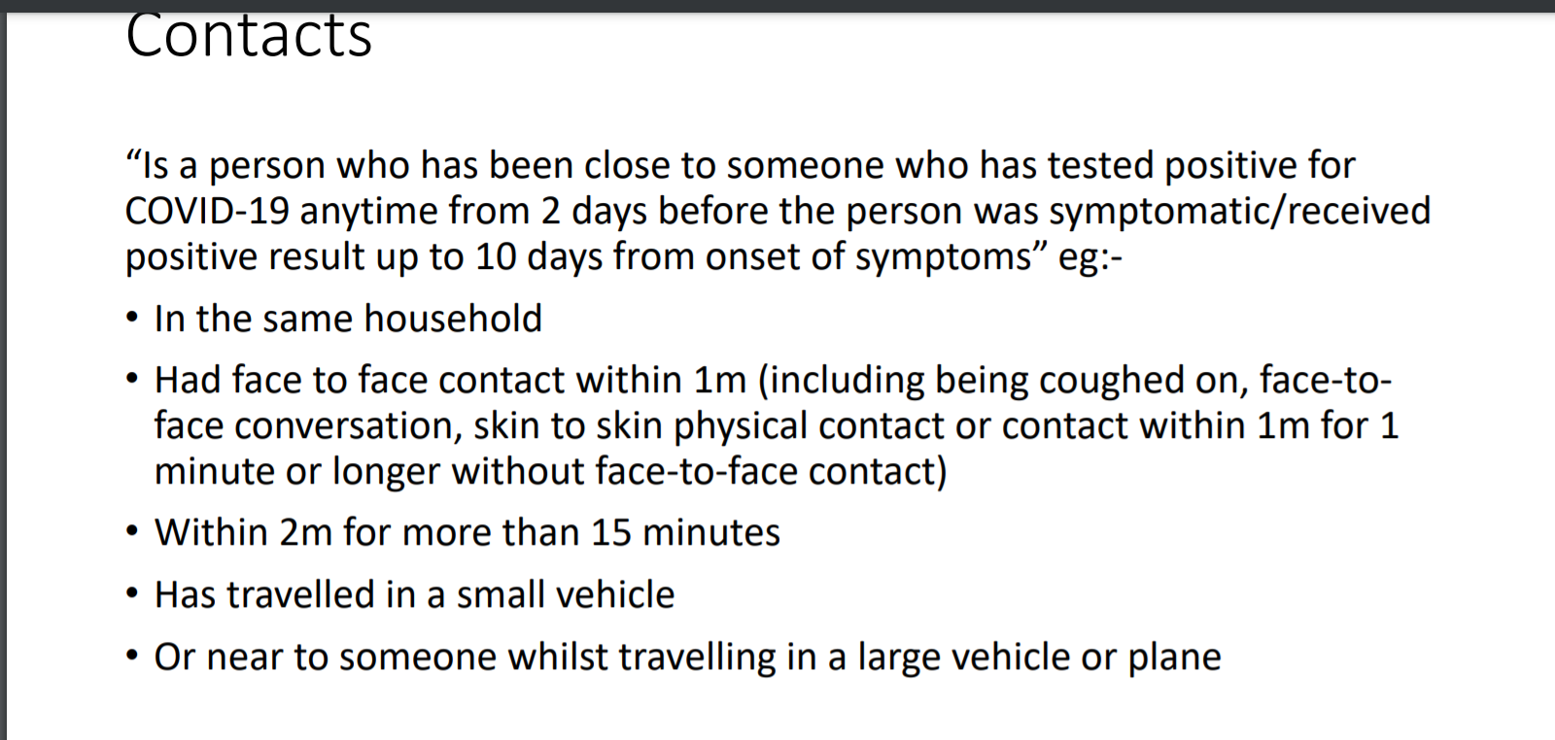

Appendix 1 Signage around the academy site

This risk assessment is supported by a video compiled to inform staff, parents and children of some of the measures put into place and this is available on the academy website – www.asna.walsall.sch.uk

- Poster in the academy corridors and classrooms
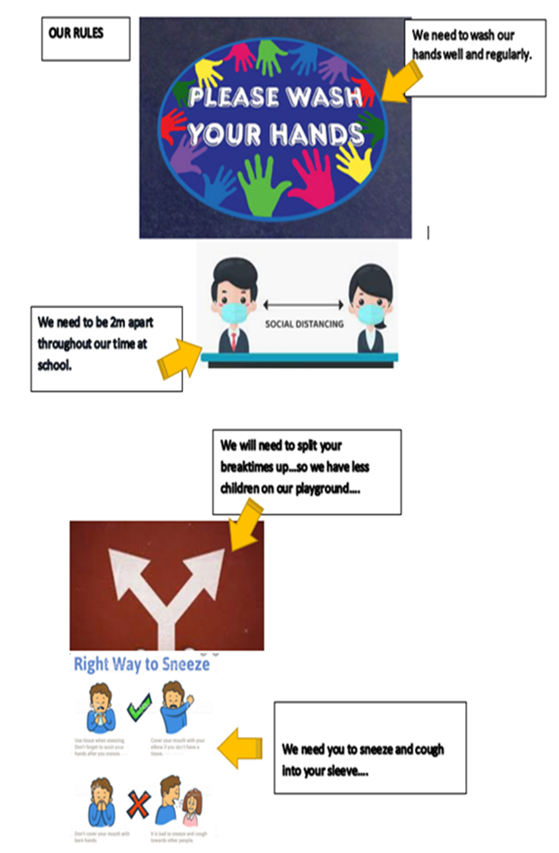

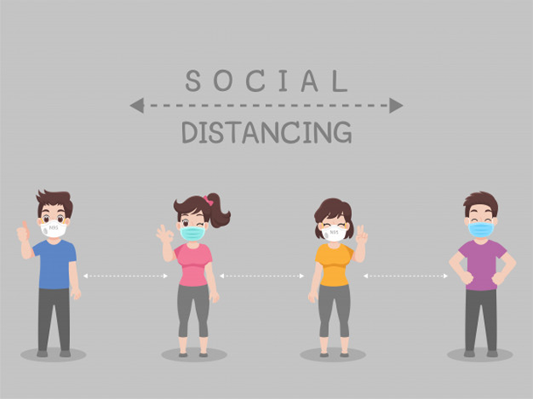

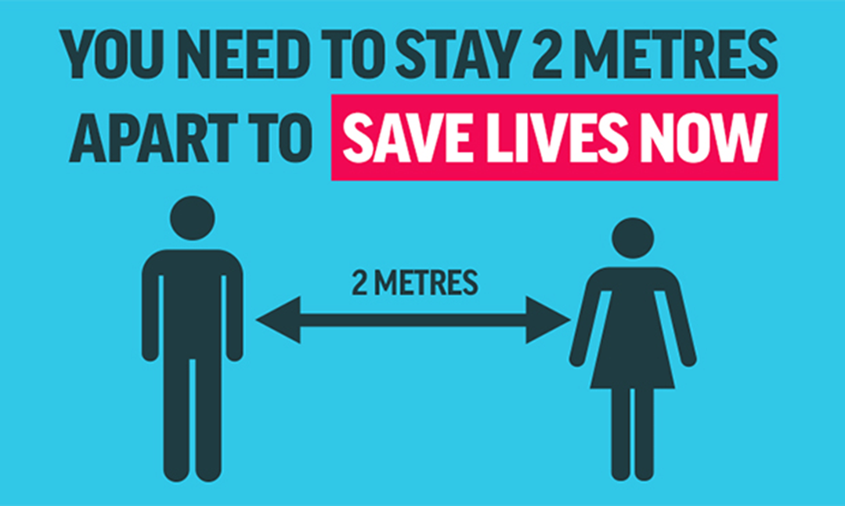
Tissue Disposal Signage for Designated Bins

Appendix 2 Signage outside of the academy to support social distancing and delivery expectations

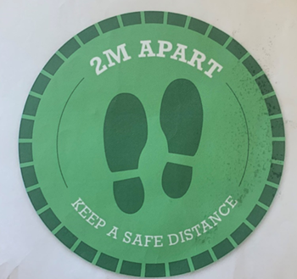

Signage on main entrance door
Appendix 3 Letter sent to parents to share academy expectations

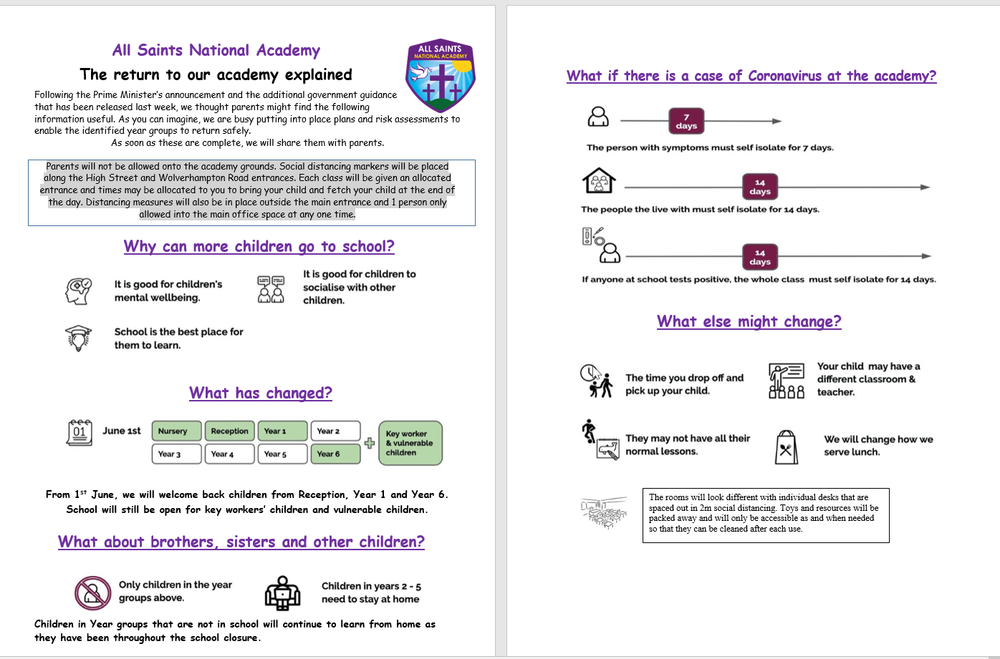

Appendix 4 External Map to show Designated Entrance and Exit Points
Reception entrance.
Queue to the right towards the park.

Barrier where staff will stand to welcome the children.
Barrier where staff will stand to welcome the children.
Year 3,4 &6 entrance. Queue to the right towards the academy staff car park
Any pupils who are late or have a designated plan for entry Main Entrance, using the designated one- way system.

Year 1,2&5
Queue to the left towards the academy main entrance

