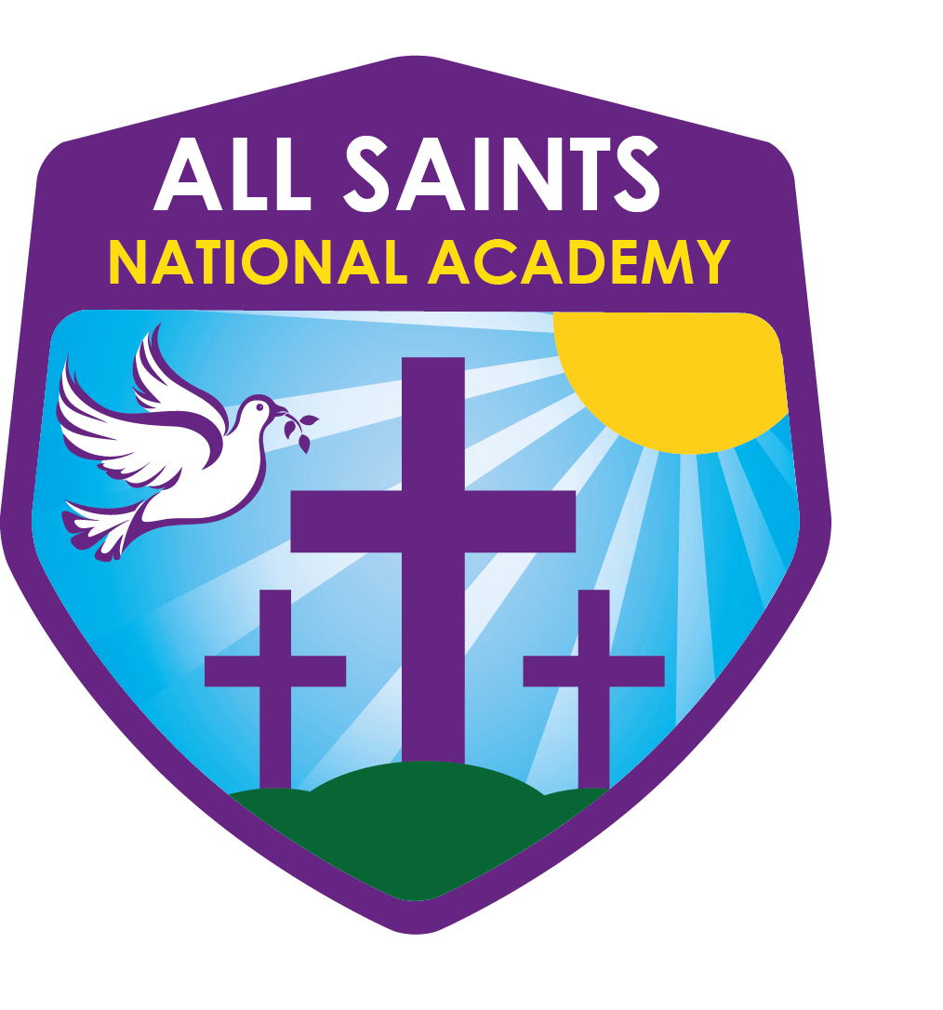
All Saints National Academy
High Street
Bloxwich
Walsall WS3 3LP
Telephone: (01922) 710210
postbox@asna.walsall.sch.uk
Principal - Mrs N. Baddeley

‘With Faith in Our Hearts, We Achieve and Succeed’
Dear Parents and Carers,
Thank you for requesting a place at the academy for your child under the key worker or vulnerable heading. This time the guidance from the government is different following the lockdown announcement. Whereas in March schools were told to legally close and the formal register did not need to be completed, during this lockdown we legally have to keep a register of the children who attend. As you would if your child was absent if the academy was open normally it will be your responsibility to report any absence by telephoning the office. If an absence is not reported we will follow our attendance policy whereby the Educational Welfare Officer is informed and a safe and well check will be completed, If we are unable to make contact then our normal protocol will be followed and an unauthorised absence code will be entered into the register, which could result in prosecution.
As stated in my previous correspondence places need to be booked for your child/ren on a weekly basis. If you can contact me by Thursday lunchtime each week stating the days and times you need, via email mskidmore@asna.walsall.sch.uk, then a place will be booked. If you know your shift pattern remains the same and is likely to stay like this for the duration of this half term then please state that in an email and I will record this for the next five weeks. Unfortunately, if notification of a required place is not received your child will be refused entry to the academy.
If you have any questions please do not hesitate to contact me. Thank you for support.
Yours sincerely

Mrs M Skidmore
Vice Principal

