Learning Project Week 4 - Viewpoints

Year Reception
Weekly Maths Tasks (Aim to do 1 per day) | Weekly Writing Tasks (Aim to do 1 per day)
- Play the Numberblocks matching pattern game –can you recognise the same patterns in a sequence  - Listen to a number song from the Cbeebies website. After listening to them, watch again and sing along if you can. Talk about the maths you can see in the video clip.  - Play the Numberblocks adding game. Can you write the number down?  - Pick up to 5 things you can spot outside your window – how any of them can you see? Write the number down – 5 red cars, 6 birds.  - Play the gingerbread man number game. Can you count the numbers, match them and order them | - We're Going on a Bear Hunt – Listen to the story – what words represent the sounds in the story? Can you think of any more that you write down? Bang! Splash! Drip drop! (These words are called onomatopoeia words.)  - Have a look at these sound words – can you think of and write a sentence using these words – an example could be: The man went splosh in the puddle.  - Make a list – What might you need to take on a bear hunt? Make a list of the things that might help you through all the tricky environments – wellies, coat, snacks. Talk about this with your family.  - Continue to use the phonics sheets sent via Dojo to support letter formation of the letters and sounds we have learned. Remind your child of their pencil grip and ask them to think of a word that starts with that letter – can they write it down?
Weekly Phonics Tasks (Aim to do 1 per day) | Weekly Reading Tasks (Aim to do 1 per day)
- Daily phonics – use the sheets sent via Dojo to continue to support your child’s sounds and continue to work on blending sounds together. Remind your child to use their funky phonics fingers.  - Play the farm phonics game – can you sound out the sounds on the farm and match the correct label to the object  - Sing Nursery Rhymes and songs together. Add in actions and change the words. Can children think of different rhyming words to add in? Repeat old favourites and learn new rhymes. You can find an A-Z of Nursery Rhymes here.  - Play I-spy with things you can see out of the window. You could alternate between the initial sound in the word e.g. “I spy with my little eye something beginning with t”. Or with oral blending e.g. “I spy with my little eye a t-r-ee” | - Continue to use the oxford reading website to read a book at home. Listen to the sounds and encourage your child to blend them together to say the word. These books support your child’s phonics and their blending to support their reading development. Logins were sent via Dojo – username - rkm1  Password – Reception  - We're Going on a Bear Hunt – Watch the story and look out for the words that represent sounds – can you spot them? Swish Swosh? What actions can you do to match the sounds  - With your child, look in magazines, newspapers and books for the tricky words they are currently learning. They could use a highlighter to highlight in magazines and newspapers.
Learning Project - to be done throughout the week
The project this week aims to provide opportunities for your child to learn more about different viewpoints. Learning may focus on physical viewpoints in terms of what you can see outside of the window at home, what others can see looking into your home and then progress onto personal viewpoints and of others.

- Take a walk around your area or have a look around your house – what can you see that match the colours of the rainbow? Can you make the rainbow using your objects? Talk to a member of your household about how a rainbow makes you feel.

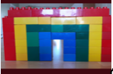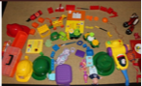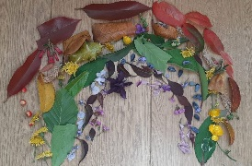

- Check out this Emotion wheel – you can make one and engage in one of the activities – it helps you manage your feelings and viewpoints around different things you feel – at this difficult time it’s a good resource to help children and adults let out their feelings

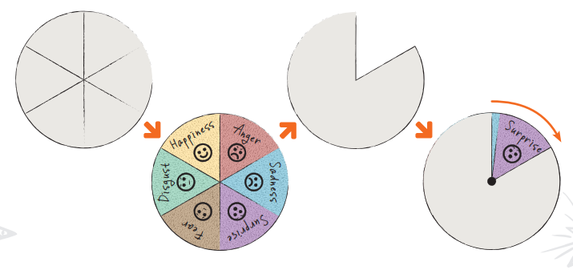

- How do we differ from others? Ask your child to look in a mirror at their hair colour, eye colour, skin colour. Ask them to create a self-portrait using either felt-tips, crayons or paint. Look at some pictures in books and magazines. Does everyone look the same way as them? How do people look different? And remember just because we look different we are all individual but are all the same.

- Pass the toy – sit in a circle or near each other. Pick a topic that you want to talk about – it could be the lockdown. Pass the toy and whoever is holding it is able to talk about their feelings on the topic or ask questions on it if they want to ask something they miht be confused about. It’s good to talk about your feelings. However this doesn’t have to be too serious – it could be a fun game and talk about something aliens maybe! Do they exist? What do you think they look like?

- Have a look at these conversation starters – They all look at different viewpoints that the family may have and can all be different to talk about with each other – they are fun and easy to talk about

