Learning Project Week 4 – Viewpoints
Year 3/4
Weekly Maths Tasks (Aim to do 1 per day) | Weekly Reading Tasks (Aim to do 1 per day)
● Go to https://www.timestables.co.uk/ and choose a times table your child need to practise. Complete the steps and the times table diploma.  ● Go to https://www.bbc.co.uk/bitesize/dailylessons and choose the year group for your child. Remember your child may need to access a year group below dependant on their ability. Choose the maths daily lesson and watch the video and complete the tasks available.  ● Play hit the button at https://www.topmarks.co.uk/maths-games/hit-the-button focus on times tables and division facts.  ● Play the daily ten https://www.topmarks.co.uk/maths-games/daily10 Daily ten has maths questions on a range of maths concepts. Please choose the correct level for your child’s ability.  ● Get a piece of paper and ask your child to show everything they know about subtraction. This could be pictures, diagrams, explanations, methods etc. They can be as creative as they want to be. | ● https://www.youtube.com/watch?v=vB07RfntTvw  https://www.sps186.org/downloads/basic/610716/The_True_Story_of_the_Three_Little_Pigs1.pdf  Listen or read The True Story of the Three Little Pigs by Jon Scieszka and test your child’s understanding by using the quiz below  https://www.softschools.com/quizzes/childrens_books/the_true_story_of_the_three_little_pigs/quiz4018.html  ● Watch Newsround and discuss what is happening in the wider world. Ask different members of your household their view on these matters.  ●Read a chapter of their current book aloud, encourage your child to use expression and intonation. Discuss what they have read and ask them questions.  ● With your child, look in magazines, newspapers and books for new vocabulary they are unfamiliar with. They could use a highlighter to highlight in magazines and newspapers. Use dictionaries, the internet or other devices like Alexa to check meanings of words.  ● https://youtu.be/eIsJjTqELiI Listen to Stanley Tucci read the first chapter of Roald Dahl’s The Witches.  Can your child answer these questions?  - What was your favourite part?  - Which words and phrases capture your attention? Make a note of them. This will help you in your writing task.
 | Weekly Writing Tasks (Aim to do 1 per day)
● Practise reading and writing the Year 3/4 for Common Exception words. (http://www.canonburrows.co.uk/serve_file/294727)  ● Choose 5 Common Exception words. Write synonyms, antonyms, the meaning and an example of how to use the word in a sentence. Can the word be modified?  ● Choose 5 Common Exception words and turn them into rainbow words. First you need to write out the words in pencil then choose 3 different coloured pencils to trace over them. This is a fun way to practise each spelling.  ● http://www.ictgames.com/littleBirdSpelling/  This spelling game has tricky words listed in the National Curriculum. It is a look, cover, write and check game. Choose your child’s year group and practise.  ● Look at this spelling pattern  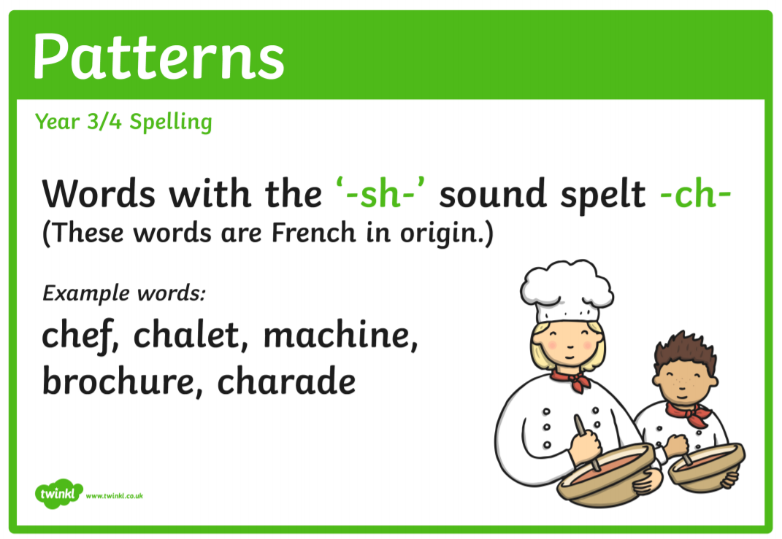  Can you think of any other words with the –sh sound spelt –ch?  Can you create sentences using as many as these words as possible?  For example - I saw the chef’s chalet in the brochure. | ● The True Story of the Three Little Pigs by Jon Scieszka tells the story of the three little pigs from the wolf’s point of view. Think about other fairy tales that might change if they were told from a different point of view. For example, how would Cinderella's stepsisters tell her famous story? How would Snow White's stepmother explain what happened to her? Write an alternate version to a fairy tale.  Use this link to help you plan your story https://www.bbc.co.uk/bitesize/topics/zfxtyrd/articles/zhh992p  ● The True Story of the 3 Little Pigs is funny and it does make the point that two different newspapers might cover the same story differently depending on who their readers are and on what those readers believe. For example, A. Wolf's story appears in The Daily Wolf. The other news reports (that tell the story of the big and bad wolf) appear in The Daily Pig. Can you write the news articles for the Daily Pig and Daily Wolf? Remember they will have different viewpoints.  Use this video to help you write your news articles. https://www.bbc.co.uk/bitesize/topics/zkgcwmn/articles/zbsbwty  ● Should the wolf be sent to jail? Do you think the wolf is guilty? Write a persuasive letter to the judge to convince them that your decision is the right one.  Use this link to help you write your letter  https://www.readingrockets.org/content/pdfs/persuasiveletter_camping.pdf  ● Using the first section of Roald Dahl’s The Witches write another negative character description of a troll, wizard or zombie. Use phrases you heard in the video to help you.  https://youtu.be/eIsJjTqELiI  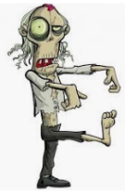  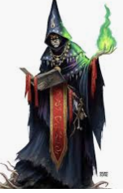
Learning Project - to be done throughout the week
The project this week aims to provide opportunities for your child to learn more
about different viewpoints. Learning may focus on physical viewpoints in terms of
what you can see outside of the window at home, what others can see looking into
your home and then progress onto personal viewpoints and of others

Let’s Wonder:
Draw a picture of themselves and label their drawing with the qualities they have. How do others see them differently? Ask people at home to add to their qualities. How are they different to other children in different parts of the world? What makes them similar to other children around the world?

Let’s Create:
Complete an observational drawing of what they see outside a window in their house. Then get out into the garden or find pictures online and find natural forms such as stones, leaves, flowers and animals. Complete sketches, showing an awareness of different viewpoints of the same object. Remember to concentrate on tone and shading.

Be Active:
Move around their home and garden taking photographs from different viewpoints. Which photos do they like? Do the people they live with like the same photos as them? Why? Why not? Take a look at the 10 minute shake-up activities on https://www.nhs.uk/change4life/activities website.

Time to Talk:
Talk about keeping safe, discuss different ways to keep safe. Basic hygiene rules, road safety, internet safety, water safety, being safe around the home, stranger danger. How do different people view this?

Understanding Others and Appreciating Differences:
Listen to different pieces of music from around the world, which styles of music do they prefer and why? Maybe they could learn a song by heart and perform it.

Reflect:
Design their own ideal world. Would their world contain the same things as other people? Which things are most important to them? What are they going to include?

