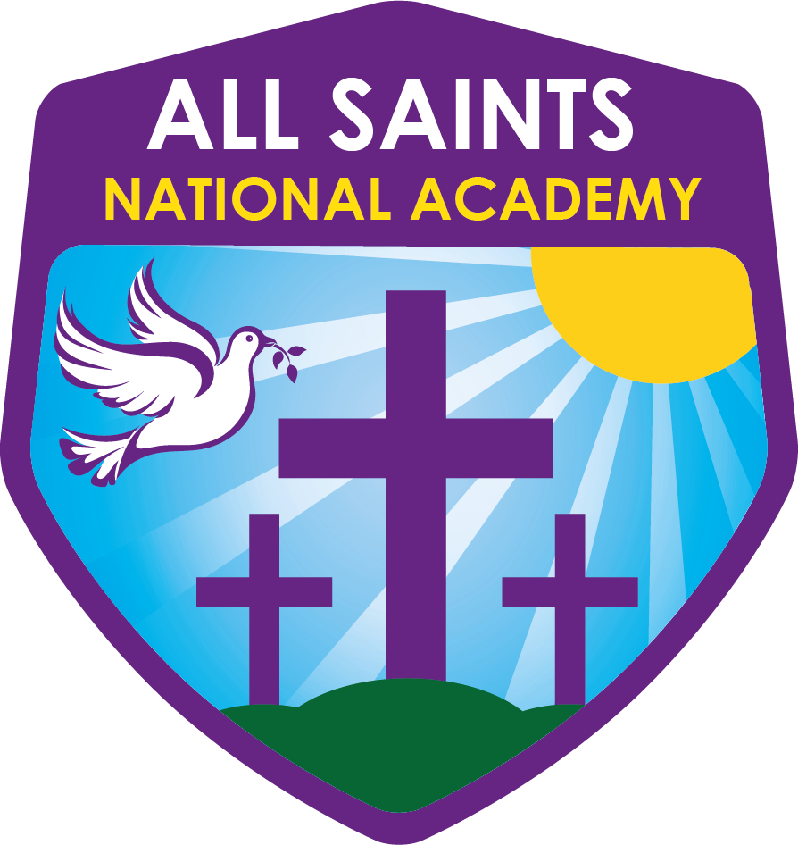

All Saints National Academy

REMOTE LEARNING POLICY

Policy Review

This policy will be reviewed in full by the Governing Body on an annual basis.

The policy was last reviewed and agreed by the Governing Body on 30/09/20

It is due for review on 30/9/21 (up to 12 months from the above date).

Signature …………………………………. Date ……………………

Principal

Signature ………………….………………. Date ….…………………

Chair of Governors

September 2015

- POLICY INTRODUCTION

At All Saints National Academy, we endeavour to help everyone achieve their potential. By listening to each other, thinking about what we do, checking our outcomes and always striving to improve we will ensure that everyone can be safe, happy and successful.

Introduction

This remote learning policy for staff aims to:
- Ensure consistency in the approach to remote learning for pupils who aren’t in school
- Set out expectations for all members of the school community with regards to remote learning
- Provide appropriate guidelines for data protection

Roles and Responsibilities
2.1 Teachers
When providing remote learning, teachers must be available between the hours of 8.30 am and 3.30pm. Staff may be teaching during these times so would respond at the earliest available opportunity. If they’re unable to work for any reason during this time, for example due to sickness or caring for a dependent, they should report this using the normal absence procedure.
When providing remote learning, teachers are responsible for:
Setting work –
  - For their own class group
  - This work will be set by 8.15 am
  - Work will be provided in line with the lessons covered across an academic day
  - Staff will plan within their phase groups to prepare the work collaboratively for their groups.
  - Parents have been consulted and all pupils have access to a machine – any that do not have access have been provided with a machine by the academy or through the LA provision.
Providing feedback on work:
  - Pupils will send work back to teachers or dependent upon the work set staff will have access to the content via the platform used
  - Staff will provide feedback to individual children’s work via Dojo or directly to the parents email address
  - Staff will be expected to provide feedback to work sent to them within 48 hours?

Keeping in touch with pupils who aren’t in school and their parents:
  - Regular contact will be made via class d’ojo and a weekly phone call conversation will be made
  - Email’s / class d’ojo messages should be answered in line with the academy communication policy and therefore should only be answered up to 6pm and from 8am
  - Any complaints should be forwarded to the principal or vice principal.
  - Safeguarding concerns should be uploaded onto My Concern and where needs be consultation with Nicky Baddeley or Mandeep Bassi
  - If children fail to complete the work set, class teachers should contact their phase leads so that this can be investigated further
Attending virtual meetings with staff, parents and pupils:
  - Dress code – staff are expected to dress professionally for any virtual meetings
  - Locations – staff need to be mindful of the location when working remotely and to aim to be in a place that is away from others.

Individual cases will be discussed whereby groups of pupils are learning remotely and staff members are isolating, the provision of work will be shared out as appropriate.
2.2 Teaching assistants
When assisting with remote learning, teaching assistants must be available between 8.45am and 3pm
If they’re unable to work for any reason during this time, for example due to sickness or caring for a dependent, they should report this using the normal absence procedure.
When assisting with remote learning, teaching assistants are responsible for:
Supporting pupils who aren’t in school with learning remotely:
  - Teaching staff will identify pupils that require additional support and what this support will look like
Attending virtual meetings with teachers, parents and pupils:
  - Dress code – staff are expected to dress professionally for any virtual meetings
  - Locations – staff need to be mindful of the location when working remotely and to aim to be in a place that is away from others
2.3 Subject leaders
Alongside their teaching responsibilities, subject leads are responsible for:
- Identifying where any aspects of the subject curriculum need to change to accommodate remote learning
- Working with teachers teaching their subject remotely to make sure all work set is appropriate and consistent
- Working with other subject leaders and senior leaders to make sure work set remotely across all subjects is appropriate and consistent, and deadlines are being set an appropriate distance away from each other
- Monitoring the remote work set by teachers in their subject – explain how they’ll do this, such as through regular meetings with teachers or by reviewing work set
- Alerting teachers to resources they can use to teach their subject remotely
2.4 Senior leaders
Alongside any teaching responsibilities, senior leaders are responsible for:
- Co-ordinating the remote learning approach across the school
- Monitoring the effectiveness of remote learning each week
- Uploading material to the website and ensuring all aspects of the technical/ICT support is available to staff and parents
- Monitoring the security of remote learning systems, including data protection and safeguarding considerations
2.5 Designated safeguarding lead
The DSL or DDSL is responsible for:

- Make contact with families of children (who are on early concern, child in need or child protection plans) who are not attending school due to COVID-19 at least weekly.
- Communicating attendance with named social worker or family support worker and EWO
2.6 IT staff
IT staff are responsible for:
- Fixing issues with systems used to set and collect work
- Helping staff and parents with any technical issues they’re experiencing
- Reviewing the security of remote learning systems and flagging any data protection breaches to the data protection officer
- Assisting pupils and parents with accessing the internet or devices
2.7 Pupils and parents
Staff can expect pupils learning remotely to:
- Be contactable during the school day – although consider they may not always be in front of a device the entire time
- Complete work to the deadline set by teachers
- Seek help if they need it, from teachers or teaching assistants
- Alert teachers if they’re not able to complete work
Staff can expect parents with children learning remotely to:
- Make the academy aware if their child is sick or otherwise can’t complete work
- Seek help from the academy if they need it such as accessing pupil login details for certain school subscriptions e.g. purple mash or support with Class Dojo to ensure communication between home and school.
- Be respectful when making any complaints or concerns known to staff
2.8 Local Academy Committee
The governing board is responsible for:
- Monitoring the school’s approach to providing remote learning to ensure education remains as high quality as possible
- Ensuring that staff are certain that remote learning systems are appropriately secure, for both data protection and safeguarding reasons

3. Who to contact
If staff have any questions or concerns about remote learning, they should contact the following individuals:
- Issues in setting work – talk to the relevant subject lead or SLT
- Issues with behaviour – talk to the relevant head of phase or SLT
- Issues with IT – talk to IT staff
- Issues with their own workload or wellbeing – talk to phase lead
- Concerns about data protection – talk to the data protection officer and IT lead
- Concerns about safeguarding – talk to the DSL or DDSL

4. Data protection
4.1 Accessing personal data
When accessing personal data for remote learning purposes, all staff members will:
- Access the data, such as on a secure cloud service or a server in your IT network
- Access the data using their designated staff laptops and not own personal devices
4.2 Processing personal data
Staff members may need to collect and/or share personal data such as academy email address as part of the remote learning system. As long as this processing is necessary for the school’s official functions, individuals won’t need to give permission for this to happen.
However, staff are reminded to collect and/or share as little personal data as possible online.
4.3 Keeping devices secure
All staff members will take appropriate steps to ensure their devices remain secure. This includes, but is not limited to:
- Keeping the device password-protected – strong passwords are at least 8 characters, with a combination of upper and lower-case letters, numbers and special characters (e.g. asterisk or currency symbol)
- Ensuring the hard drive is encrypted – this means if the device is lost or stolen, no one can access the files stored on the hard drive by attaching it to a new device
- Making sure the device locks if left inactive for a period of time
- Not sharing the device among family or friends
- Ensuring that antivirus and anti-spyware software is installed on devices
- Keeping operating systems up to date – always install the latest updates

5. Safeguarding
This policy links to the current Safeguarding policy.

6. Monitoring arrangements
This policy will be reviewed on a termly basis by the Principal. At every review, it will be approved by the Local Academy Committee

7. Links with other policies
This policy is linked to our:
- Behaviour policy
- Child protection policy
- Data protection policy and privacy notices
- Home-school agreement
- ICT and internet acceptable use policy
- Online safety policy

